

MFIP Status Updates (9/22/23)

Local Policy Update
This document contains important information that impacts the delivery of MFIP Employment Services in Hennepin County. Contracted Employment Services Providers (ESPs) are responsible for implementing changes to agency policy and procedure according to the information in this document, effective as of the date listed above.
Contact: Rebecca Golden, Hennepin County MFIP Employment Services Coordinator
rebecca.golden@hennepin.us
Tina Dudzinski, Hennepin County MFIP Employment Services Coordinator
Tina.dudzinski@hennepin.us

Communicating with Hennepin County
Hennepin County MFIP Employment Services Providers have a responsibility to communicate MFIP case information in a secure and timely manner with the appropriate Hennepin County team. This policy outlines the types of information that must be communicated and how to do so correctly.

Use of DWP/MFIP Status Update Form (DHS-3165)
Official case related information between MFIP ESPs and Hennepin County teams should be documented using the DWP/MFIP Status Update Form and stored in the official case file.
These communications include:
- Changes in circumstances the participant reports to the ESP that may impact MFIP eligibility. Participants are required to report certain changes within 10 days and may report them to the ESP as a contracted partner of Hennepin County. In these cases, the ESP is responsible for communicating information that is known to the agency within 10 days of the change. Communicate these changes to the assigned eligibility team. Common examples include:
  - Any change in household composition, including births, returns to and departures from the home of unit members, a unit member temporarily absent from the home, or a change in custody of a minor child.
  - Any change in family status of a unit member (marriage, legal separation, divorce, death).
  - Any change in employment status and hours.
  - Any change in address or residence (including returned mail/unknown residence status).
  - Requests to begin, change, or end the Child Under 12 Months Old Exemption.
  - See DHS Combined Manual 7.15 for a complete list.
- Changes to Family Stabilization Services (including Family Violence Waiver) eligibility status. Communicate these changes to the TTL team.
- Requests to impose and cure sanctions. Communicate these changes to the Sanction Expert team.

Communicating with CCAP
When communicating changes about the CCAP case to the assigned Childcare Worker, ESP staff should use the Childcare Assistance Plan (CCA-MN Child Care Plan - HC12362A), rather than the Status Update Form. Follow the same steps outlined below to send a worker communication to the assigned Childcare Worker once the document is in ECF.

Generating Status Updates in WF1
Status Updates created by ESP staff must be stored in the Workforce One (WF1) case file. A Status Update can be generated by navigating to the left menu in the person file, in the Outgoing Status Update tab. Status Updates generated here will automatically save a copy in the file.
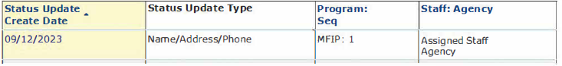
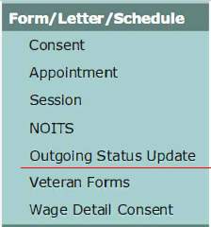

Alternatively, the if a Status Update form is generated outside of WF1, it must be uploaded to EDS (Document Type: Program Specific, Document name: DWP/MFIP Status Update Form (DHS-3165)).

Adding Status Updates to ECF
After saving a copy of the Status Update in WF1, ESP staff must also add the Status Update to ECF so that Hennepin County staff can access it and take the appropriate action on the case. ESP staff can add Status Updates to ECF in two primary ways. For more information see the ECF Next Training video on the MFIP ESP Website.
Create Form from Template in ECF: Create a duplicate copy of the Status Update on file in WF1 by retyping in the fields on the form. (When creating a duplicate, be sure that all the information on the Status Update identically matches the version in WF1.)
Upload Content: Export the copy of the Status Update from WF1 and upload it into the ECF case file.

Sending Worker Communication in ECF
Adding the Status Update document into the ECF case file is the first in a two-step process. Sending an ECF Worker Communication to the appropriate Hennepin County team is a critical step to ensure the document is treated as a new work item and acted on appropriately. (Follow the same steps below to communicate with the assigned Childcare Worker about a new Childcare Plan pending review.)
- In the case file, make sure the Status Update that you want to send is visible in the content list. If necessary, change the date range filter.
- Then, to initiate the Worker Communication do one of the following:
  - On the sidebar menu, click Worker Communication OR
  - On the content menu, click Launch.

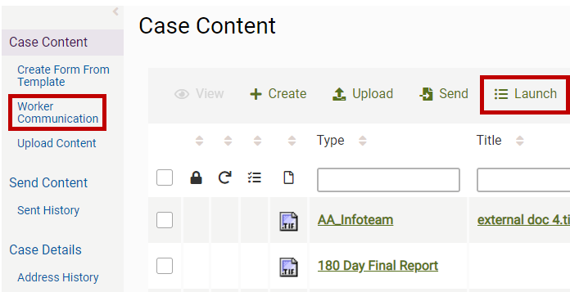
- Select the form you are sending by placing a check mark in front of the form:
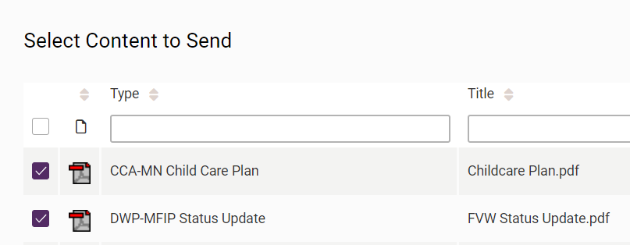

- To remove a selected form from the Content Manifest table, click the Remove button (trash icon).
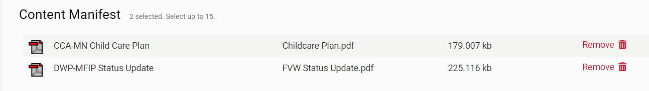

- Click the Select Recipients button on the bottom of the page.
- Click Show Workers from button to filter the worker list:
  - Assigned: Worker who is assigned to the case. (The currently assigned eligibility team and CCAP worker can be found here.)
  - My Favorites: Workers that you have added as Favorites. (See Adding or Removing Worker Favorites below).
  - All: All workers.
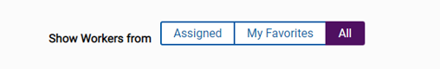
- If searching all workers, you can select to search by Last Name, First Name, Network ID, or State ID. In the Search field, type the required information. After you type the minimum number of characters (minimum number varies), suggestions appear, and the Search button becomes active. To clear the Search field, click the x next to the field.
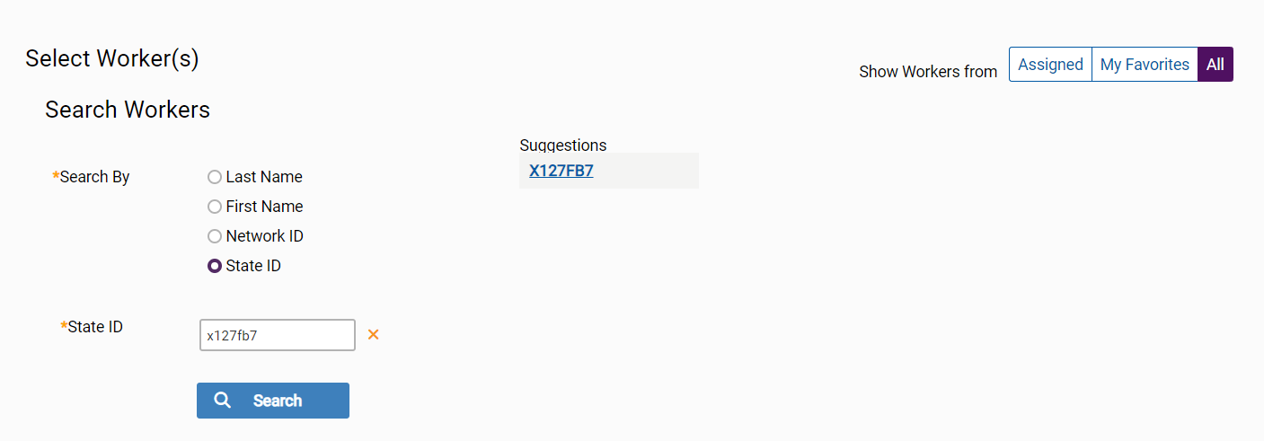

- Either click the Search button or click a suggestion.
- In the worker table, select one or more workers.
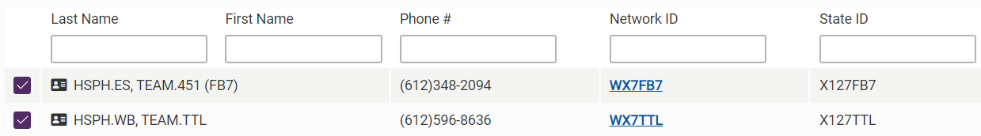

- To remove a worker from the Recipients table, click the Remove button (trash icon).
- Click the Review Communication button.
- In the Optional Details panel, enter the following, if appropriate.
  - Due date: This is optional.
  - Details: Message to the recipients. The message is displayed on the Notifications page.
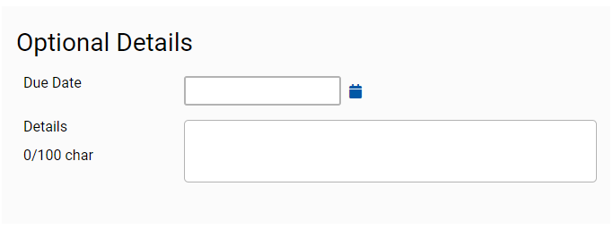
- Click the Send Communication button.

Finding and Adding Favorite Workers in ECF
To add or remove a worker from your worker favorites, click the star next to the worker’s name in the search results.

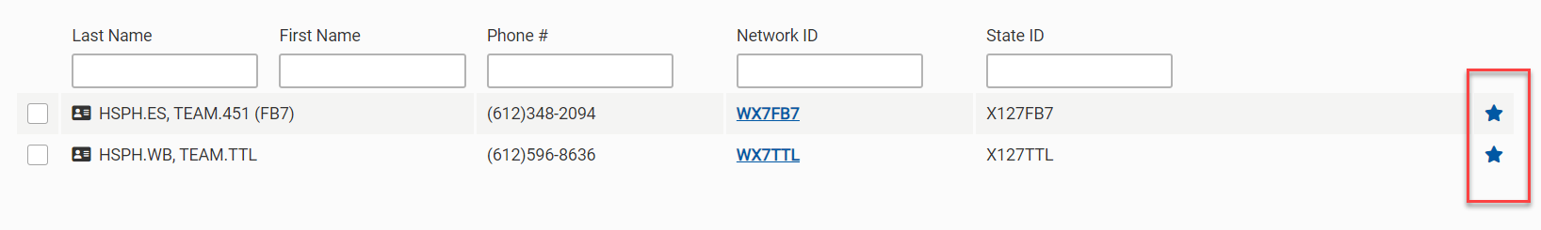
Common ESP partners include:
- TTL/Joint Strategies: X127TTL
- Sanction Experts: X127FB7
- Your agency’s assigned CCAP workers.

You can also view the case’s assigned workers via the Workers tab in the left menu of the case:
