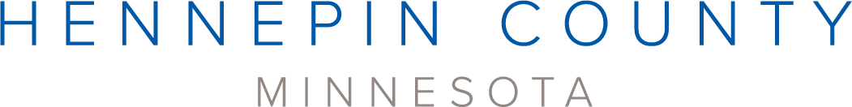

Multifamily recycling grants media kit

About the grants
Hennepin County offers grants for multifamily properties to start or improve recycling or organics recycling, reduce contamination, prevent waste, and educate their residents on recycling and waste prevention. Applications will be accepted on an ongoing basis until Monday, November 10, 2025, or until the annual program budget is exhausted, whichever occurs first.
Grant information can be accessed here: hennepin.us/apartmentrecycling#apply-for-grants. Use the article, social media posts, and images below to help promote the grants.
If people have questions about grants, contact the apartment recycling program coordinator at apartmentrecycling@hennepin.us or 612-596-8133.

Multifamily recycling grants
Areas of focus can include purchasing bins and compostable bags, paying for hauling costs, constructing waste enclosures or chutes, managing or preventing the waste of bulky items, and educating residents. Applicants may apply for up to $3,000 for bins and compostable bags and up to $20,000 for all other categories combined. Review the grant flyer (PDF) to learn more.

Apply
- Review the 2025 Multifamily recycling grant guidelines (PDF).
- To receive application materials, submit a multifamily recycling grant inquiry form.

Note: The multifamily bin and compostable bag grants are similar to the grants offered through the business recycling program. If a business that is not a multifamily property inquires about applying for bins and bags, refer them to the business recycling website for more information: hennepin.us/businessrecycling

Sample newsletter article
Share the sample newsletter article on your organization’s website or in your newsletters.

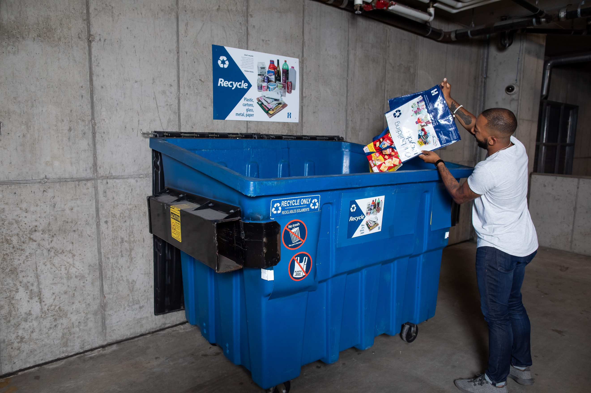
Grants are available to multifamily properties
Hennepin County offers grants for multifamily properties to start or improve recycling or organics recycling, reduce contamination, prevent waste, and educate their residents on recycling and waste prevention. Applications will be accepted on an ongoing basis until Monday, November 10, 2025, or until the annual program budget is exhausted, whichever occurs first.

Recycling grants
Areas of focus can include purchasing bins and compostable bags, paying for hauling costs, constructing waste enclosures or chutes, managing or preventing the waste of bulky items, and educating residents. Applicants may apply for up to $3,000 for bins and compostable bags and up to $20,000 for all other categories combined. Review the 2025 Multifamily recycling grant guidelines (PDF) and grant flyer (PDF) to learn more.
To receive application materials, submit a multifamily recycling grant inquiry form.
If you have questions about grants, contact the apartment recycling program coordinator at apartmentrecycling@hennepin.us or visit the apartment recycling webpage.
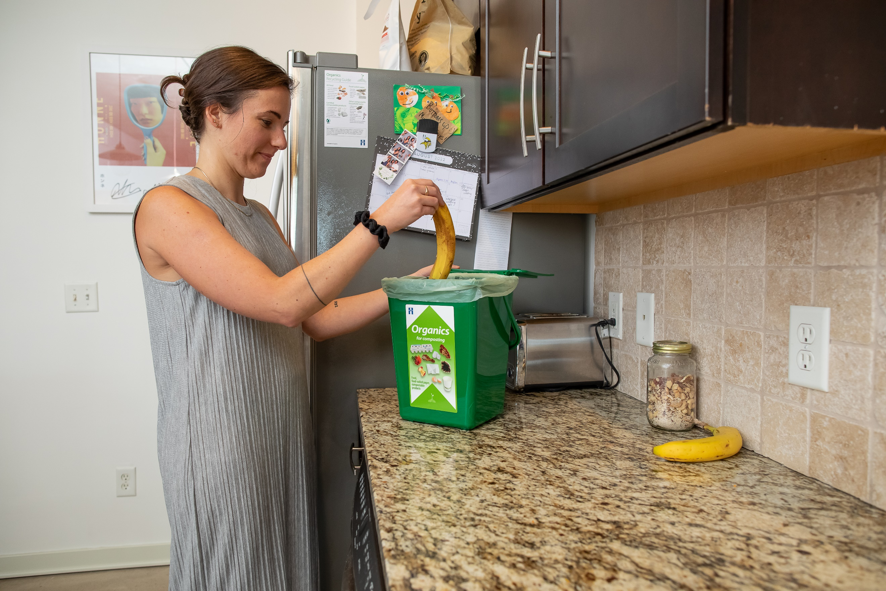

Social media posts
Share these posts through your social media channels.

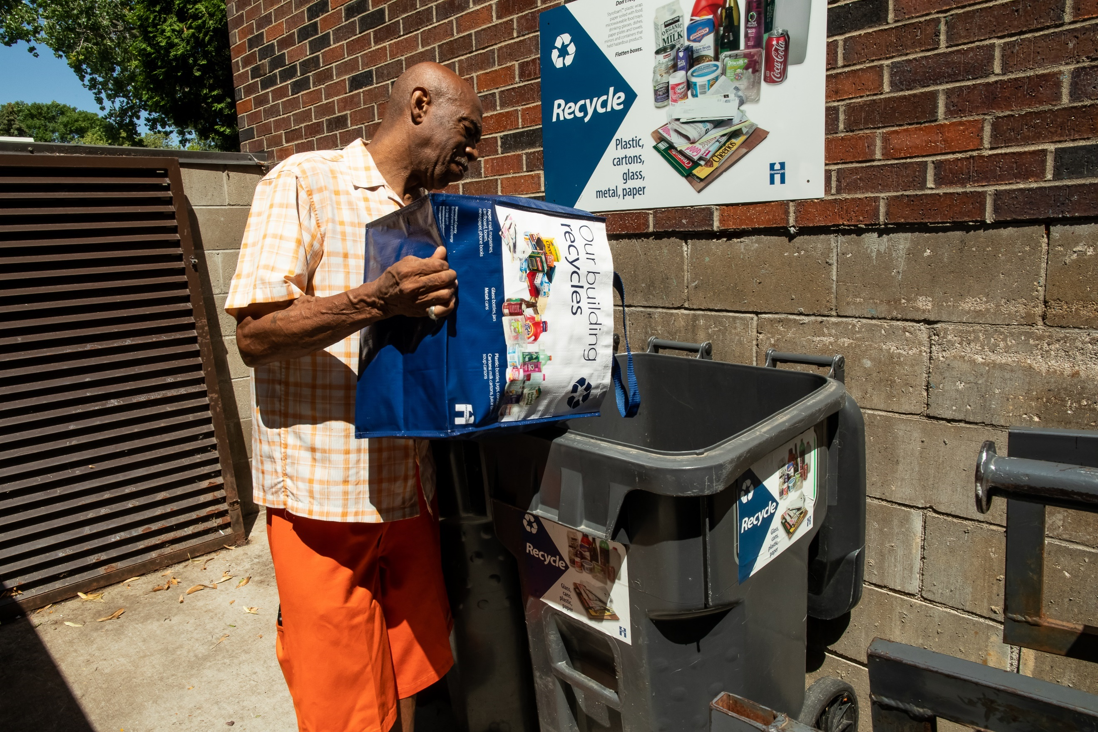
Facebook
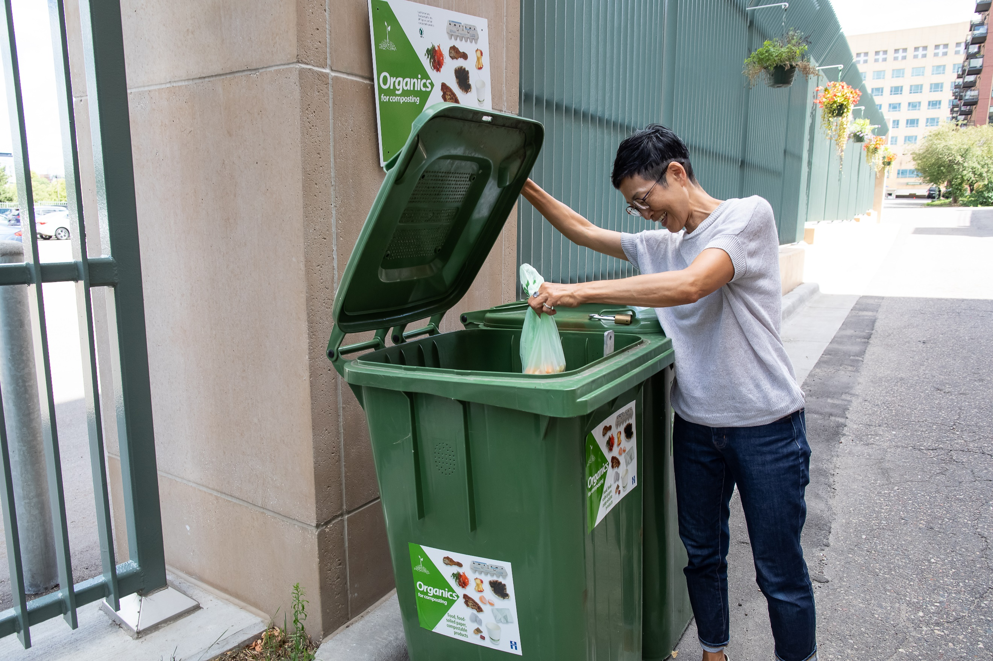
Hennepin County offers grants for multifamily properties to start or improve recycling or organics recycling, reduce contamination, prevent waste, and educate their residents on recycling and waste prevention. Areas of focus can include purchasing bins and compostable bags, paying for hauling costs, constructing waste enclosures or chutes, managing or preventing the waste of bulky items, and educating residents. Learn more and apply: hennepin.us/apartmentrecycling

Twitter/X
Hennepin County offers grants for multifamily properties to start or improve recycling or organics recycling, reduce contamination, prevent waste, and educate their residents. Learn more and apply: hennepin.us/apartmentrecycling #ApartmentRecycling #Recycle #Reduce

Contact
If you have questions about grants, contact the apartment recycling program coordinator at apartmentrecycling@hennepin.us or 612-596-8133.

