

Backyard composting media kit

About backyard composting

Composting is one of the best opportunities to reduce our trash – about 25 percent of what we throw away is organic materials like food scraps and compostable paper that could be put to better use as compost. Backyard composting involves collecting food scraps and yard waste in a bin, which break down into compost. This process creates a nutrient-rich material that can be used in gardens and landscaping projects.

Resources to promote backyard composting
Ways to educate the public about backyard composting:
- Use the sample newsletter articles to share on your organization’s website or in your newsletters. These are editable so you can customize the length or message.
- Use the sample social media posts to share through your social media channels. These are editable so you can customize the message.
- Download the backyard composting flyer to share or order free printed copies.
- Share Hennepin County’s Climate Action article about composting at home.
- Follow and reshare messages posted on the Hennepin County Environment and Energy social media channels: Hennepin Environment on Facebook, Hennepin Environment on Instagram, and @hennepinenviro on X.
- Share the information and resources available at hennepincounty.gov/composting.

Contact
For more information about backyard composting, contact:
- Kira Berglund, Composting & Recycling Specialist, Kira.Berglund@hennepin.us
- Addison Motta, Environmental Educator, Addison.Motta@hennepin.us

Sample newsletter article

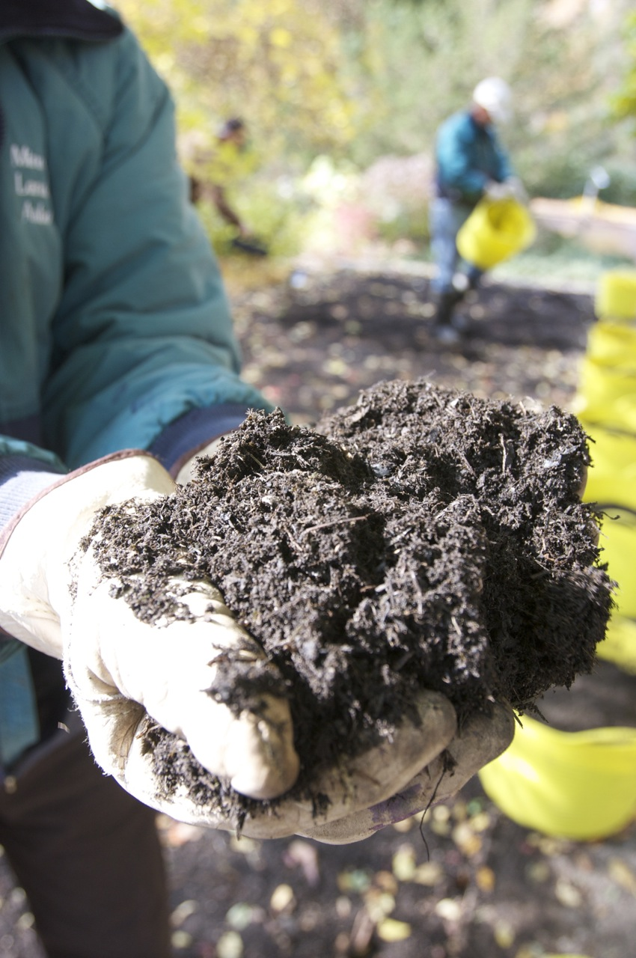
Hennepin County offers free backyard composting webinars
Start turning your food scraps and yard waste into compost—right in your own backyard. About 25 percent what we throw away is organic materials like food, napkins and paper towels that could be put to better use as compost. Hennepin County offers free online webinars to help you get started.

Free backyard composting webinars
Composting & Recycling Specialist Kira Berglund will share tips for backyard composting in free online webinars. Learn how to set up your compost pile, what materials you can compost, how to get the mix right, and more. There is no charge to sign up, but registration is required.
- Friday, May 8 from noon to 1 p.m. Virtual on Microsoft Teams. Register.
- Tuesday, May 19 from 7 to 8 p.m. Virtual on Microsoft Teams. Register.

In-person classes
Hennepin is offering backyard composting classes in partnership with Minneapolis Community Education. Register for one of the following in-person classes:
- Monday, May 4 from 6:30 to 7:30 at Washburn High School. Register.
- Thursday, May 14 from 6:30 to 7:30 at Las Estrellas Dual Language Elementary. Register.
Learn more about backyard composting in Hennepin County at hennepincounty.gov/composting.
- Questions? Contact Kira Berglund, Composting & Recycling Specialist, Kira.Berglund@hennepin.us

Social media posts
Suggested hashtags: #Compost #BackyardComposting
To use images and graphics: right click on image and select save as picture. Alt text for you to use is included with the pictures and graphics.

Post 1: Make a difference with composting
Facebook: Make a difference with composting! About 25 percent of what we throw away is organic materials like food, napkins and paper towels that could be put to better use as compost. Composting, helps the environment, provides nutrients for your soil, and results in a visible reduction in trash. Learn more at hennepincounty.gov/composting
X: Make a difference with composting! About 25 percent of what we throw away is organic materials that could be put to better use as compost. Composting helps the environment, provides nutrients for your soil, and visibly reduces your trash. Learn more at hennepincounty.gov/composting #Compost #BackyardComposting
Instagram: Make a difference with composting! About 25 percent of what we throw away is organic materials like food, napkins, and paper towels that could be put to better use as compost. Composting helps the environment, provides nutrients for your soil, and results in a visible reduction in trash. Learn more at the link in our bio. #Compost #BackyardComposting
Link to: hennepincounty.gov/composting
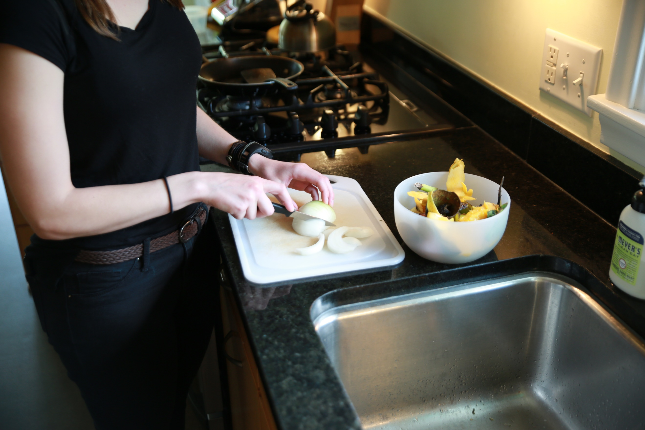
Image alt text: Preparing food on the counter with scraps in a small bowl.

Post 2: Register for a backyard composting webinar
Facebook: Start turning food scraps and yard waste into compost—right in your own backyard! Hennepin County is holding virtual workshops to help you get started. Registration is free but required. Pick one of the following dates and register at hennepincounty.gov/composting
- Friday, May 8 from noon to 1 p.m. Virtual on Microsoft Teams.
- Tuesday, May 19 from 7 to 8 p.m. Virtual on Microsoft Teams.
X: Start turning food scraps and yard waste into compost—right in your own backyard! Hennepin County is holding online webinars May 8 and 19 to help you get started. Registration is free but required. Learn more and register here: hennepincounty.gov/composting. #Compost #BackyardComposting
Instagram: Start turning food scraps and yard waste into compost—right in your own backyard! Hennepin County is holding online webinars May 8 and 19 to help you get started. Registration is free but required. Register at the link in our bio. #Compost #BackyardComposting
Link to: hennepincounty.gov/composting
Post 3: Register for a backyard composting in-person workshop
Facebook: Join Hennepin County and Minneapolis Community Education for an in-person workshop where you will learn the ins and outs of backyard composting. Learn what to include in your compost, how to maintain the pile, and what to do with the finished product. Register for one of the following classes at https://minneapolis.ce.eleyo.com/search?q=backyard+composting&redirected_yet=true
- Monday, May 4 from 6:30 to 7:30 at Washburn High School.
- Thursday, May 14 from 6:30 to 7:30 at Las Estrellas Elementary.
X: Join Hennepin County and Minneapolis Community Education for an in-person workshop where you will learn the ins and outs of backyard composting. Learn what to include in your compost, how to maintain the pile, and what to do with the finished product. Register at https://minneapolis.ce.eleyo.com/search?q=backyard+composting&redirected_yet=true
Instagram: Join Hennepin County and Minneapolis Community Education for an in-person workshop where you will learn the ins and outs of backyard composting. Learn what to include in your compost, how to maintain the pile, and what to do with the finished product. Register at the link in our bio.
Link to https://minneapolis.ce.eleyo.com/search?q=backyard+composting&redirected_yet=true

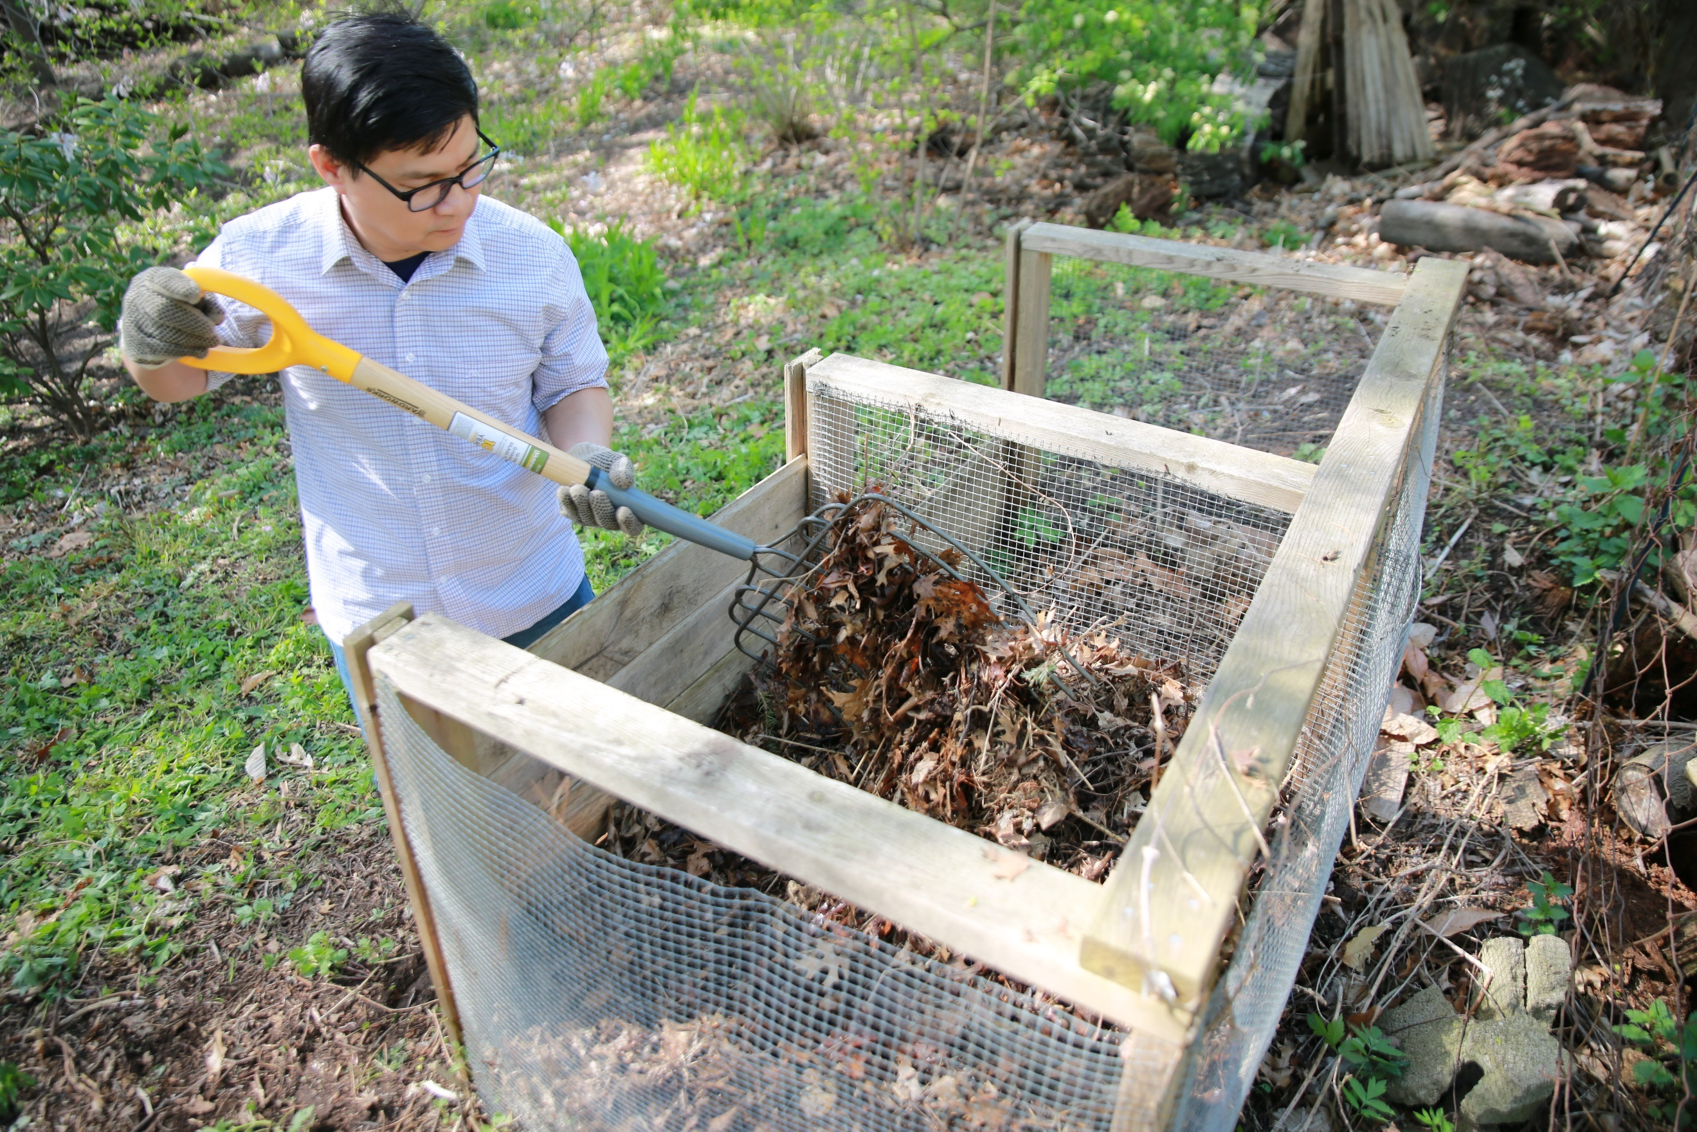Image alt text: Man turning compost in compost bin with pitchfork.

Post 4: Give back to nature with backyard composting
Facebook: Give back to nature by composting in your backyard! About 25 percent of what we throw away is organic materials like food, napkins, and paper towels that could be put to better use as compost. Learn more at hennepincounty.gov/composting
X: Give back to nature by composting in your backyard! About 25 percent of what we throw away is organic materials like food, napkins, and paper towels that could be put to better use as compost. Learn more at hennepincounty.gov/composting. #Compost #BackyardComposting
Instagram: Give back to nature by composting in your backyard! About 25 percent of what we throw away is organic materials like food, napkins, and paper towels that could be put to better use as compost. #Compost #BackyardComposting
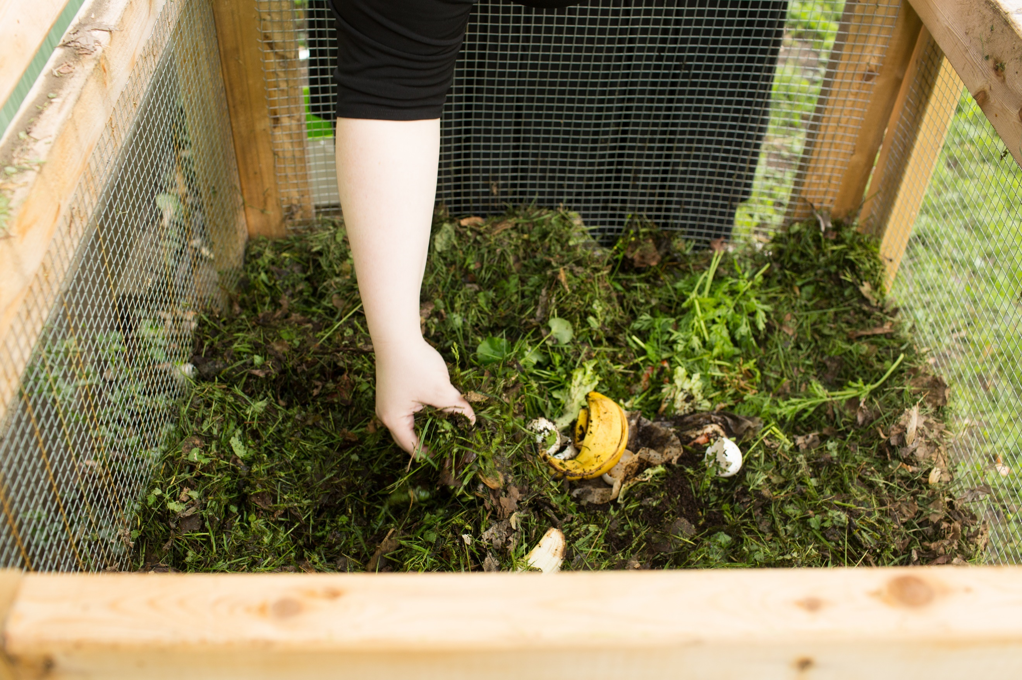Image alt text: Woman reaching into outdoor compost bin.

Post 5: How backyard composting works
Facebook: Food scraps are a resource, not a waste! Here’s how backyard composting works:
- Get a compost bin. Many lawn and garden stores sell compost bins.
- Separate and collect your food scraps, coffee grounds, paper towels, and other organic materials in your home and layer them with brown materials, such as dry leaves, in your compost bin.
- Maintain your compost pile by turning it with a shovel or pitchfork weekly or monthly. In six months to a year, the materials are turned into nutrient-rich compost.
- Compost can be used in gardens and flower beds to add nutrients to the soil to help plants grow.
Learn more at hennepincounty.gov/composting.
X: Food scraps are a resource. Don’t let them be a waste! Start composting in your backyard by collecting food scraps and other organic materials, layering them with dry leaves, and mixing once a month. Nutrient-rich compost can be used to help gardens grow! hennepincounty.gov/composting #Compost #BackyardComposting
Instagram: Food scraps are a resource, not a waste! Start composting in your backyard by collecting food scraps and other organic materials, layering them with brown materials such as dry leaves in your compost bin, and mixing once a month. Nutrient-rich compost can be used to help gardens grow! #Compost #BackyardComposting
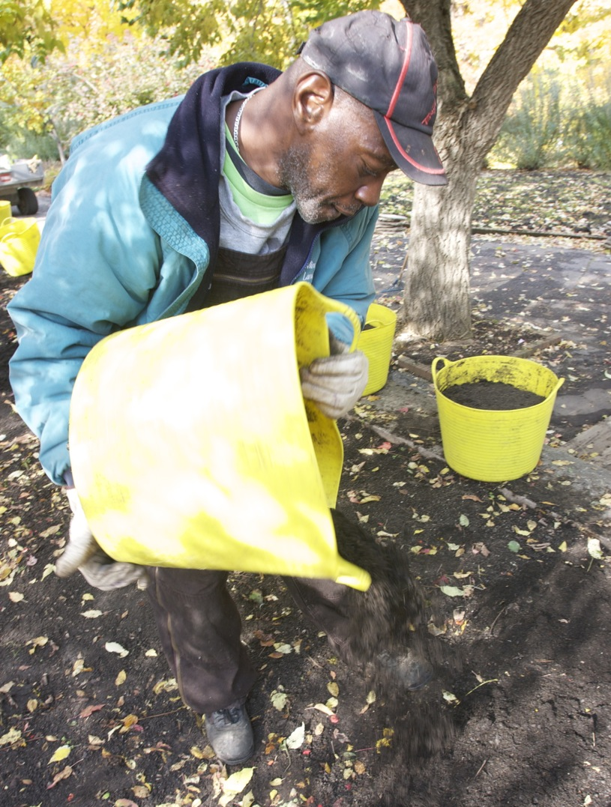
Image alt text: a man spreading compost

Post 6: Important items to keep out of your compost pile
Facebook: It is important to keep some materials out of your compost pile. The items below will not break down well in a backyard compost pile:
- Meat, fish, or dairy products
- Greasy foods
- Weeds with seeds
- Pet waste
- Cloth
- Compostable utensils or cups that look like plastic
Learn more about the dos and don’ts of backyard composting at hennepincounty.gov/composting
X: It is important to keep some materials out of your compost pile because they will not break down well and may cause your pile to smell. Avoid meat, fish, and dairy products in your backyard pile. Learn more hennepincounty.gov/composting. #Compost #BackyardComposting
Instagram: It is important to keep some materials out of your compost pile because they will not break down well and may cause your pile to smell. Some items to keep out of your compost pile include meat, fish, dairy products, and pet waste. #Compost #BackyardComposting
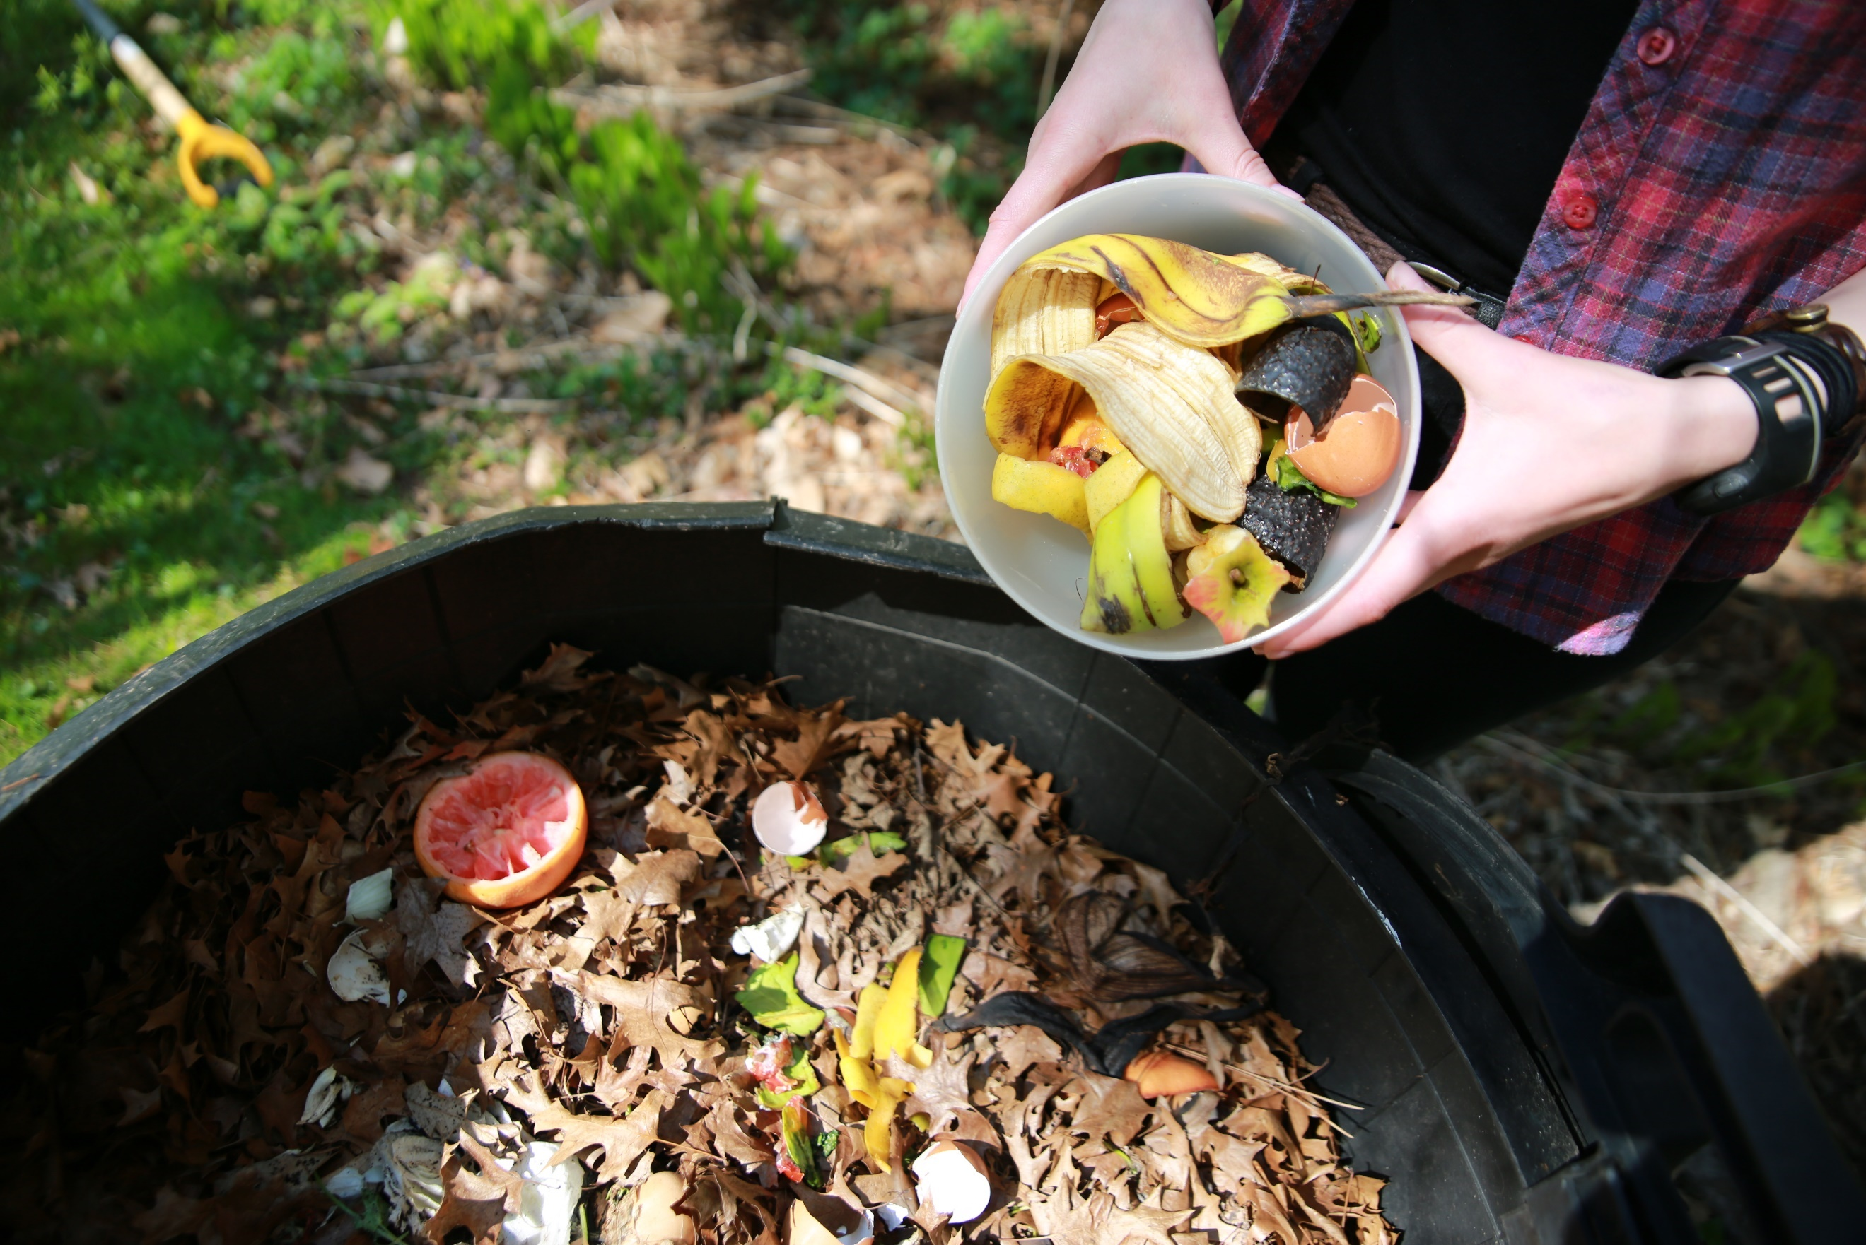Image alt text: Person dumping bowl of food scraps into outdoor compost bin.

Additional photos
To use images and graphics: right click on image and select save as picture. Alt text for you to use is included with the pictures and graphics.
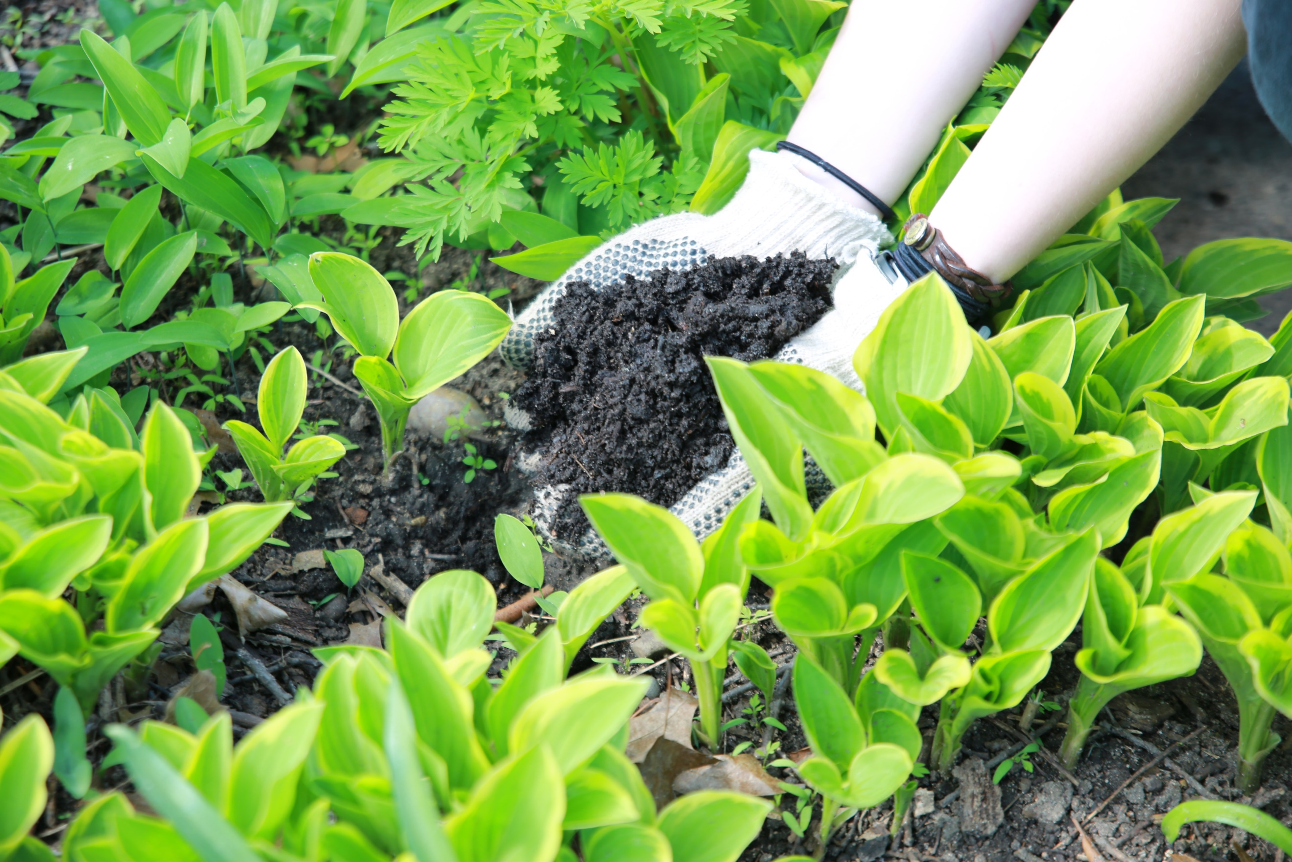
Image alt text: Gloved hands scooping compost into garden.
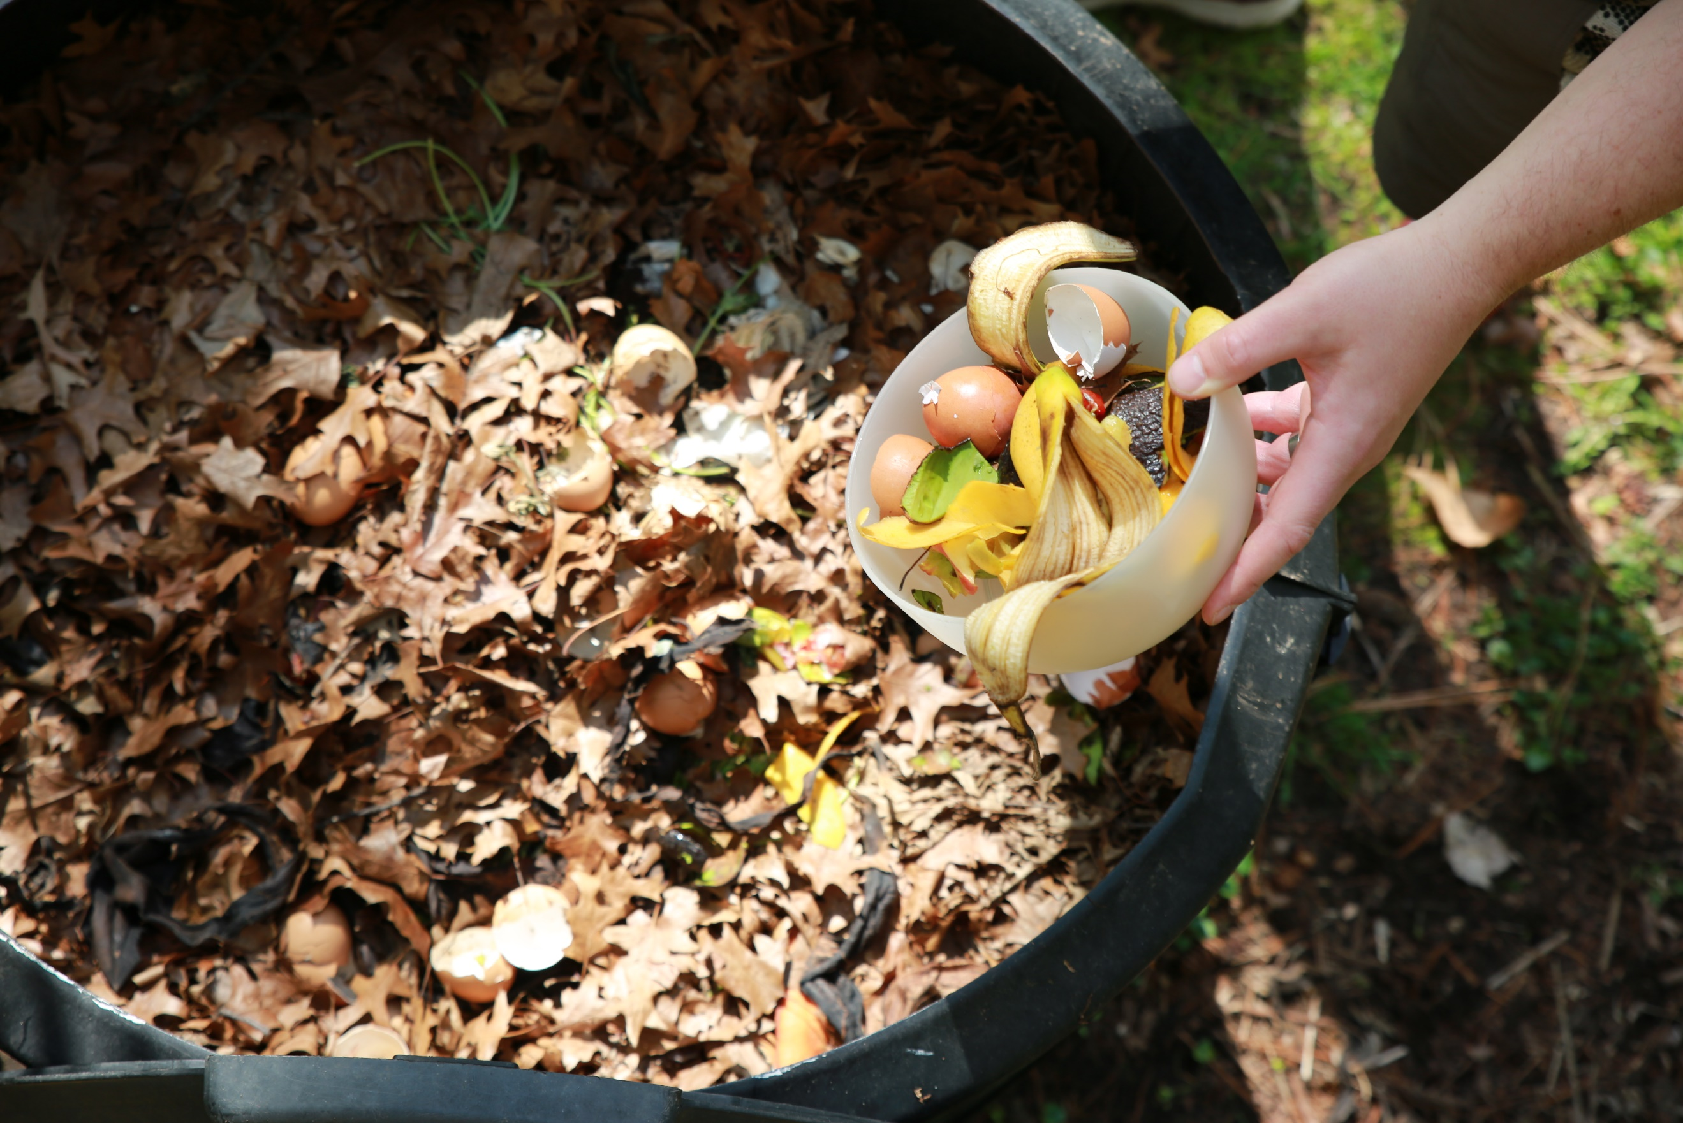
Image alt text: Person dumping bowl of food scraps into outdoor compost bin.
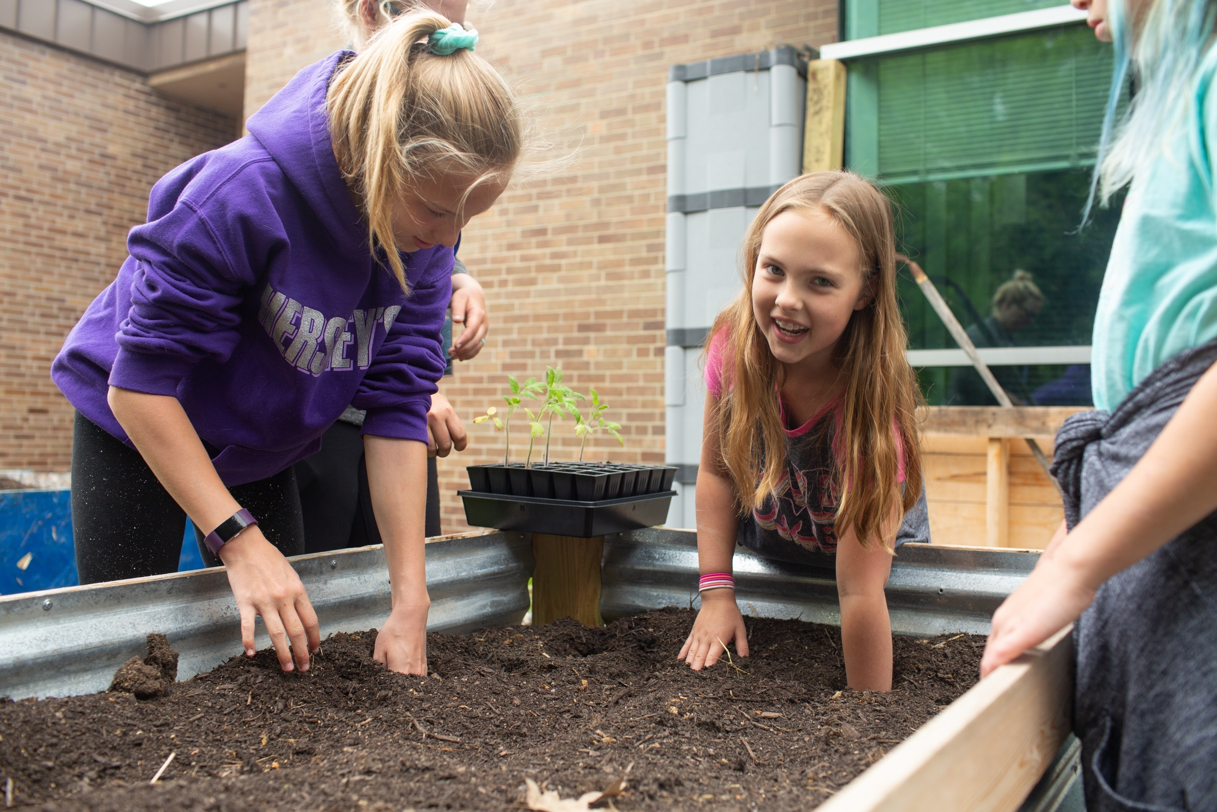
Image alt text: Two young girls creating holes in a raised garden bed to plant seedlings.
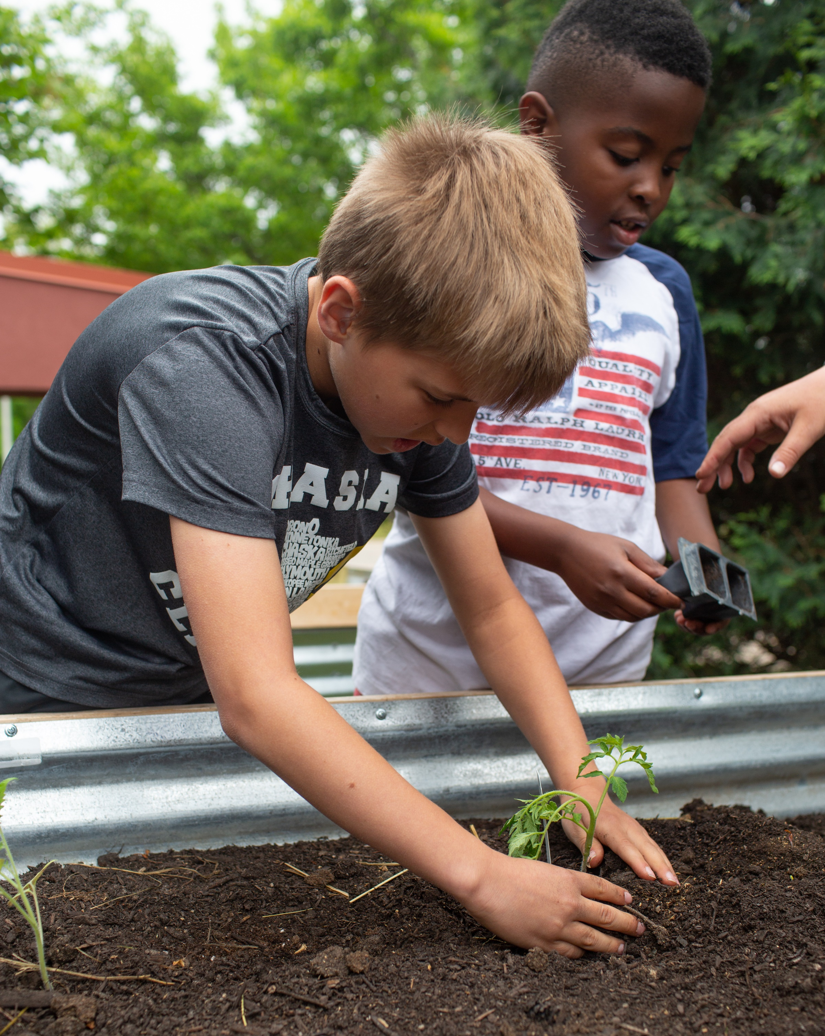
Image alt text: Two young boys planting seedlings in a raised garden bed.

