

Reducing food waste media kit

About reducing food waste
About 40% of food is wasted somewhere along the supply chain, and consumers are the biggest source of food waste. Food waste costs a lot. The average family of four spends $1,800 on food they’ll never eat and just end up throwing away. Wasted food wastes a ton of resources, including all of the water and energy that goes into growing and transporting it. Taking steps to reduce food waste is one of the most effective things you can do to reduce the amount of waste generated and address climate change.

Resources to promote food waste reduction
Ways to educate the public about reducing food waste:
- Use the sample newsletter article to share on your organization’s website or in your newsletters. These are editable so you can customize the length or message.
- Use the sample social media posts to share through your social media channels. These are editable so you can customize the message and website.
- Share the refrigerator insider and tips to fight food waste factsheet. Printed copies can be ordered from https://environmentalresources.hennepin.us/items
- Encourage participants to participate in the Stop Food Waste Challenge (usually offered in the fall). People can sign up to be notified of future challenges at hennepin.us/zerowastechallenge
- Follow and reshare messages posted on the Hennepin County Environment and Energy social media channels: Hennepin Environment on Facebook, Hennepin Environment on Instagram, and @hennepinenviro on Twitter
- Share the Climate Action article https://www.hennepin.us/climate-action/what-we-can-do/create-meals-not-waste

Contact
For more information about this topic, contact
Kaitlin Steinberg, residential recycling coordinator, kaitlin.steinberg@hennepin.us
Alisa Reckinger, communications and outreach specialist, alisa.reckinger@hennein.us

Sample newsletter article – short

Create meals, not waste: Tips for reducing food waste
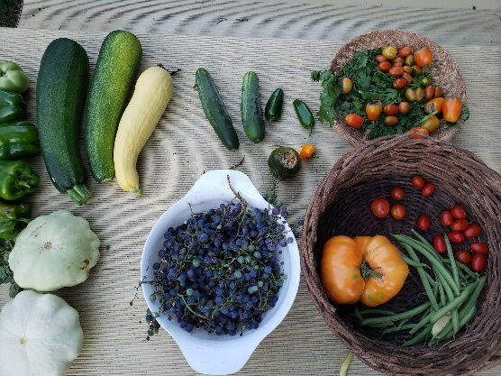
We love food, which leaves us wondering: why do we waste so much of it? About 40% of food is wasted somewhere along the supply chain.
Food waste costs a lot. The average family of four spends $1,800 on food they’ll never eat and just end up throwing away. Taking steps to reduce food waste is one of the most effective things you can do to reduce the amount of waste generated and address climate change.
Surprisingly, consumers are the biggest contributor to the food waste problem. But that’s also good news. We have the power to significantly reduce the amount of food that goes to waste and save ourselves money by making changes right at home in our kitchens and when we go shopping.

Ways to save food
Food is wasted for a lot of different reasons. Whether it’s produce that goes bad before we prepare it, crackers that get lost in the back of the cupboard, or leftovers we just don’t eat up, that wasted food has a big impact. Fortunately, there’s a lot we can do about it!
- Plan ahead: Practice meal planning by deciding what meals you will have for the week and base your grocery list off of that. Keep an inventory of the food you have in your fridge, freezer, and pantry, and check what foods you already have at home before heading to the grocery store.
- Eat the food you buy: Prepare food in advance, such as pre-chopping or slicing vegetables, to be used for cooking later. Create an “eat first” bin in your fridge for food that needs to be used up before it spoils.
- Store fresh produce to make it last: Learning how to properly store fresh produce is important to make sure that food gets enjoyed instead of going to waste. Find tips in Eureka Recycling’s A to Z food storage guide or on Save the Food.
- Use your refrigerator and freezer to save food: To extend the life of food, reorganize your fridge to take advantage of different temperature and humidity levels, and keep your fridge at 40 degrees Fahrenheit or below. See the refrigerator insider (PDF) to learn how to use your refrigerator and freezer to save food.
- Understand food labeling: Ensure that you’re not throwing out food early by understanding food date labels. "Use by" indicates that the product should be consumed by the date listed on the package, while “best if used by" describes product quality. Using your senses can be the best measure of whether or not food is safe to consume.

Sample newsletter article – long

Create meals, not waste: Tips for reducing food waste
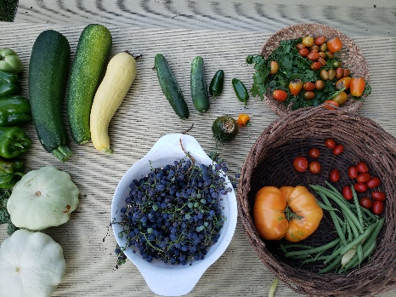
We love food, which leaves us wondering: why do we waste so much of it? About 40% of food is wasted somewhere along the supply chain. That’s like leaving the grocery store with five bags of food and dropping two of them in the parking lot. It’s hard to believe, but we do it every day.

The opportunity to reduce food waste
Food waste costs a lot. The average family of four spends $1,800 on food they’ll never eat and just end up throwing away. Taking steps to reduce food waste is one of the most effective things you can do to reduce the amount of waste generated and address climate change.
Surprisingly, consumers are the biggest contributor to the food waste problem. But that’s also good news. We have the power to significantly reduce the amount of food that goes to waste and save ourselves money by making changes right at home in our kitchens and when we go shopping.

Ways to save food
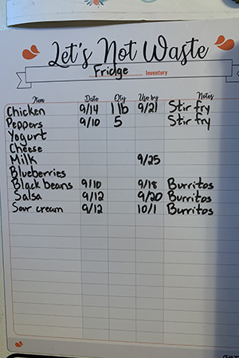
Food is wasted for a lot of different reasons. Whether it’s produce that goes bad before we prepare it, crackers that get lost in the back of the cupboard, or leftovers we just don’t eat up, that wasted food has a big impact. Fortunately, there’s a lot we can do about it!
Plan ahead
Using up the food you have seems simple but can go a long way in reducing food waste. This requires some planning and organization, but that effort should make mealtime easier in the long run.
Practice meal planning by deciding what meals you will have for the week and base your grocery list off of that. Be sure to account for activities you have during the week and plan meals around those.
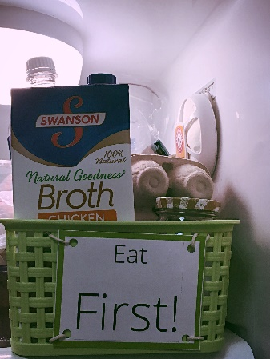
Keep an inventory of the food you have in your fridge, freezer, and pantry. Check what foods you already have at home before heading to the grocery store. You can also use a recipe generator to help you use up the food that you already have - just search online to find one that works for you!
Eat the food you buy
Prepare food in advance, such as pre-chopping or slicing vegetables, to be used for cooking later. Store food in clear containers so you can easily see what’s in them. Create an “eat first” bin in your fridge for food that needs to be used up before it spoils.
Store fresh produce to make it last
Learning how to properly store fresh produce is important to make sure that food gets enjoyed instead of going to waste. But remembering what to do with different items can be tricky. Find tips in Eureka Recycling’s A to Z food storage guide or on Save the Food.
Use your refrigerator and freezer to save food
To extend the life of food, reorganize your fridge to take advantage of different temperature and humidity levels, and keep your fridge at 40 degrees Fahrenheit or below.
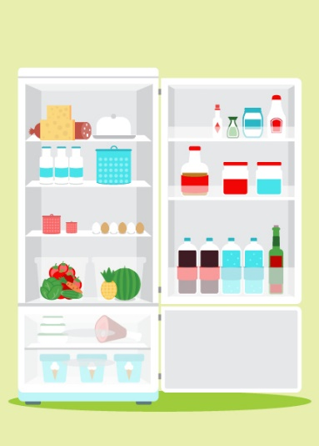
- Top shelf: The top shelf maintains a more consistent temperature than rest of the fridge, so store your butter, cheese, and cooked meats here.
- Door: The door is the warmest place in the fridge, so keep condiments and hard to spoil items here.
- Bottom shelf: This is the coldest area of the fridge, so store eggs, milk, raw meat, and perishable items here.
- Crisper drawer: This area controls humidity better than any other area of the fridge. Use low humidity for fruits and veggies and high humidity for lettuce.
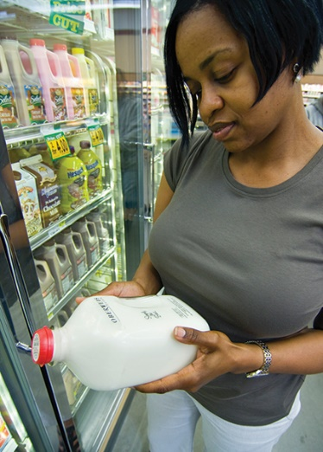
- Freezer: Your freezer is the ultimate pause button – it can be the simplest and quickest way to save food that is close to going to waste. The freezer allows you to rescue leftovers, save your extra fruits and vegetables, make bread or meat last longer, or take a more active approach by meal prepping or buying food specifically to preserve.
Understand food labeling
Ensure that you’re not throwing out food early by understanding food date labels. The two date labels that show up on products are "Use by" and "Best if used by", which mean the following:
- "Use by" indicates that the product should be consumed by the date listed on the package.
- "Best if used by" describes product quality. After that date, the product may not be at peak flavor but is generally safe to consume.
Remember to use your senses as they're the best measure of whether or not food is safe to consume. It’s also a good idea to write the date that an item is opened on the packaging so you’re not left wondering later.

Social media posts
Suggested hashtags: #foodwaste #stopfoodwaste #hennepinzerowaste #zerowaste
To use images and graphics: right click on image and select save picture as

Post 1: Amount of food wasted
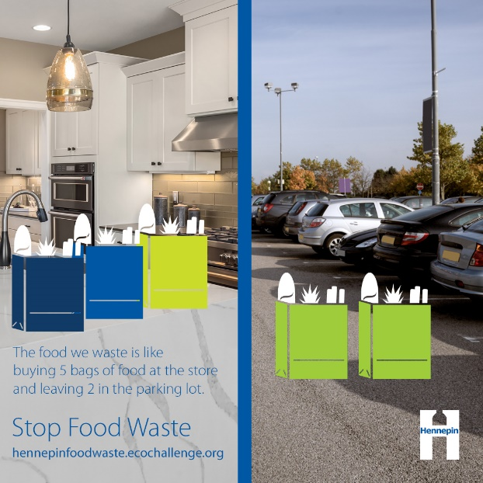
Facebook: We love food, which leaves us wondering: why do we waste so much of it? About 40% of food is wasted somewhere along the supply chain. That’s like leaving the grocery store with five bags of food and dropping two of them in the parking lot. It’s hard to believe, but we do it every day. Learn ways to reduce food waste at https://www.hennepin.us/climate-action/what-we-can-do/create-meals-not-waste
Twitter: We love food, which leaves us wondering: why do we waste so much of it? About 40% of food goes to waste, which is like leaving the grocery store with 5 bags of food and dropping 2 of them in the parking lot. Learn ways to reduce food waste at https://www.hennepin.us/climate-action/what-we-can-do/create-meals-not-waste #stopfoodwaste
Instagram: We love food, which leaves us wondering: why do we waste so much of it? About 40% of food is wasted somewhere along the supply chain. That’s like leaving the grocery store with five bags of food and dropping two of them in the parking lot. It’s hard to believe, but we do it every day. Learn ways to reduce food waste at https://www.hennepin.us/climate-action/what-we-can-do/create-meals-not-waste
#foodwaste #stopfoodwaste #hennepinzerowaste #zerowaste

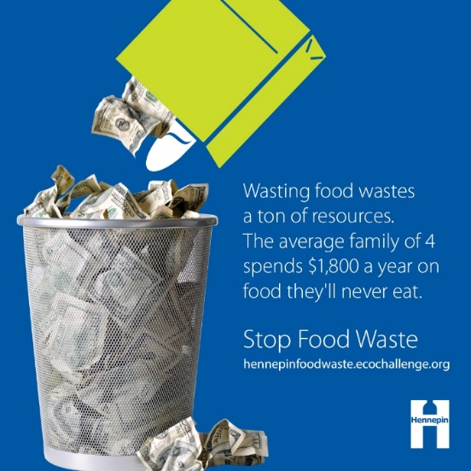
Post 2: Food waste costs a lot
Facebook: Food waste costs a lot. The average family of four spends $1,800 on food they’ll never eat and just end up throwing away. Wasted food wastes a ton of resources, including all of the water and energy that goes into growing and transporting it. Fortunately, there’s a lot we can do to reduce the impacts of food waste. Learn ways to reduce food waste at https://www.hennepin.us/climate-action/what-we-can-do/create-meals-not-waste
Twitter: Food waste costs a lot. The average family of four spends $1,800 on food they’ll never eat and end up throwing away. Wasted food also wastes the water and energy that goes into growing and transporting it. Learn ways to reduce food waste https://www.hennepin.us/climate-action/what-we-can-do/create-meals-not-waste #stopfoodwaste
Instagram: Food waste costs a lot. The average family of four spends $1,800 on food they’ll never eat and just end up throwing away. Wasted food wastes a ton of resources, including all of the water and energy that goes into growing and transporting it. Fortunately, there’s a lot we can do to reduce the impacts of food waste. Learn ways to reduce food waste at https://www.hennepin.us/climate-action/what-we-can-do/create-meals-not-waste
#foodwaste #stopfoodwaste #hennepinzerowaste #zerowaste

Post 3: Food waste as a climate solution
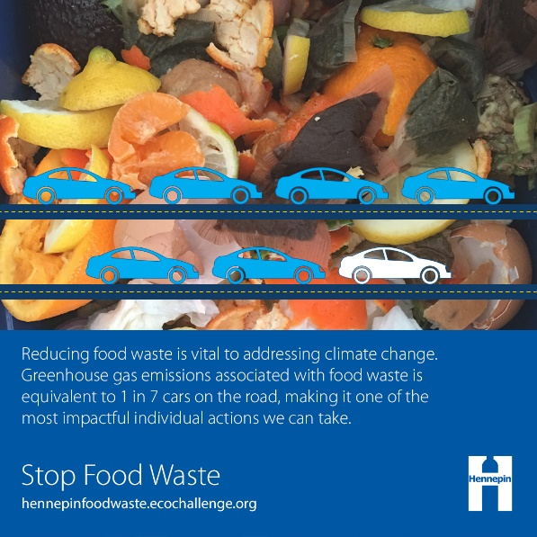
Facebook: Reducing food waste is a surprisingly powerful climate solution. About 40% of food is wasted somewhere along the supply chain. The amount of greenhouse gas emissions associated with wasted food is equivalent to 1 in 7 cars on the road. Reducing food waste is a top strategy for addressing climate change according to Project Drawdown. Learn ways to reduce food waste at https://www.hennepin.us/climate-action/what-we-can-do/create-meals-not-waste
Twitter: Reducing food waste is a surprisingly powerful climate solution. Greenhouse gas emissions associated with wasted food is equivalent to 1 in 7 cars on the road, making it a top climate solution according to @ProjectDrawdown. Learn ways to reduce food waste https://www.hennepin.us/climate-action/what-we-can-do/create-meals-not-waste
Instagram: Reducing food waste is a surprisingly powerful climate solution. About 40% of food is wasted somewhere along the supply chain. The amount of greenhouse gas emissions associated with wasted food is equivalent to 1 in 7 cars on the road. Reducing food waste is a top strategy for addressing climate change according to @ProjectDrawdown.
#stopfoodwaste #hennepinzerowaste #zerowaste #climateaction #hennepinclimateaction #climatechange

Post 4: Opportunity to reduce food waste
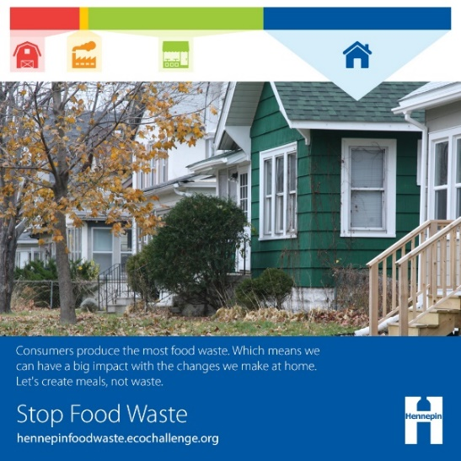
Facebook: You may not think you waste a lot of food at home, but the little bits here and there add up. In fact, compared to food wasted during production, processing, and at retail, consumers are the biggest contributor to the food waste problem. But that’s also good news. We have the power to significantly reduce the amount of food that goes to waste and save ourselves money by making changes right at home in our kitchens and when we go shopping. Learn ways to reduce food waste at https://www.hennepin.us/climate-action/what-we-can-do/create-meals-not-waste
Twitter: Surprisingly, consumers are the biggest source of food waste, which means we have the power to significantly reduce food waste and save money by making changes in our kitchens and when we go shopping. Learn ways to reduce food waste at https://www.hennepin.us/climate-action/what-we-can-do/create-meals-not-waste #stopfoodwaste
Instagram: You may not think you waste a lot of food at home, but the little bits here and there add up. In fact, compared to food wasted during production, processing, and at retail, consumers are the biggest contributor to the food waste problem. But that’s also good news. We have the power to significantly reduce the amount of food that goes to waste and save ourselves money by making changes right at home in our kitchens and when we go shopping.
#foodwaste #stopfoodwaste #hennepinzerowaste #zerowaste

Post 5: Stop food waste strategy – plan ahead
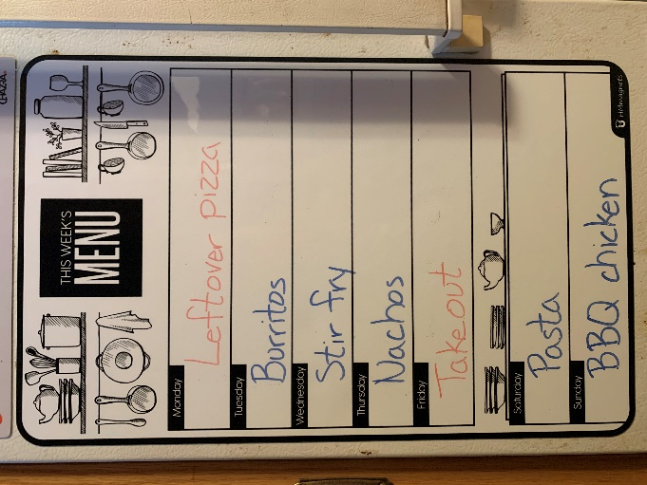
Facebook: Using up the food you have seems simple but can go a long way in reducing food waste. Practice meal planning by deciding what meals you will have for the week and base your grocery list off of that. Keep an inventory of the food you have in your fridge, freezer, and pantry, and check what foods you already have at home before heading to the grocery store. Learn more ways to reduce food waste at https://www.hennepin.us/climate-action/what-we-can-do/create-meals-not-waste
Twitter: Using up the food you have seems simple but can go a long way in reducing food waste. Practice meal planning by deciding what meals you will have for the week. Check what foods you have at home before heading to the store. Learn more at https://www.hennepin.us/climate-action/what-we-can-do/create-meals-not-waste #stopfoodwaste
Instagram: Using up the food you have seems simple but can go a long way in reducing food waste. Practice meal planning by deciding what meals you will have for the week and base your grocery list off of that. Keep an inventory of the food you have in your fridge, freezer, and pantry, and check what foods you already have at home before heading to the grocery store.
#foodwaste #stopfoodwaste #hennepinzerowaste #zerowaste

Post 6: Stop food waste strategy – eat the food you buy
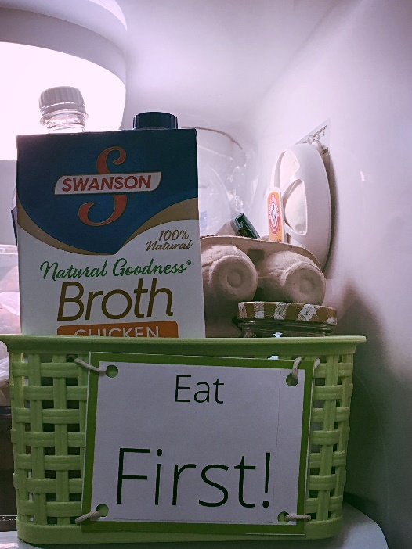
Facebook: Having a plan to use up all the food you buy and making sure you don’t lose track of it can go a long way toward reducing food waste. Try preparing food in advance, such as pre-chopping or slicing vegetables, to be used for cooking later. Store food in clear containers so you can easily see what’s in them. Create an “eat first” bin in your fridge for food that needs to be used up before it spoils. Learn more ways to reduce food waste at https://www.hennepin.us/climate-action/what-we-can-do/create-meals-not-waste
Twitter: Having a plan to use up all the food you buy. Prepare food in advance by pre-chopping or slicing vegetables to be used for cooking later. Store food in clear containers, and create an “eat first” area of your fridge. Learn more ways to reduce food waste at https://www.hennepin.us/climate-action/what-we-can-do/create-meals-not-waste
Instagram: Having a plan to use up all the food you buy and making sure you don’t lose track of it can go a long way toward reducing food waste. Try preparing food in advance, such as pre-chopping or slicing vegetables, to be used for cooking later. Store food in clear containers so you can easily see what’s in them. Create an “eat first” bin in your fridge for food that needs to be used up before it spoils.
#foodwaste #stopfoodwaste #hennepinzerowaste #zerowaste

Post 7: Stop food waste strategy – store fresh product to make it last
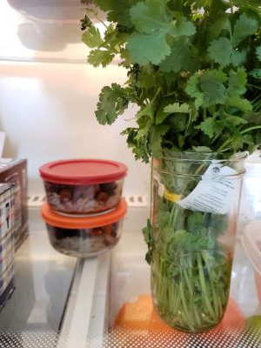
Facebook: Learning how to properly store fresh produce is important to make sure that food gets enjoyed instead of going to waste. Find tips in Eureka Recycling’s A to Z food storage guide (https://eurekarecycling.org/resource/a-z-food-storage-guide/) or on Save the Food (https://savethefood.com/storage)
Twitter: Learning how to properly store fresh produce is important to make sure that food gets enjoyed instead of going to waste. Find tips in the @EurekaMN A to Z food storage guide (https://eurekarecycling.org/resource/a-z-food-storage-guide/) or on @SaveTheFood (https://savethefood.com/storage) #stopfoodwaste
Instagram: Learning how to properly store fresh produce is important to make sure that food gets enjoyed instead of going to waste. Find tips in the @eurekarecyclingmn A to Z food storage guide (https://eurekarecycling.org/resource/a-z-food-storage-guide/) or on @savethefood (https://savethefood.com/storage) #foodwaste #stopfoodwaste #hennepinzerowaste #zerowaste

Post 8: Stop food waste strategy – use your refrigerator and freezer to save food
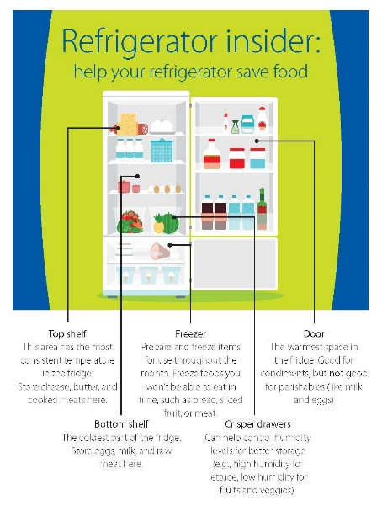
Facebook: To extend the life of food, reorganize your fridge to take advantage of different temperature and humidity levels, and keep your fridge at 40 degrees Fahrenheit or below. Learn how to use your refrigerator and freezer to save food using our refrigerator insider https://www.hennepin.us/-/media/hennepinus/business/work-with-hennepin-county/environmental-literature/save-the-food-flyer.pdf
Twitter: To extend the life of food, reorganize your fridge to take advantage of different temperature and humidity levels. Learn how to use your refrigerator and freezer to save food using our refrigerator insider https://www.hennepin.us/-/media/hennepinus/business/work-with-hennepin-county/environmental-literature/save-the-food-flyer.pdf #stopfoodwaste
Instagram: To extend the life of food, reorganize your fridge to take advantage of different temperature and humidity levels, and keep your fridge at 40 degrees Fahrenheit or below.
The top shelf is best for butter, cheese, and cooked meats. The door is best for condiments. Store perishable items like eggs, milk, and raw meat on the bottom shelf. Use the crisper drawers for fruits and vegetables. And use your freezer as the ultimate pause button.
#foodwaste #stopfoodwaste #hennepinzerowaste #zerowaste

Post 9: Stop food waste strategy – understand food labeling
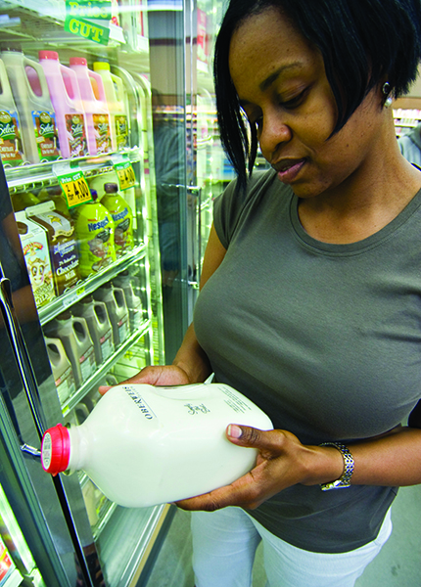
Facebook: Ensure you’re not throwing out food early by understanding food date labels. "Use by" indicates you should eat the product by that date, while “best if used by" describes product quality. Often, you can use your senses to determine if food is still good to eat. Learn more ways to reduce food waste at https://www.hennepin.us/climate-action/what-we-can-do/create-meals-not-waste
Twitter: Don't throw food out early by understanding food labels. "Use by" indicates you should eat the product by that date, while “best if used by" describes product quality. Often, you can use your senses to determine if food is still good to eat. https://www.hennepin.us/climate-action/what-we-can-do/create-meals-not-waste #stopfoodwaste
Instagram: Ensure you’re not throwing out food early by understanding food date labels. "Use by" indicates you should eat the product by that date, while “best if used by" describes product quality. Often, you can use your senses to determine if food is still good to eat.
#foodwaste #stopfoodwaste #hennepinzerowaste #zerowaste

