

Swap It: Outdoor gear content kit

About Hennepin County’s Swap-It events
Swap-It events are a fun sustainable way to reduce waste, share resources, build community and support local reuse efforts. The events are held in cities across Hennepin County and focus on a variety of materials, such as toys, household goods, building materials, and more. Reuse Minnesota runs the events on behalf of Hennepin County.

Swap It: Outdoor gear
The theme for this Swap-It event is outdoor gear. From camp stoves to coolers, sleeping bags to tents, there’s something for every camper and explorer. Let’s get outside!

Saturday, May 2, noon to 2:30 p.m.
Early drop-off only beings at 11 a.m. (no swapping); final items accepted at 2 p.m.

Rockford Road Library

6401 N 42nd Avenue

Crystal, MN 55427

Resources to promote Swap It: Kitchen gadgets
We need your help to make it a success. Here are ways to educate the public about the Swap It: Outdoor gear event on May 2, 2026.
- Use the sample newsletter article and social media post to share on your organization’s website, newsletters, and social media channels. They are editable so you can customize the length or message.
- Follow and reshare messages posted on the Hennepin County Environment and Energy social media channels: Hennepin Environment on Facebook, Hennepin Environment on Instagram, and @hennepinenviro on X/Twitter.
- Share the information and resources available at HennepinCounty.gov/swap-it.

Contact
For more information about Hennepin County’s Swap-It events, contact: Kirsten Wahlberg, Kirsten.wahlberg@hennepin.us or 612-543-0430.

Newsletter article
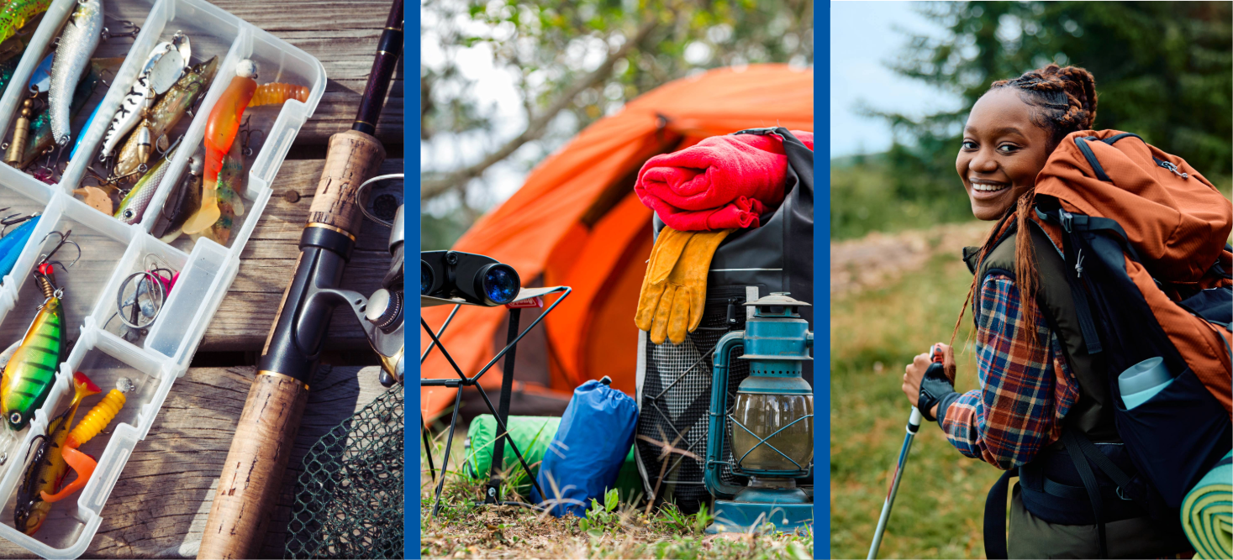
Note: To use images: Right click on image and select save as picture.
Swap It: Outdoor gear

Saturday, May 2, noon to 2:30 p.m.
Early drop-off only beings at 11 a.m. (no swapping); final items accepted at 2 p.m.

Rockford Road Library

6401 N 42nd Avenue

Crystal, MN 55427

Bring gently used gear you no longer need. Take outdoor equipment you can use. Swap it—for free! The theme for this Swap-It event is outdoor gear. From camp stoves to coolers, sleeping bags to tents, there’s something for every camper and explorer. Let’s get outside!
What to expect
- No registration required. Anyone can participate, and kids are welcome.
- You do not need to bring items to take items.
- Everything is free.
- Check in at the event table, where volunteers will check, weigh, and sort your items.
- Staff and volunteers are unable to help with unloading or loading items in attendee vehicles.
- Remaining items will be donated to the Southwest Metro Lending Library.
For a complete list of items accepted and those that won’t be accepted can be found here: HennepinCounty.gov/swap-it.
Questions? Contact Kirsten Wahlberg, kirsten.wahlberg@hennepin.us or 612-543-0430.

Social media post
Note: To use image: right click on image and select save as picture.

Text
Bring gently used gear you no longer need. Take outdoor equipment you can use. Swap it—for free! The theme for this Swap-It event is outdoor gear. From camp stoves to coolers, sleeping bags to tents, there’s something for every camper and explorer. Let’s get outside! Swap It: Outdoor Gear.

