

Eco-friendly holiday disposal media kit

About eco-friendly holiday disposal:

The holidays generate a lot of waste and knowing what is recyclable, compostable, or trash can be challenging! This guide provides resources to help educate people about disposing of holiday items after the season is over.

Resources to promote eco-friendly holiday disposal:
Ways to educate the public about being eco-friendly during the holidays:
- Use the sample newsletter article to share on your organization’s website or in your newsletters. These are editable so you can customize the length or message.
- Use the sample social media posts to share through your social media channels. These are editable so you can customize the message and website.
- Share these resources:
  - Green Disposal Guide (hennepin.us/green-disposal-guide)
  - Hennepin County drop-off facilities (hennepin.us/dropoffs)
  - Yard and tree waste disposal (hennepin.us/yardwaste)
- Follow and reshare messages posted on the Hennepin County Environment and Energy social media channels: Hennepin Environment on Facebook, Hennepin Environment on Instagram, and @hennepinenviro on X

Contact
For more information about eco-friendly holiday disposal, contact:
Environmental Education and Outreach Team, environment@hennepin.us

Sample newsletter article

Holiday disposal guide
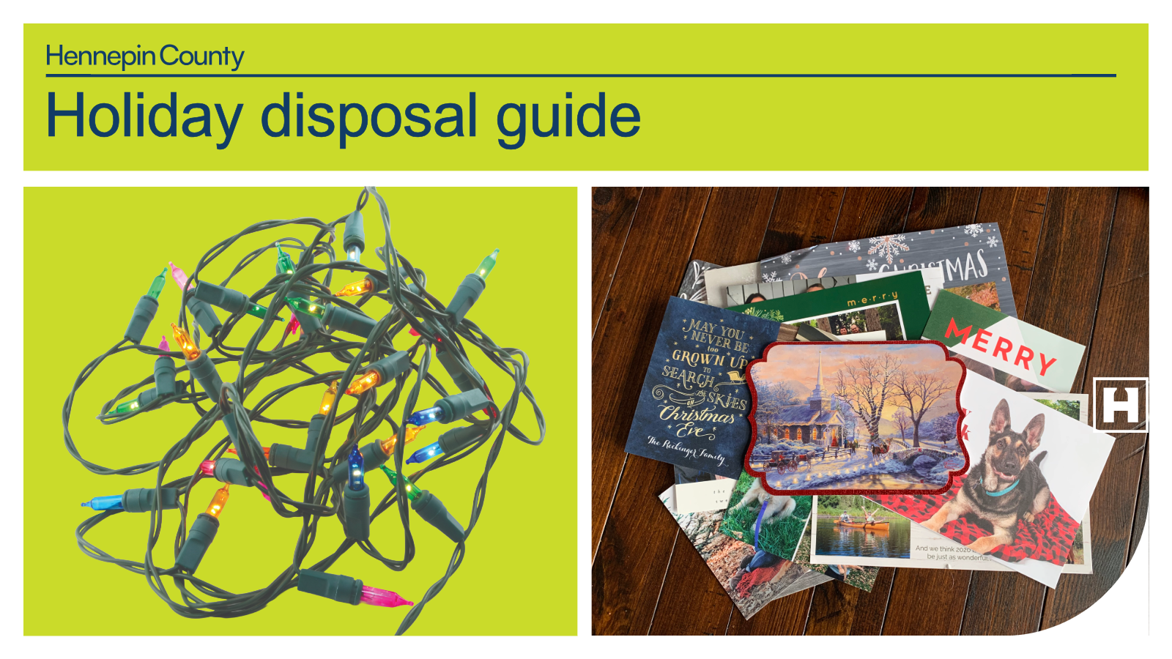
Between packaging from deliveries, decorations, gift wrap, and more, the holiday season is a time when we often have a lot of stuff to get rid of. To make sure you recycle and reuse as much as you can, review the holiday disposal guide tips below for the best way to get rid of common holiday items.

Recycle at home

Boxes
This includes cardboard boxes, boxes from deliveries, shoe boxes, and electronics boxes. Empty and flatten boxes before putting them in the recycling. If you have a lot of boxes, check with your hauler to see if they can be placed alongside your recycling cart. Cardboard is also accepted at Hennepin County drop-off facilities.

Paper
You can recycle packing paper, cards, and envelopes made of plain paper, and newspaper, Kraft paper, or other plain paper used as gift wrap. Flatten paper before recycling to ensure it gets properly sorted at the recycling facility.

Bring to a drop-off facility for recycling

Plastic bags, film, and bubble wrap
Deliveries can come with a lot of plastic packaging. You can bring shipping envelopes made entirely of plastic, plastic film, air pillows, and bubble wrap to a drop-off for recycling. Plastic bags and film must be clean and dry, and plastic air pillows should be deflated. Some retail and grocery stores have collection containers, and these items are accepted at Hennepin County drop-off facilities.

String lights, electronics, and batteries
It’s common this time of year to have things like string lights that no longer work, electronics that you are upgrading, or items with batteries that you need to get rid of. These items are accepted at Hennepin County drop-off facilities for recycling or proper disposal. Find options for disposing of common household items on the Green Disposal Guide.

Trash

Packing materials
StyrofoamTM is not recyclable. Reuse StyrofoamTM for future packaging and mailing needs or put it in the trash. Shipping envelopes made of multiple materials (such as paper and bubble wrap) go in the trash.

Gift wrap disposal
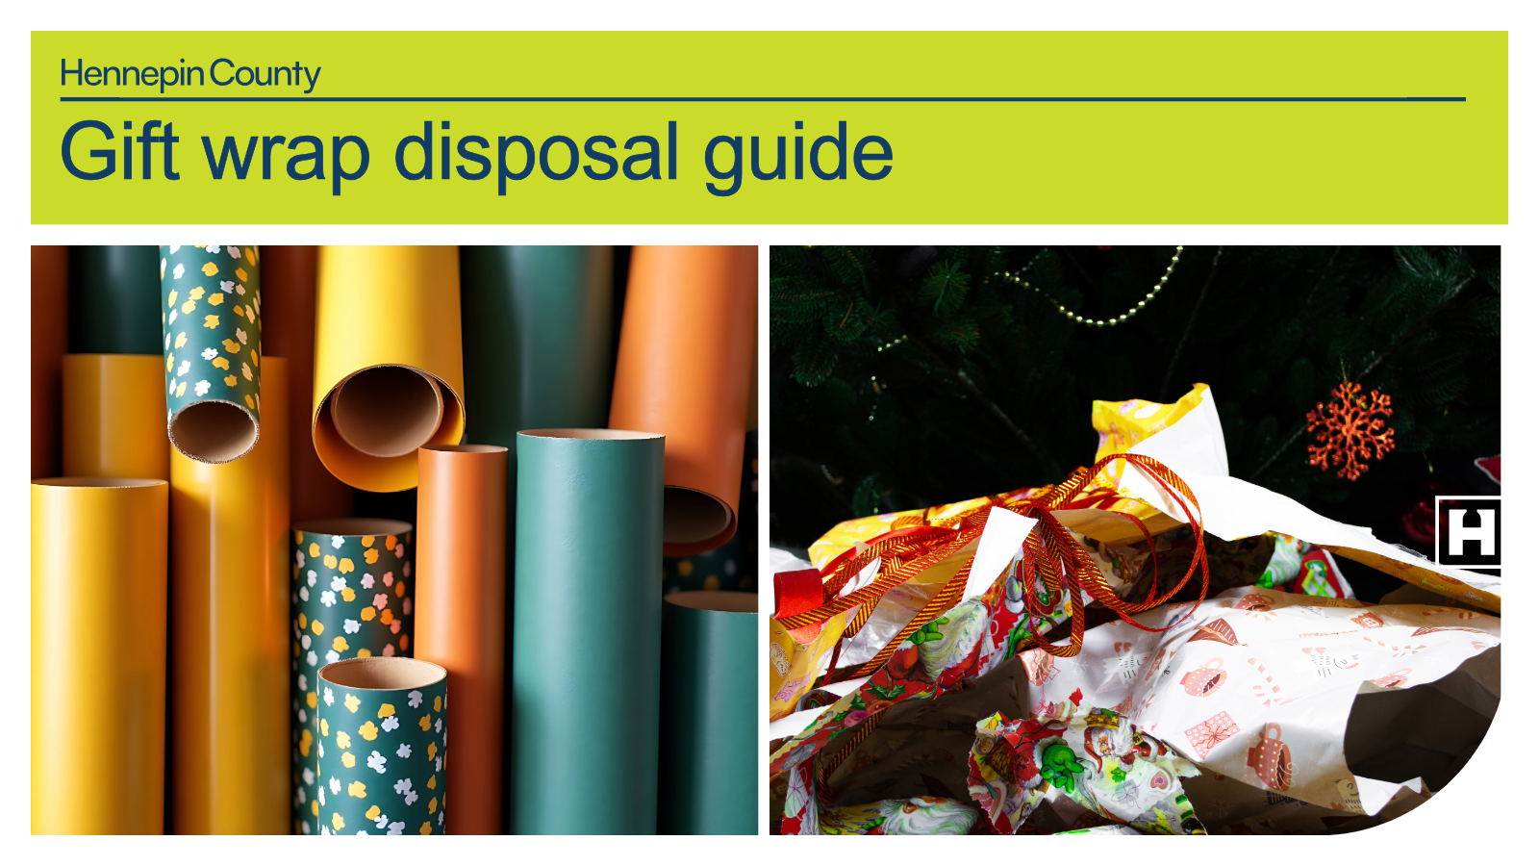

Reuse gift wrap and decorations
As you clean up during the holidays, items like gift bags, gift boxes, ribbons, and bows are great to save and reuse next year! Newspaper, Kraft paper, or other plain paper used as gift wrap can be reused or recycled at home. Flatten paper before recycling to ensure it gets properly sorted at the recycling facility.
Unfortunately, many items commonly used to decorate gifts become too damaged to reuse or cannot be recycled. These should go in the trash:
- Glossy, shiny, or glittery wrapping paper
- Tissue paper
- Cards that have glitter, foil, or plastic adornments
- Cards printed on photo paper

Holiday tree disposal
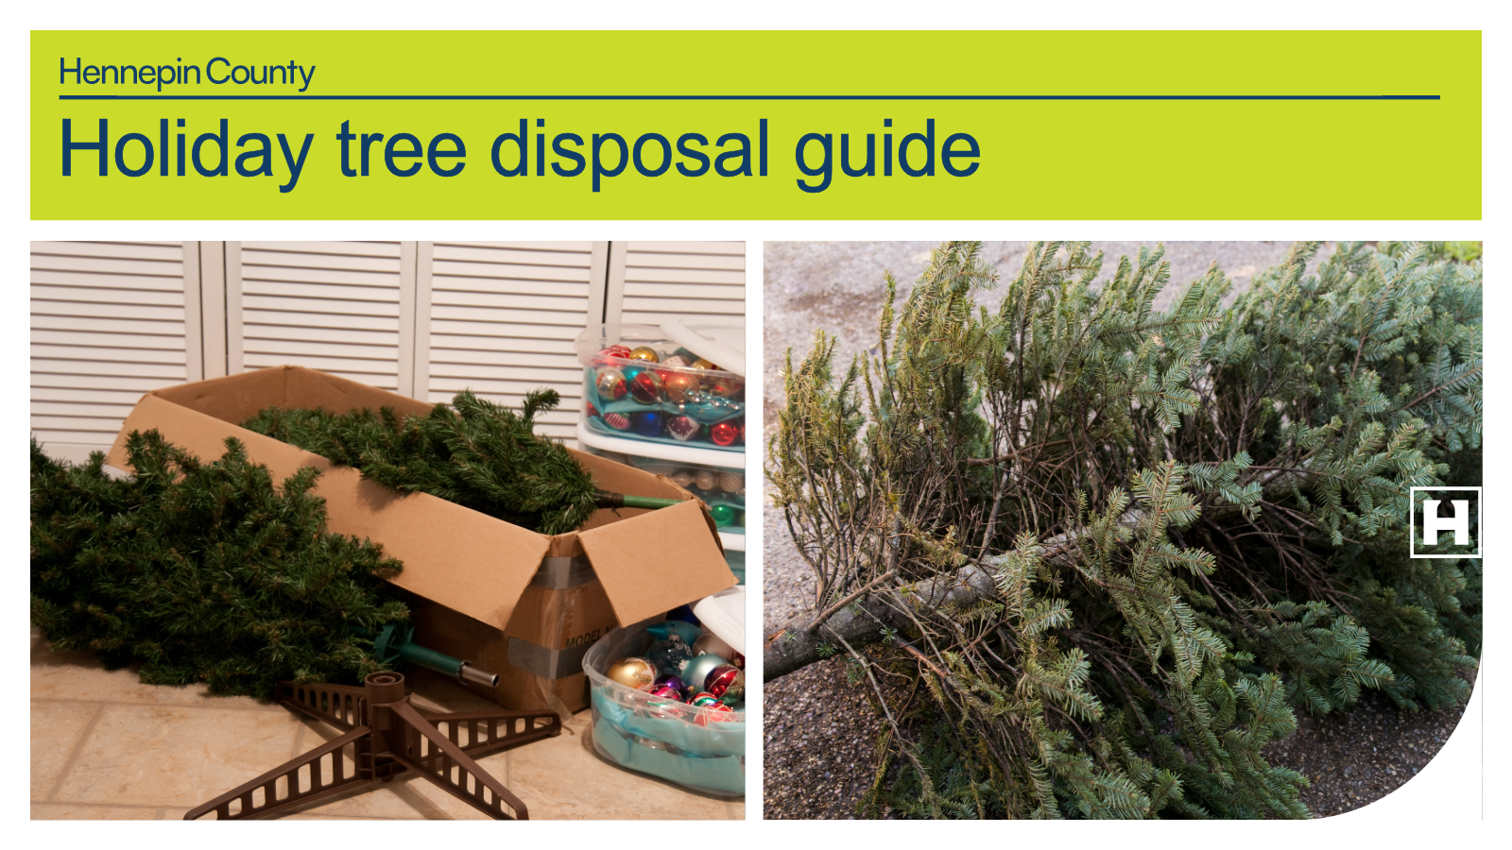

Real Christmas trees, wreaths, and greenery
At the end of the season, check with your city, garbage hauler, or yard waste drop-off site for disposal options. Remove all decorations prior to disposing of your live tree.
If wreaths and greenery are not accepted by your hauler, put them in a plastic bag in the trash. Unless you know your tree and greenery was grown in Minnesota, the Minnesota Department of Agriculture recommends you shouldn’t leave them in your backyard because of concerns about pests. Learn more about best practices for holiday greenery.

Artificial trees or greenery with flocking or glitter
Artificial trees and wreaths in good condition should be saved for reuse, given away, or donated. Trees, wreaths, and other greenery with flocking (a covering of artificial snow), glitter, or other decorations that cannot be removed should go in the trash.

Social media posts
Suggested hashtags: #LowWaste #Recycle #Reuse #Holiday
To use images and graphics: right click on the image and select Save as Picture.

Carousel of graphics
<< select series of images from the full library of social media graphics below>>
Facebook: Between packaging from deliveries, decorations, gift wrap, and more, the holiday season is a time when we often have a lot of stuff to get rid of. Review these tips to make sure you recycle and reuse as much as you can!
X: Between packaging from deliveries, decorations, gift wrap, and more, the holiday season is a time when we often have a lot of stuff to get rid of. Review these tips to make sure you recycle and reuse as much as you can!
Instagram: Between packaging from deliveries, decorations, gift wrap, and more, the holiday season is a time when we often have a lot of stuff to get rid of. Review these tips to make sure you recycle and reuse as much as you can!
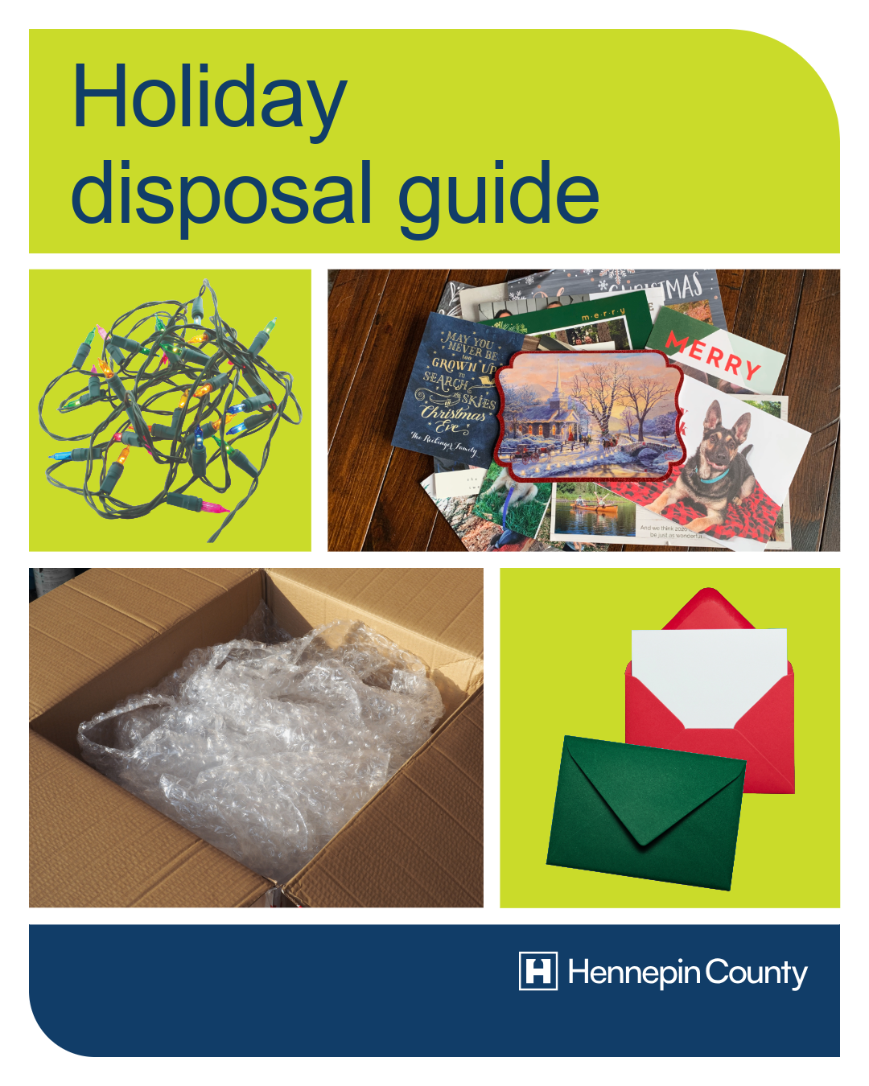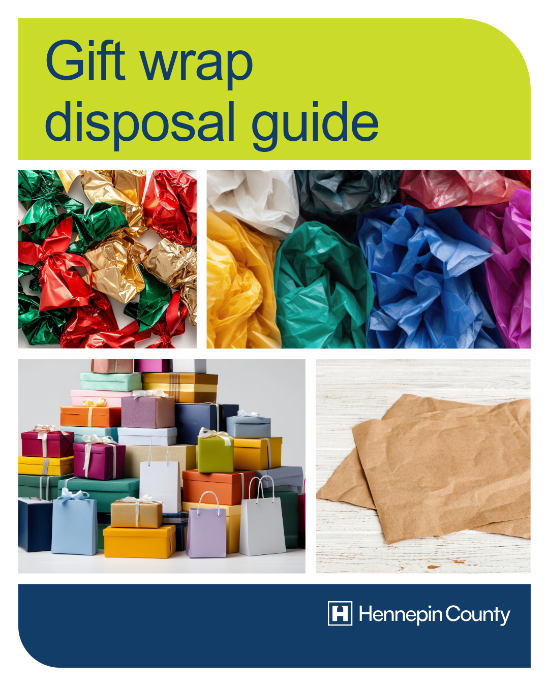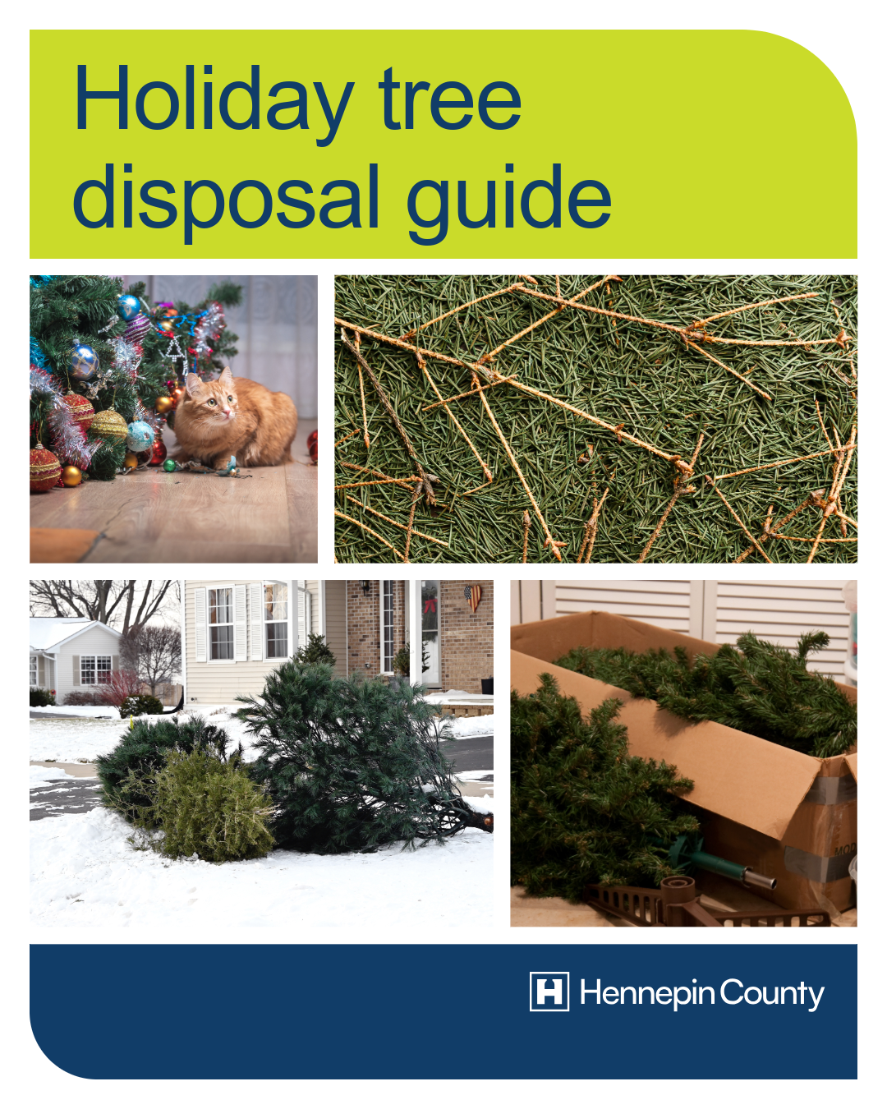

Individual tips

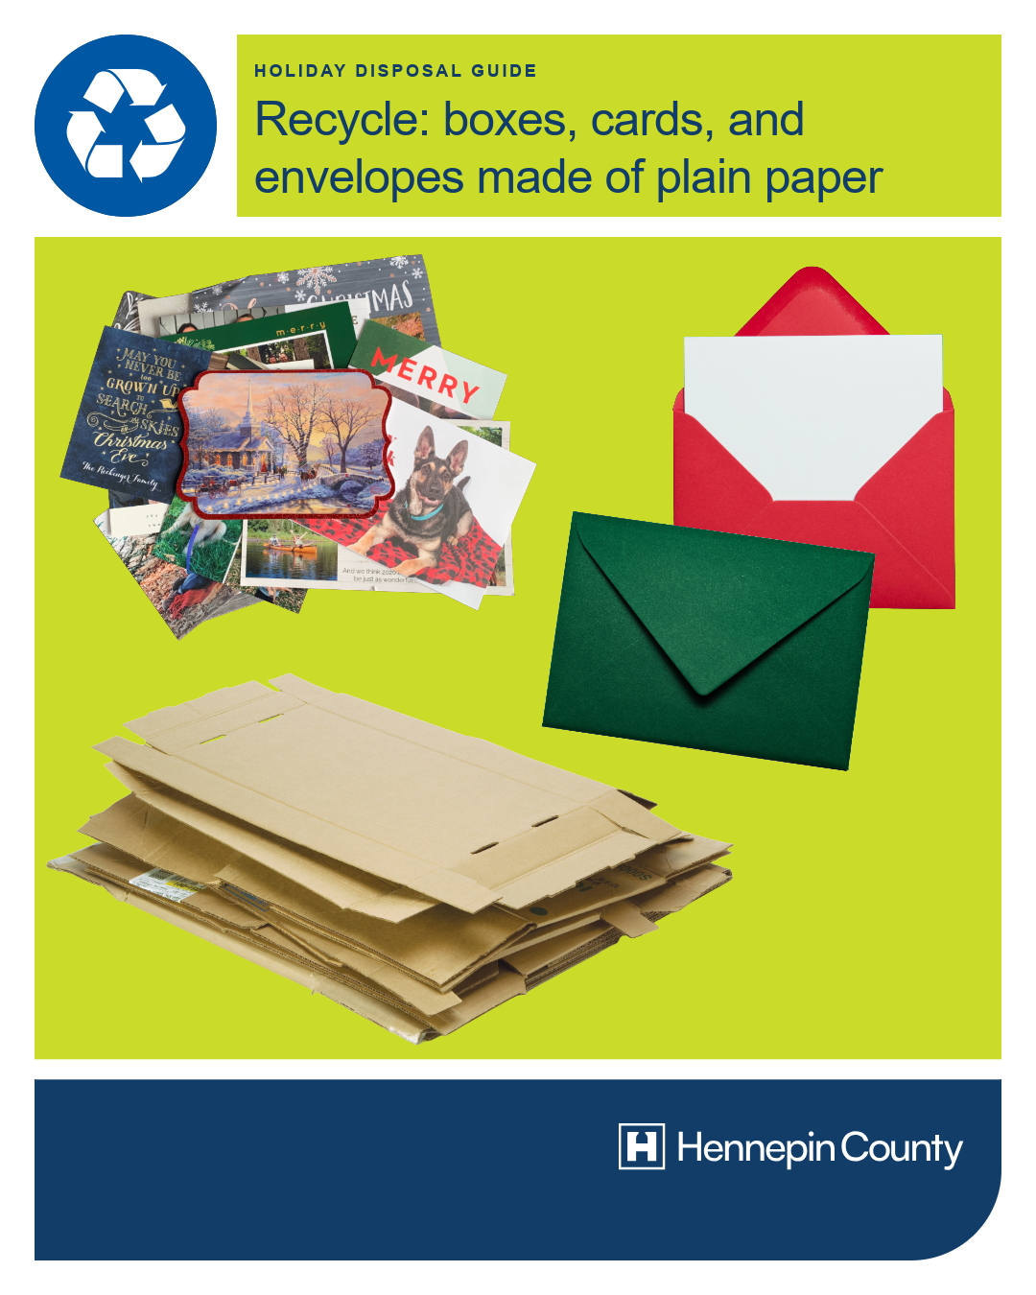
Post 1: Cardboard and paper – recycle at home
Facebook: As you clean up from the holidays, follow these tips for the best way to get rid of common holiday items like cardboard! You can flatten and recycle cardboard boxes as well as cards, envelopes, and gift wrap made from plain paper at home.
X: As you clean up from the holidays, follow these tips for the best way to get rid of common holiday items like cardboard! You can flatten and recycle cardboard boxes as well as cards, envelopes, and gift wrap made from plain paper at home.
Instagram: As you clean up from the holidays, follow these tips for the best way to get rid of common holiday items like cardboard! You can flatten and recycle cardboard boxes as well as cards, envelopes, and gift wrap made from plain paper at home.

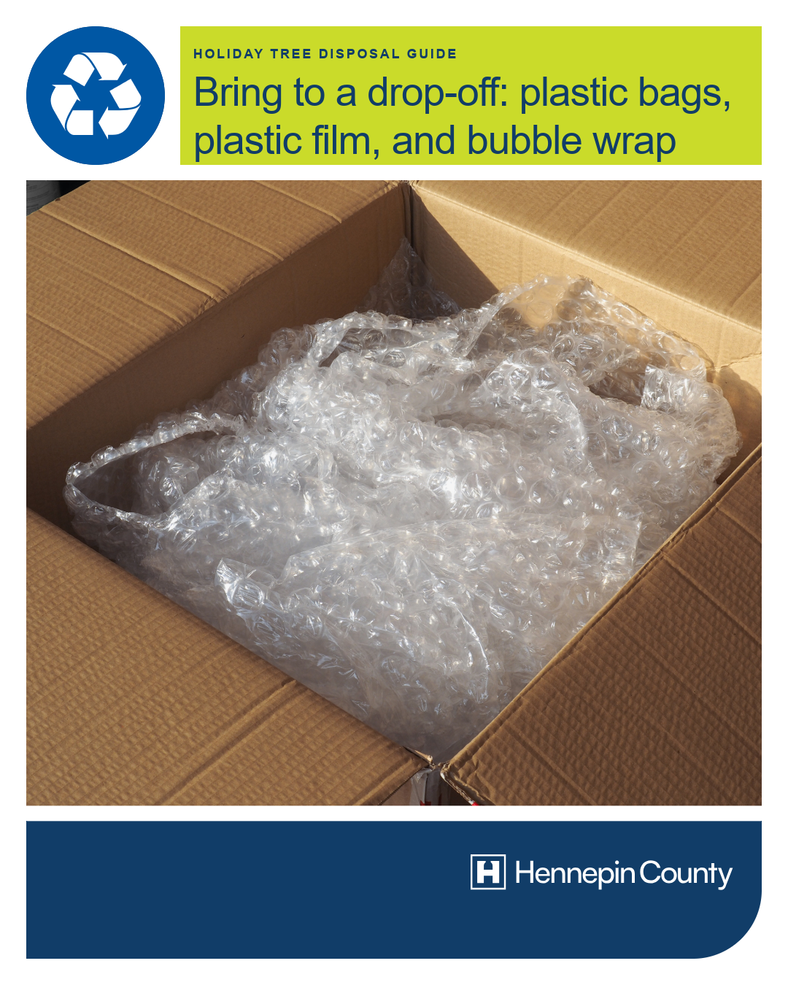
Post 2: Plastic bags, film, and bubble wrap – bring to a drop-off
Facebook: Deliveries can come with a lot of plastic packaging. Bring shipping envelopes made entirely of plastic, plastic film, air pillows, and bubble wrap to a drop-off for recycling. Plastic bags and film must be clean and dry, and plastic air pillows should be deflated. hennepin.us/dropoffs
X: Deliveries come with a lot of plastic packaging. Bring shipping envelopes made of plastic, plastic film, air pillows, and bubble wrap to a drop-off for recycling. Plastic bags and film must be clean and dry, and plastic air pillows should be deflated. hennepin.us/dropoffs
Instagram: Deliveries can come with a lot of plastic packaging. Bring shipping envelopes made entirely of plastic, plastic film, air pillows, and bubble wrap to a drop-off for recycling. Plastic bags and film must be clean and dry, and plastic air pillows should be deflated.

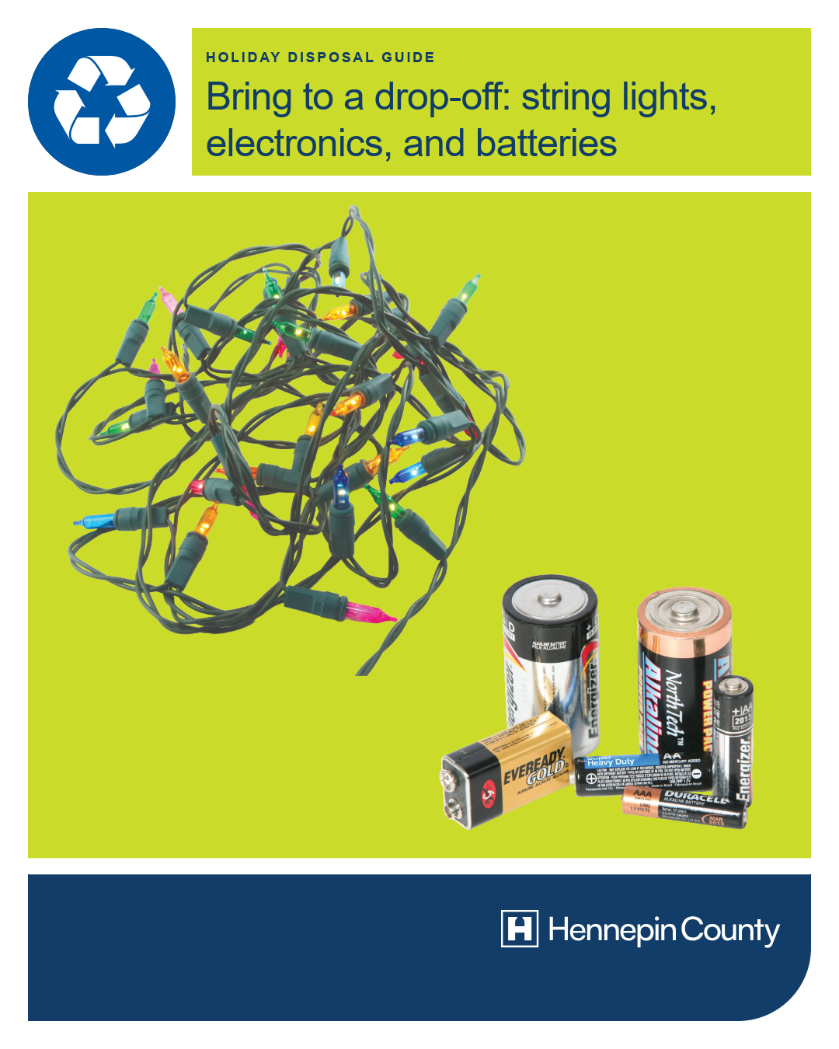
Post 3: Electronics and string lights – bring to a drop-off
Facebook: It’s common this time of year to have things like string lights that no longer work, electronics that you are upgrading, or items with batteries that you need to get rid of. These items are accepted at Hennepin County drop-off facilities for recycling or proper disposal. hennepin.us/dropoffs
X: It’s common this time of year to have things like string lights that no longer work, electronics that you are upgrading, or items with batteries that you need to get rid of. These items are accepted at Hennepin County drop-off facilities for recycling or proper disposal. hennepin.us/dropoffs
Instagram: It’s common this time of year to have things like string lights that no longer work, electronics that you are upgrading, or items with batteries that you need to get rid of. These items are accepted at Hennepin County drop-off facilities for recycling or proper disposal.

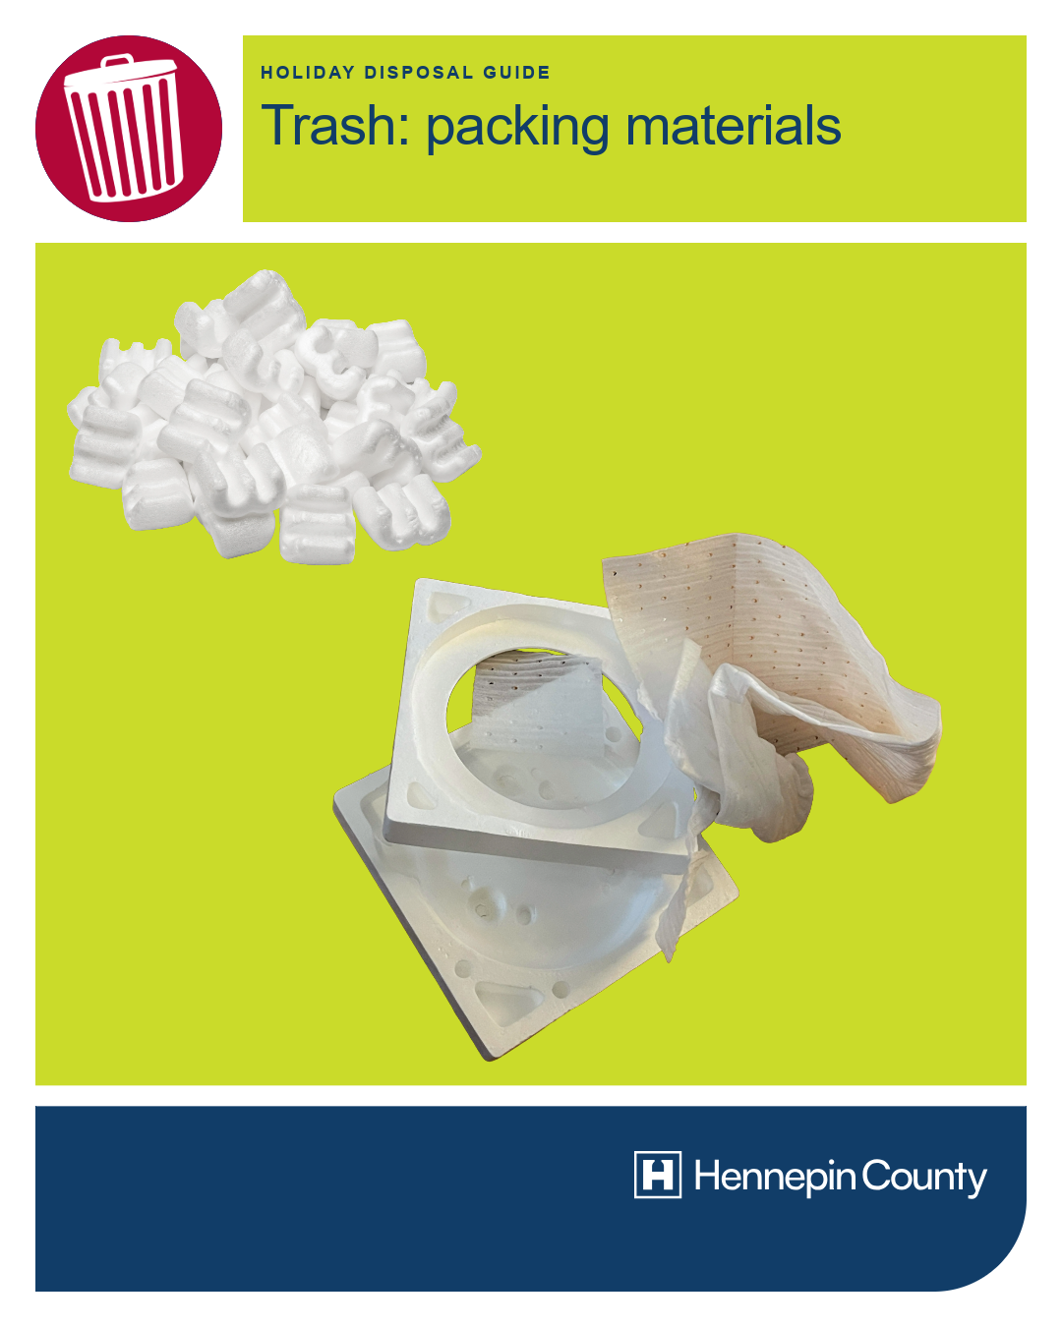
Post 4: Packing materials – trash
Facebook: Packing materials are most often not recyclable. Reuse StyrofoamTM and other packing materials for future packing and mailing needs or put them in the trash. Shipping envelopes made of multiple materials (such as paper and bubble wrap) also go in the trash.
X: Packing materials are most often not recyclable. Reuse StyrofoamTM and other packing materials for future packing and mailing needs or put them in the trash. Shipping envelopes made of multiple materials (such as paper and bubble wrap) also go in the trash.
Instagram: Packing materials are most often not recyclable. Reuse StyrofoamTM and other packing materials for future packing and mailing needs or put them in the trash. Shipping envelopes made of multiple materials (such as paper and bubble wrap) also go in the trash.

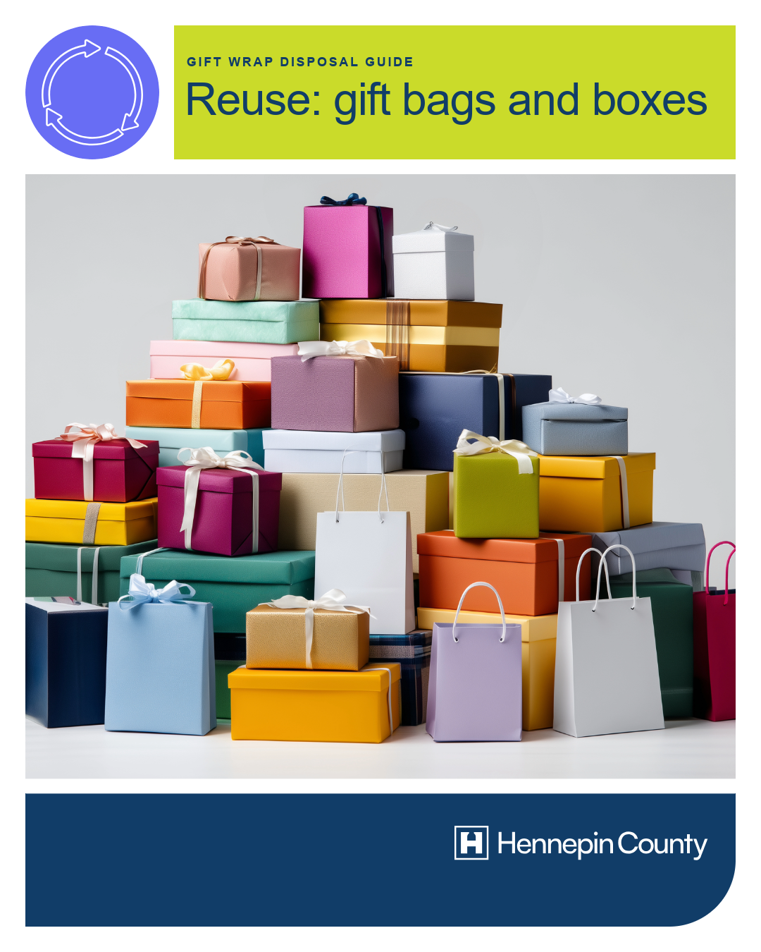
Post 5: Gift wrap – reuse or recycle
Facebook: As you clean up during the holidays, items like gift bags, gift boxes, ribbons, and bows are great to save and reuse next year! Newspaper, Kraft paper, or other plain paper used as gift wrap can be reused or recycled at home. Flatten paper before recycling to ensure it gets properly sorted at the recycling facility.
X: Gift bags, gift boxes, ribbons, and bows are great to save and reuse next year! Newspaper, Kraft paper, or other plain paper used as gift wrap can be reused or recycled at home. Flatten paper before recycling to ensure it gets sorted properly.
Instagram: As you clean up during the holidays, items like gift bags, gift boxes, ribbons, and bows are great to save and reuse next year! Newspaper, Kraft paper, or other plain paper used as gift wrap can be reused or recycled at home. Flatten paper before recycling to ensure it gets properly sorted at the recycling facility.
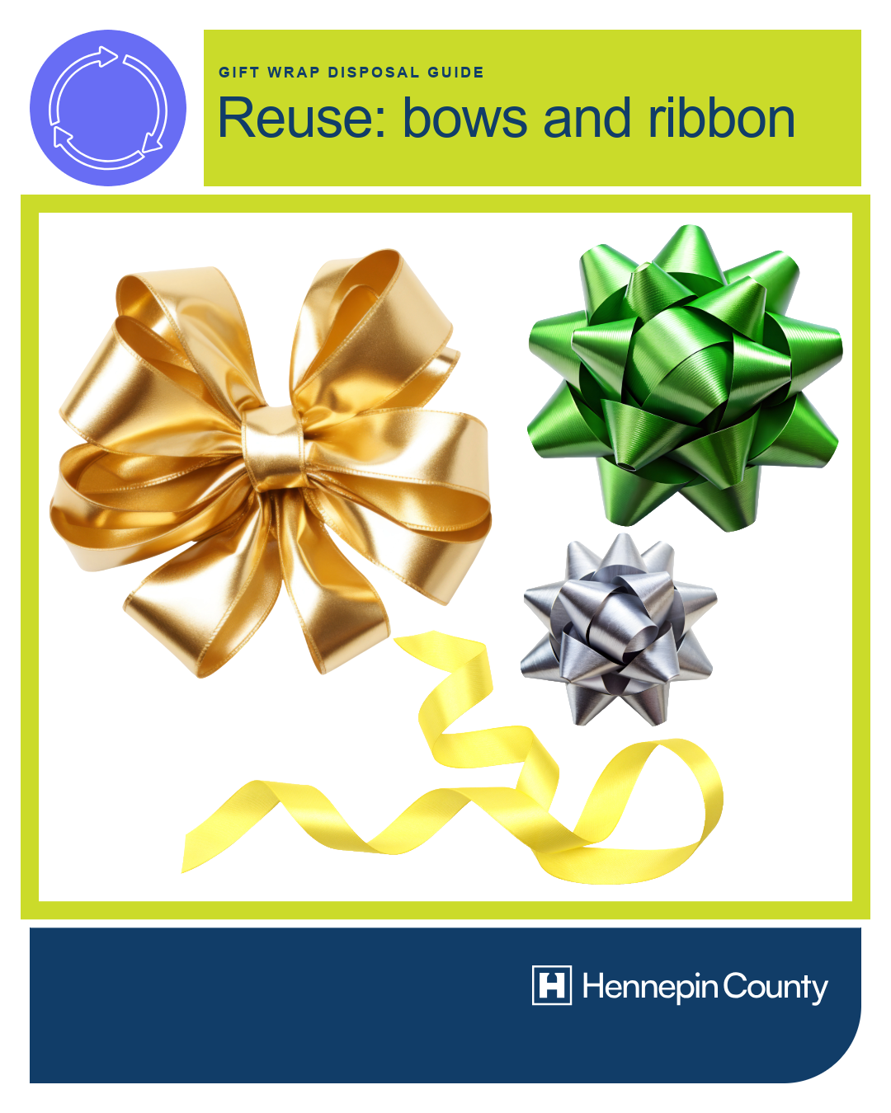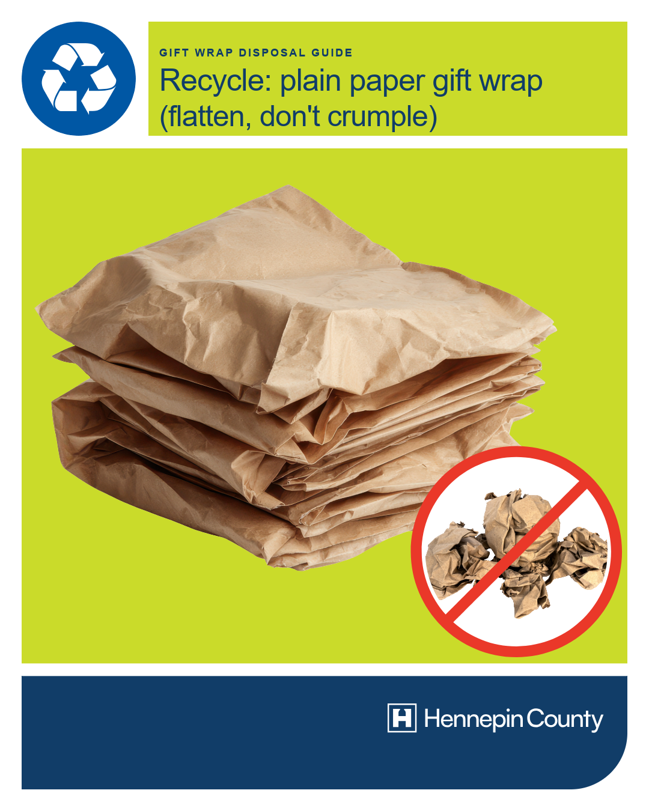

Post 6: Glossy/shiny paper, glitter, tissue paper – trash
Facebook: Unfortunately, many items commonly used to decorate gifts become too damaged to reuse or cannot be recycled. These should go in the trash: glossy, shiny, or glittery wrapping paper, tissue paper, cards that have glitter, foil, or plastic adornments, cards printed on photo paper.
X: Unfortunately, many items commonly used to decorate gifts become too damaged to reuse or cannot be recycled. These should go in the trash: glossy, shiny, or glittery wrapping paper, tissue paper, cards that have glitter, foil, or plastic adornments, cards printed on photo paper.
Instagram: Unfortunately, many items commonly used to decorate gifts become too damaged to reuse or cannot be recycled. These should go in the trash: glossy, shiny, or glittery wrapping paper, tissue paper, cards that have glitter, foil, or plastic adornments, cards printed on photo paper.
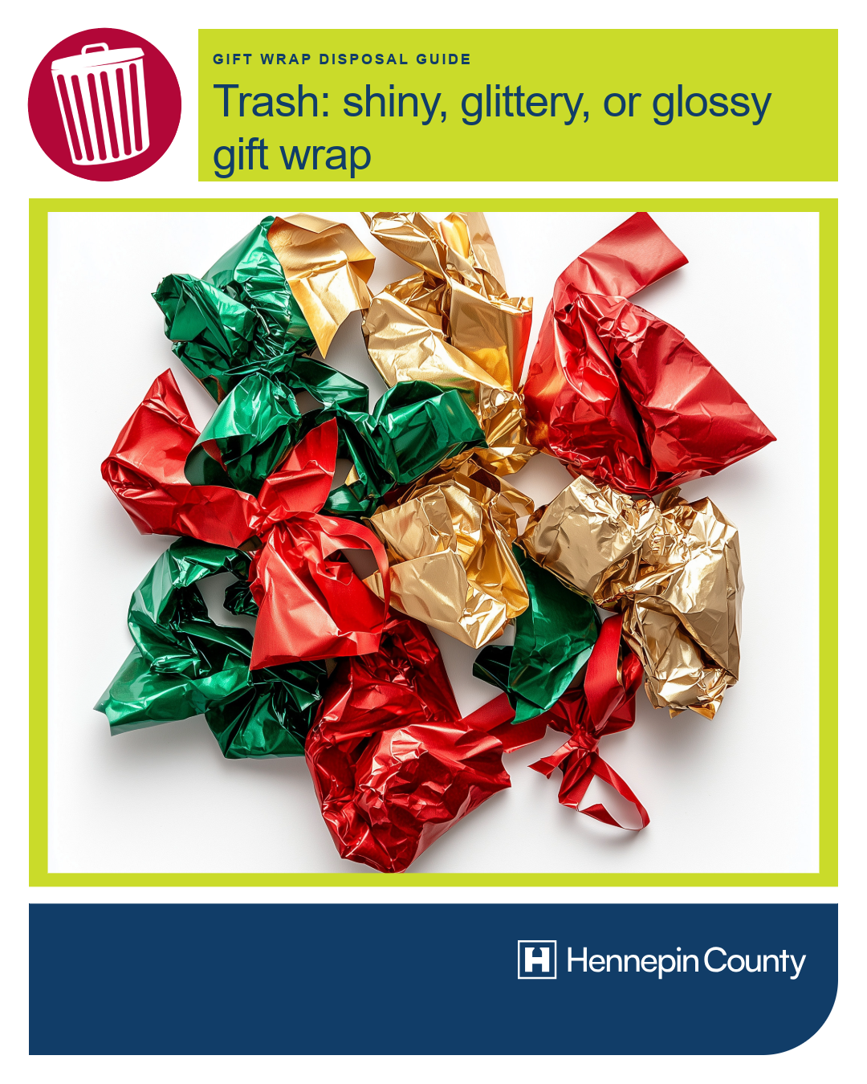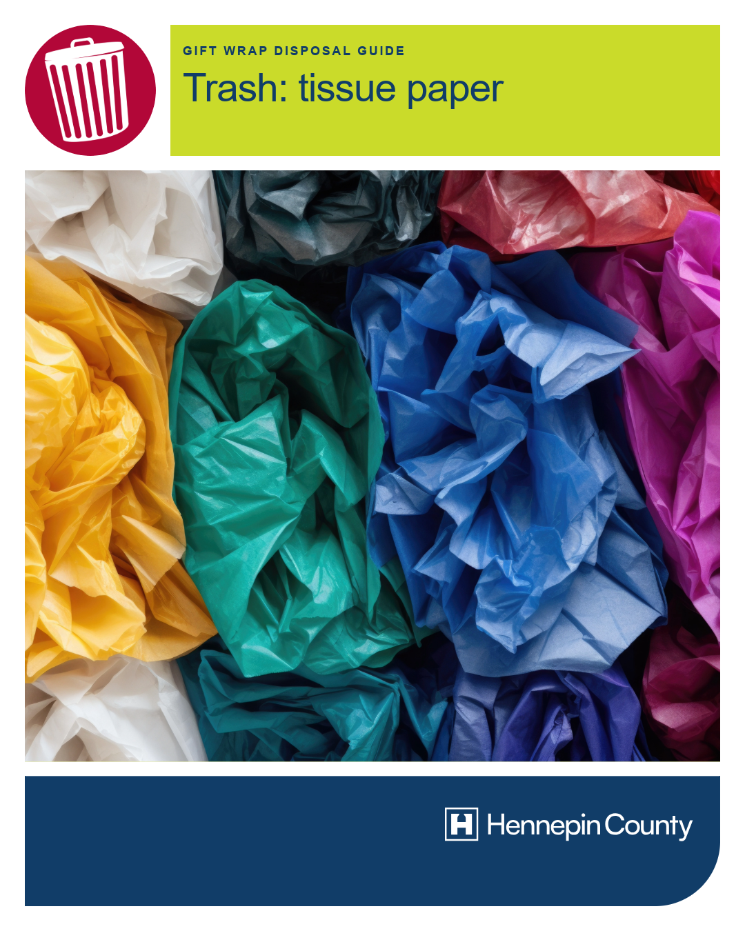

Post 7: Real trees
Facebook: Disposal of real holiday trees: at the end of the season, check with your city, garbage hauler, or yard waste drop-off site for disposal options. Remove all decorations prior to disposing of your live tree.
X: Disposal of real holiday trees: at the end of the season, check with your city, garbage hauler, or yard waste drop-off site for disposal options. Remove all decorations prior to disposing of your live tree.
Instagram: Disposal of real holiday trees: at the end of the season, check with your city, garbage hauler, or yard waste drop-off site for disposal options. Remove all decorations prior to disposing of your live tree.
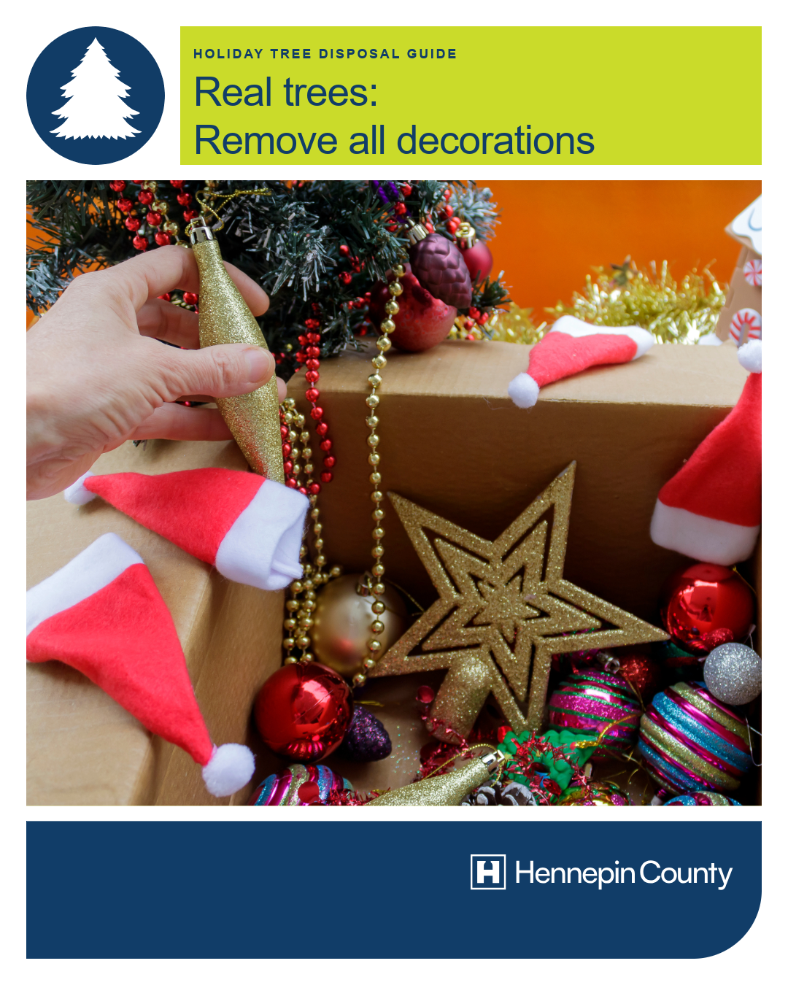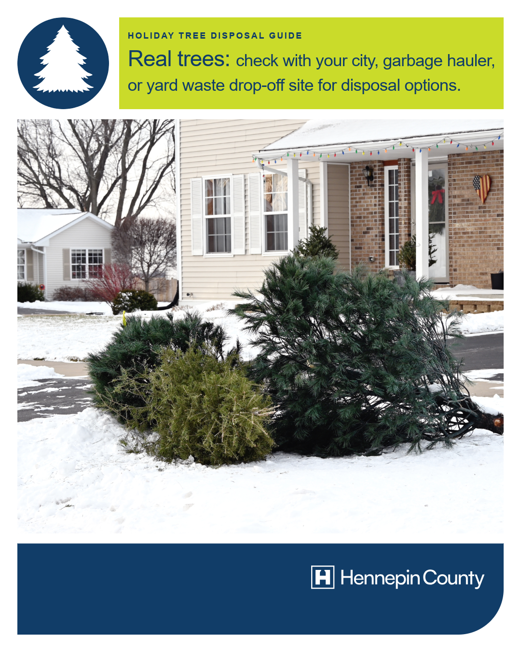

Post 8: Artificial trees and flocking
Facebook: Artificial trees and wreaths in good condition should be saved for reuse, given away, or donated. Trees, wreaths, and other greenery with flocking (a covering of artificial snow), glitter, or other decorations that cannot be removed should go in the trash.
X: Artificial trees and wreaths in good condition should be saved for reuse, given away, or donated. Trees, wreaths, and other greenery with flocking (a covering of artificial snow), glitter, or other decorations that cannot be removed should go in the trash.
Instagram: Artificial trees and wreaths in good condition should be saved for reuse, given away, or donated. Trees, wreaths, and other greenery with flocking (a covering of artificial snow), glitter, or other decorations that cannot be removed should go in the trash.
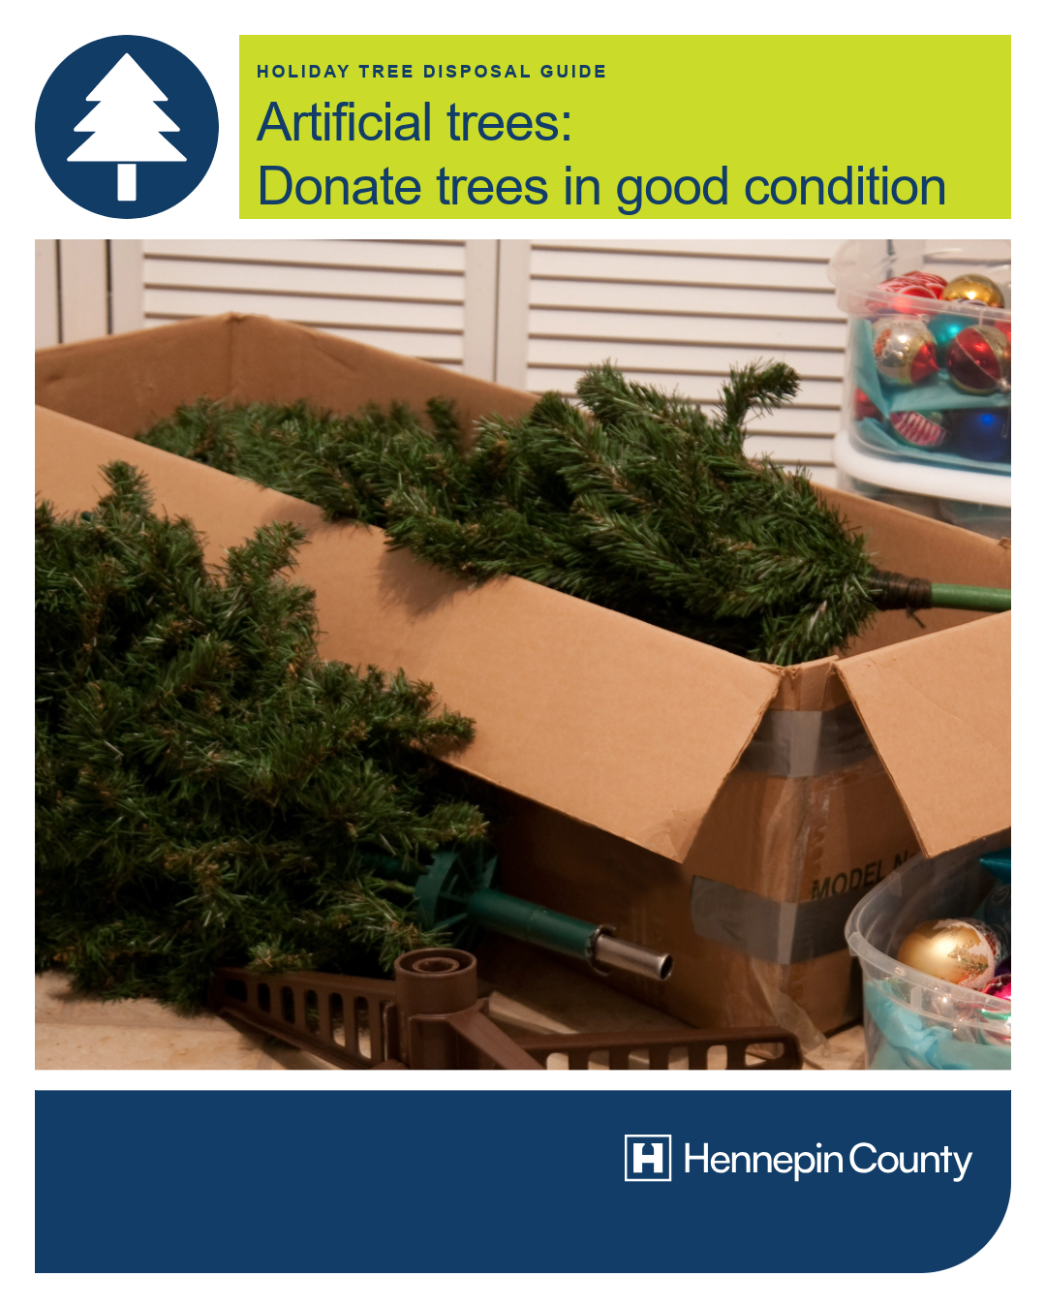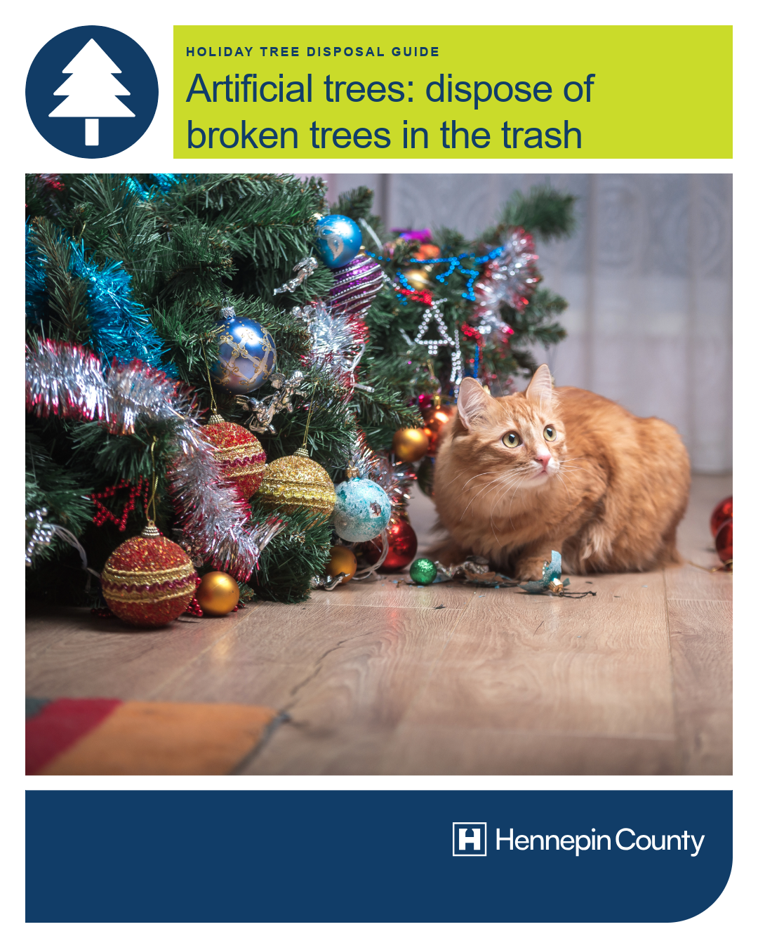

Graphics – Full library
Below is a series of graphics about eco-friendly holiday disposal to use in social media posts.
To use images and graphics: right click on image and select Save as Picture.

Holiday disposal guide – newsletter

Holiday disposal guide – feed posts

Holiday disposal guide – stories
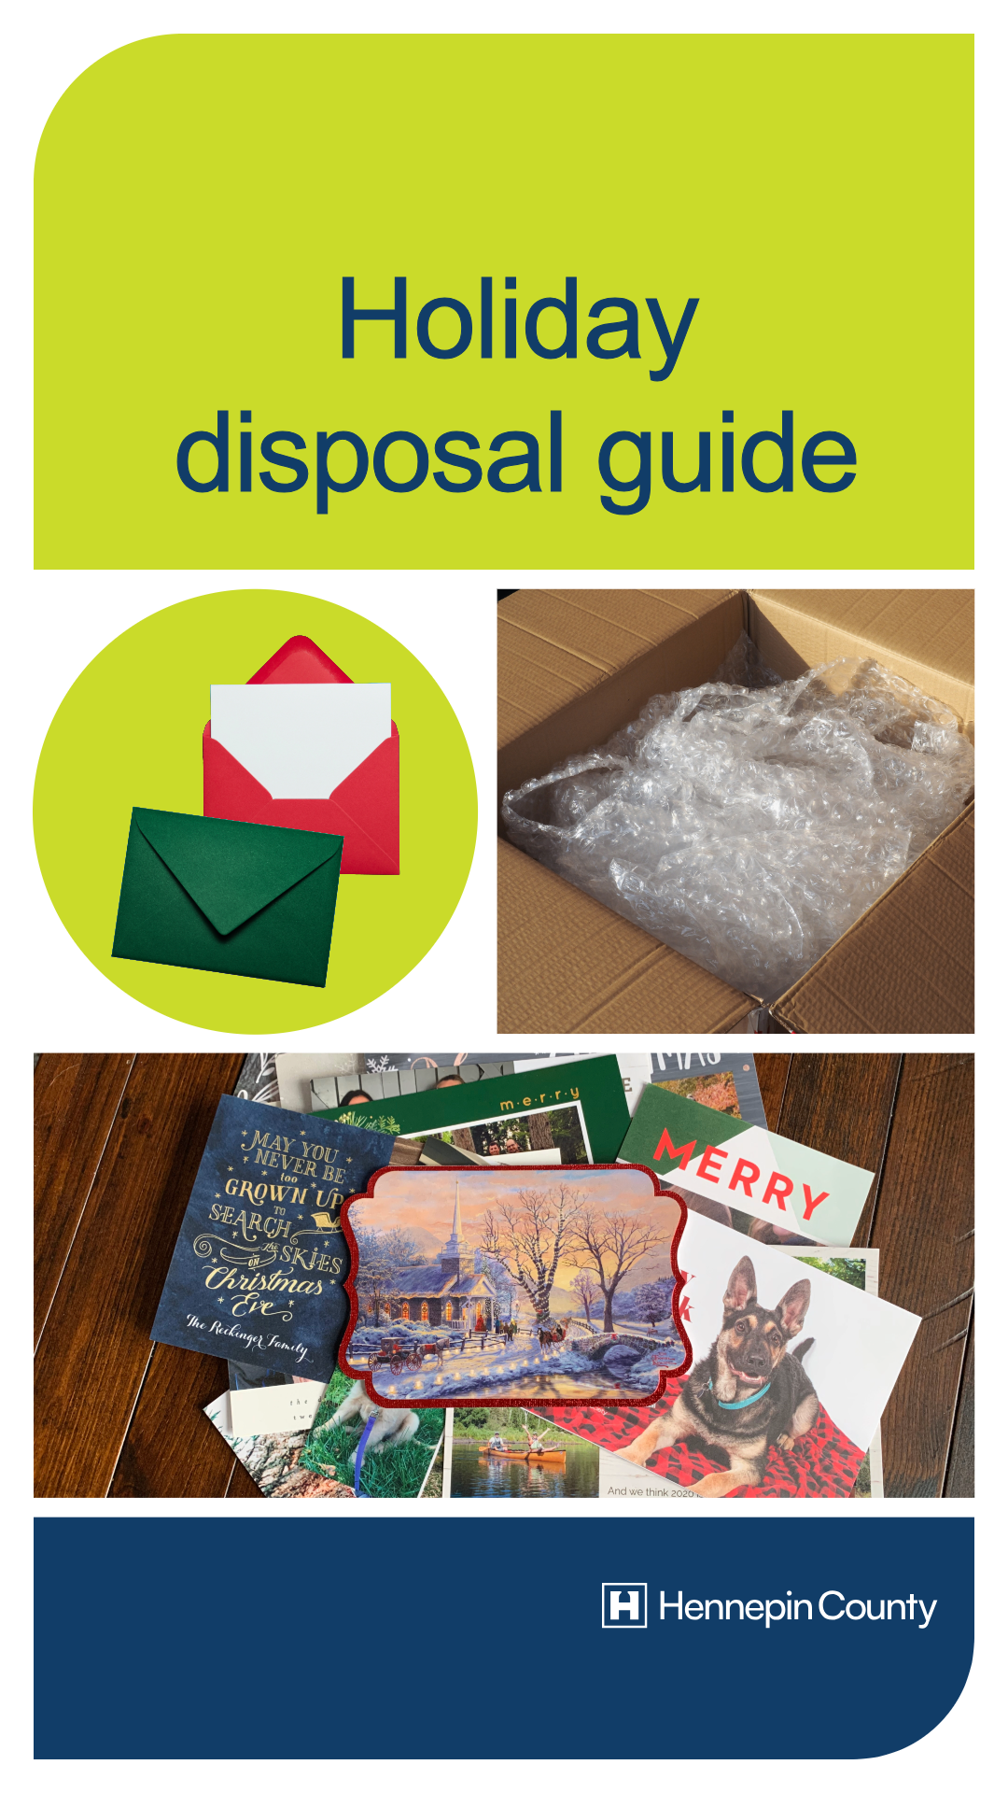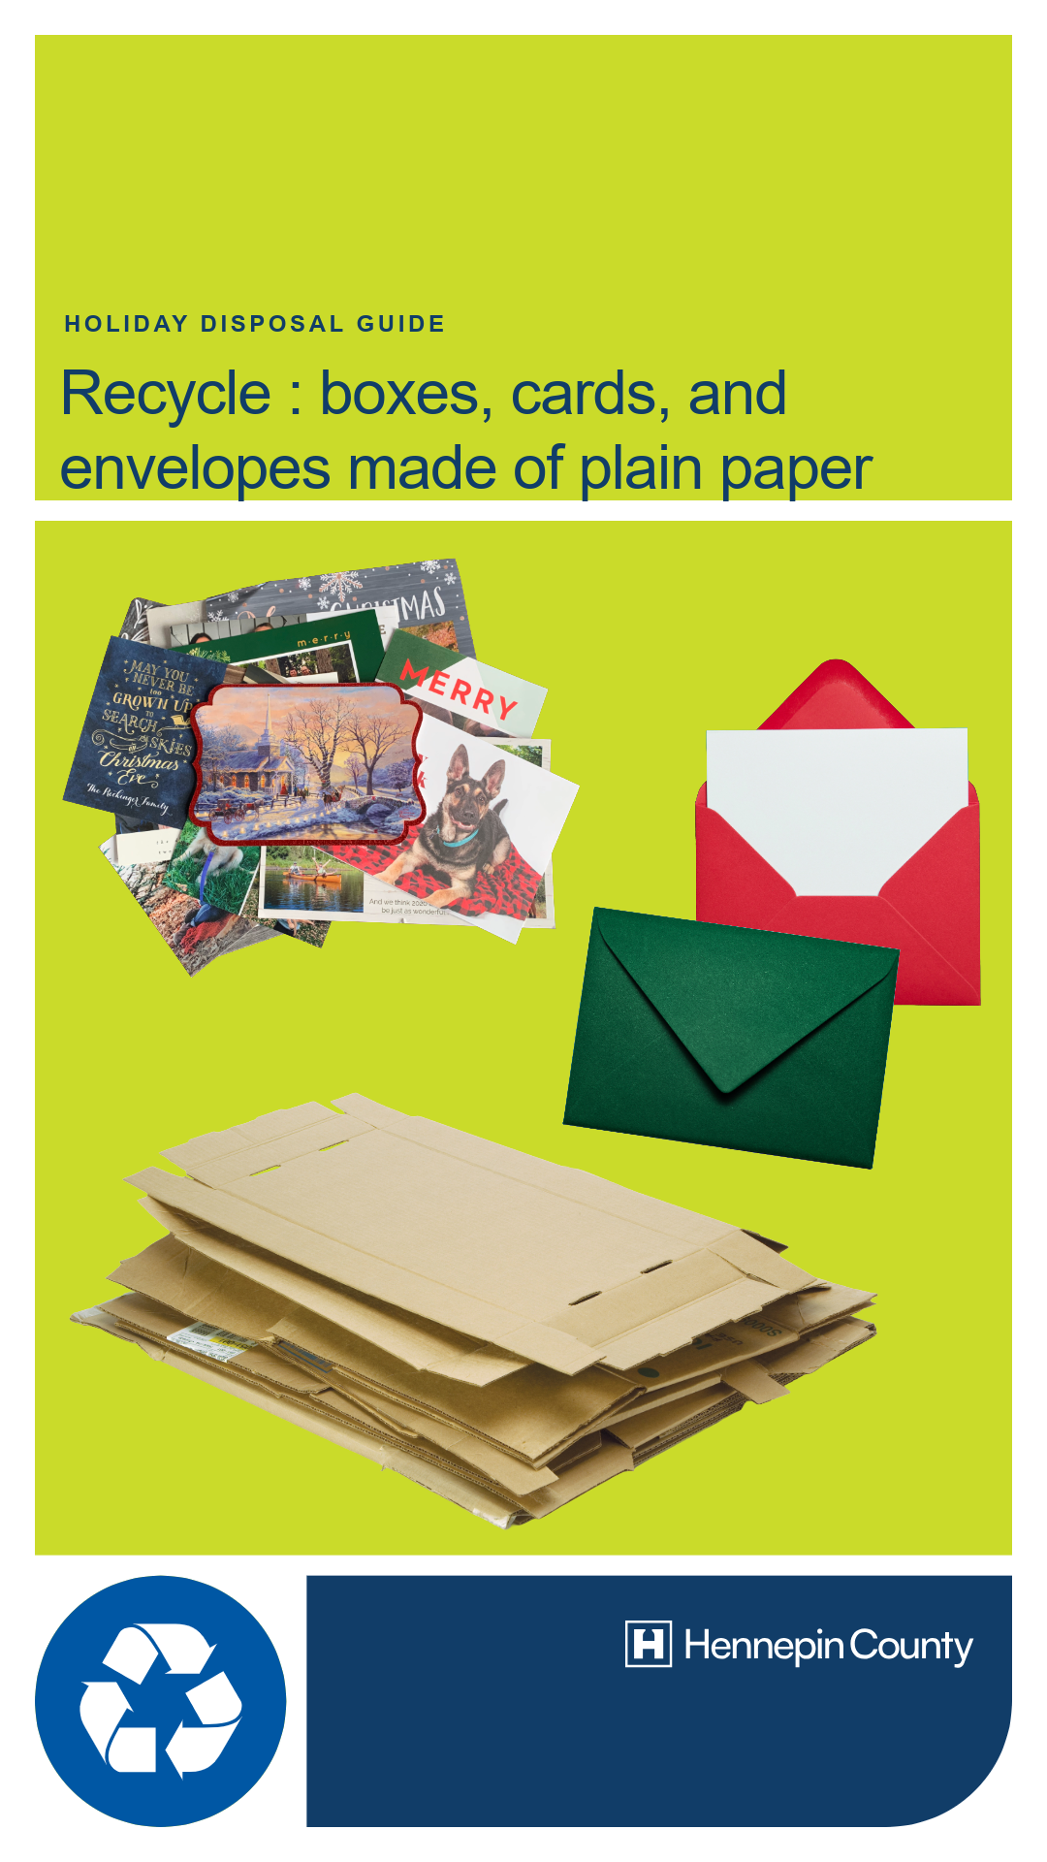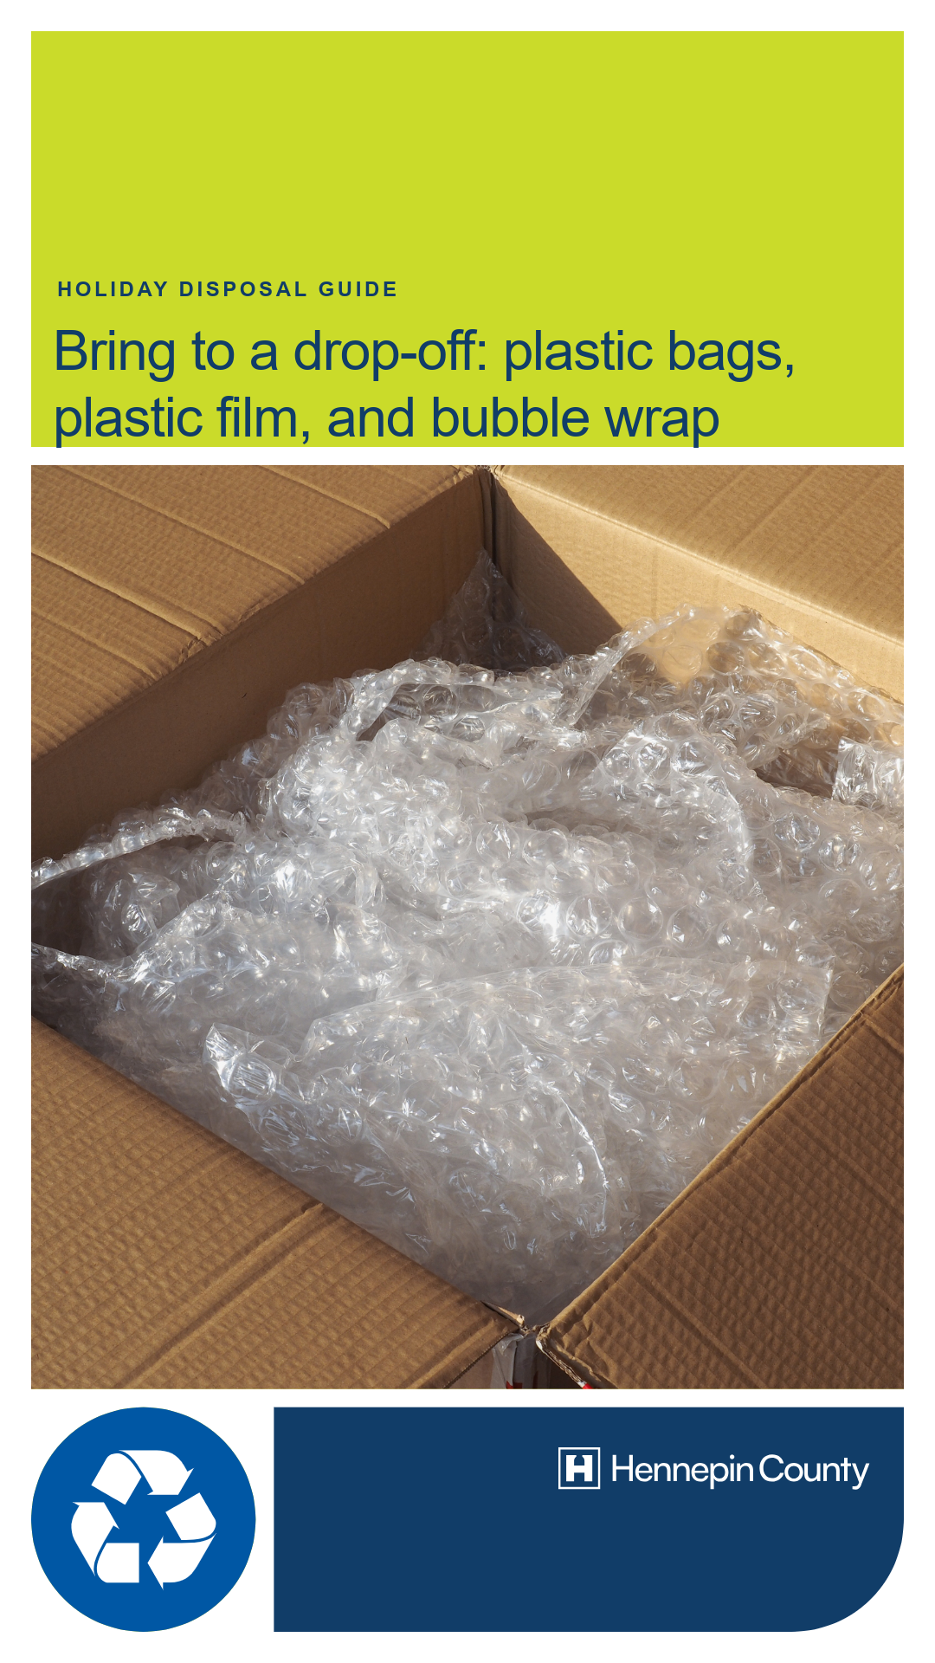
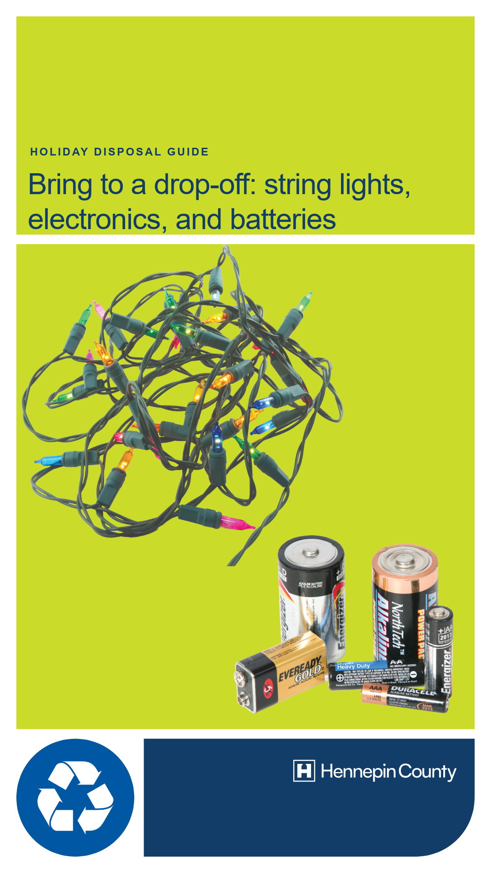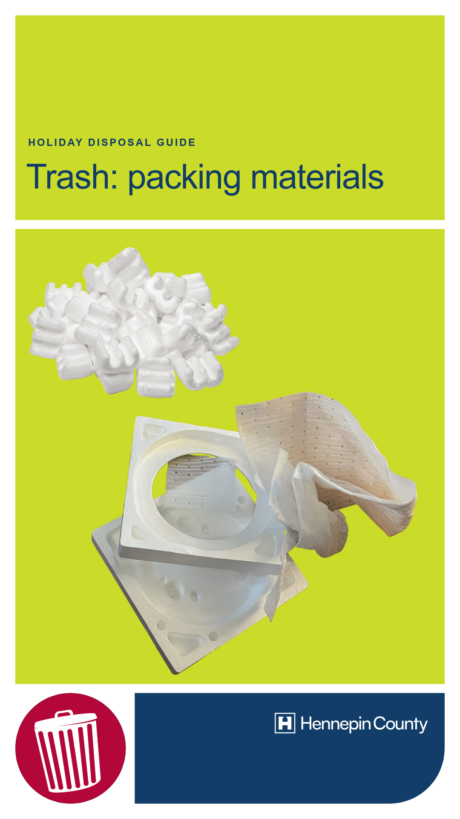

Gift wrap disposal guide – newsletter

Gift wrap disposal guide – feed posts

Gift wrap disposal guide – stories
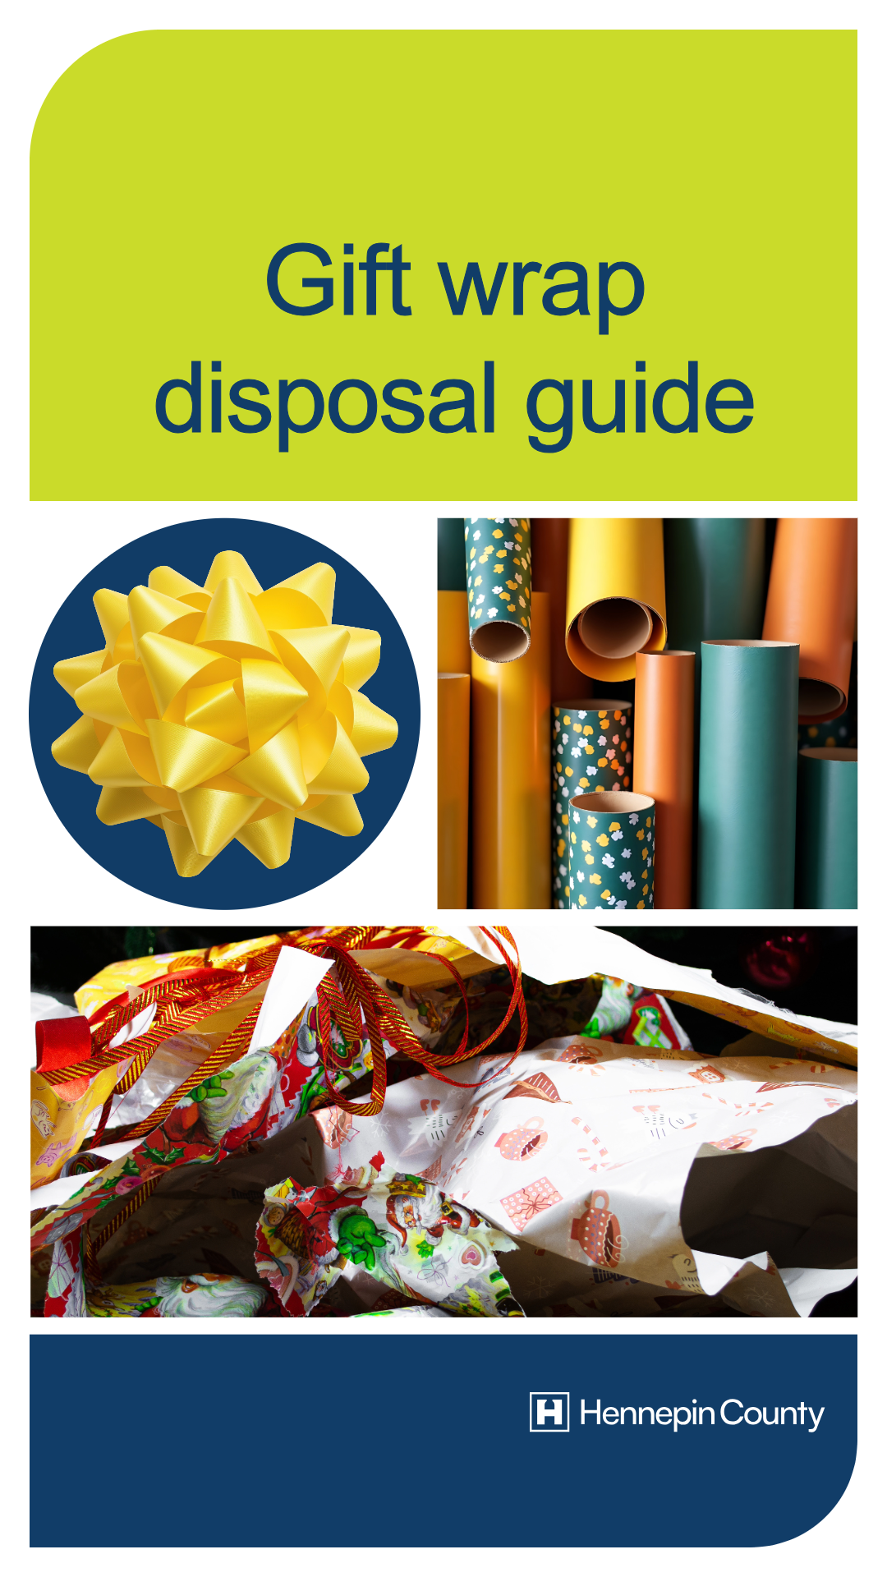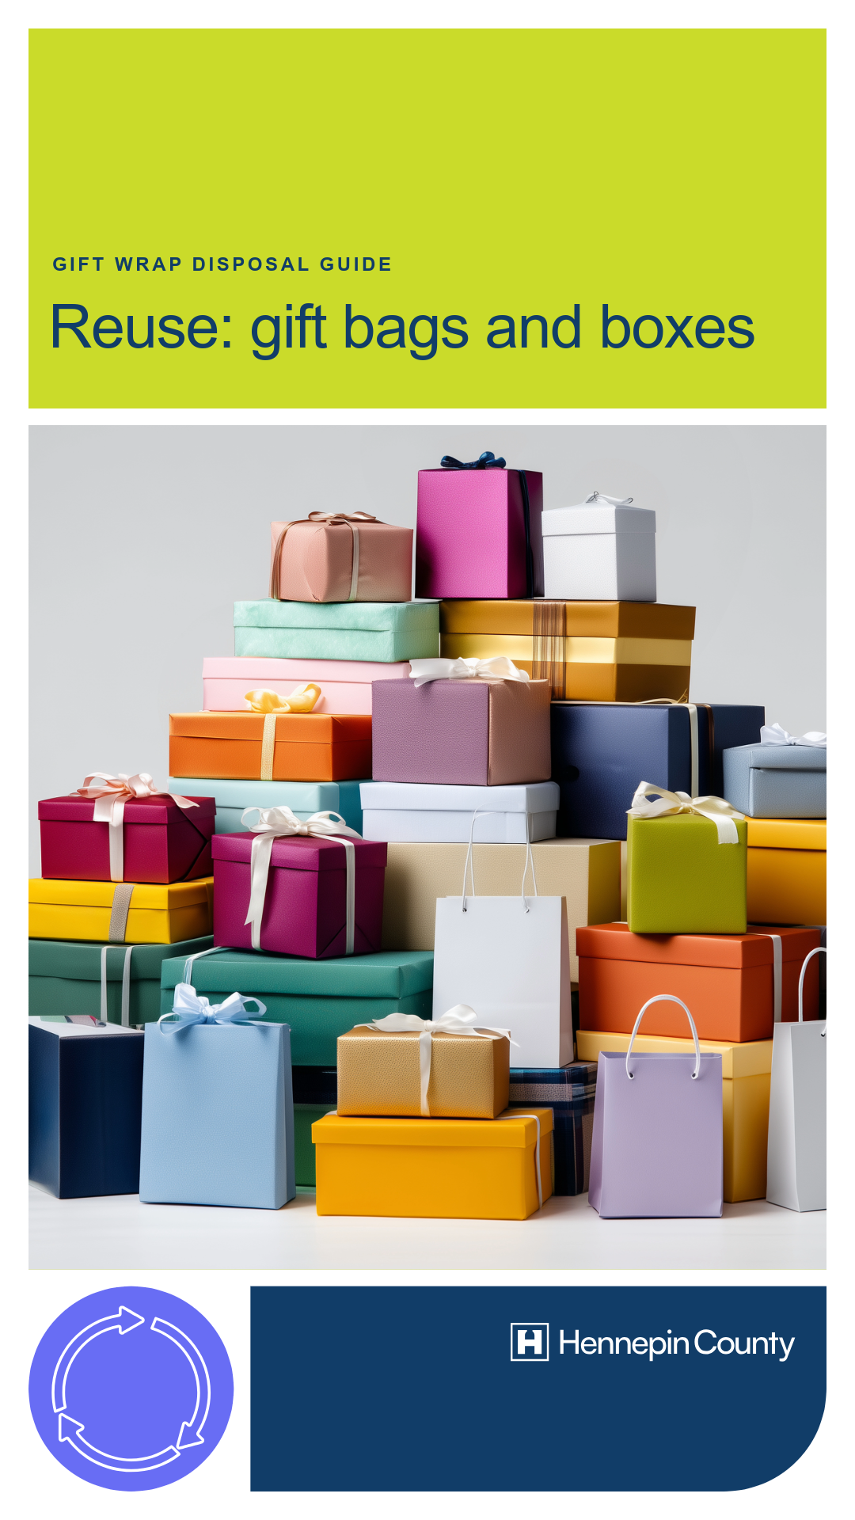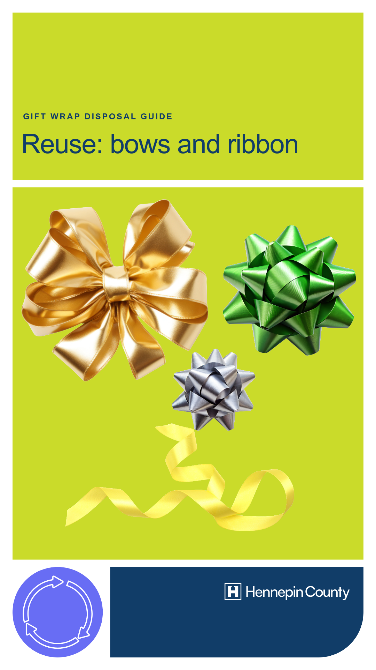
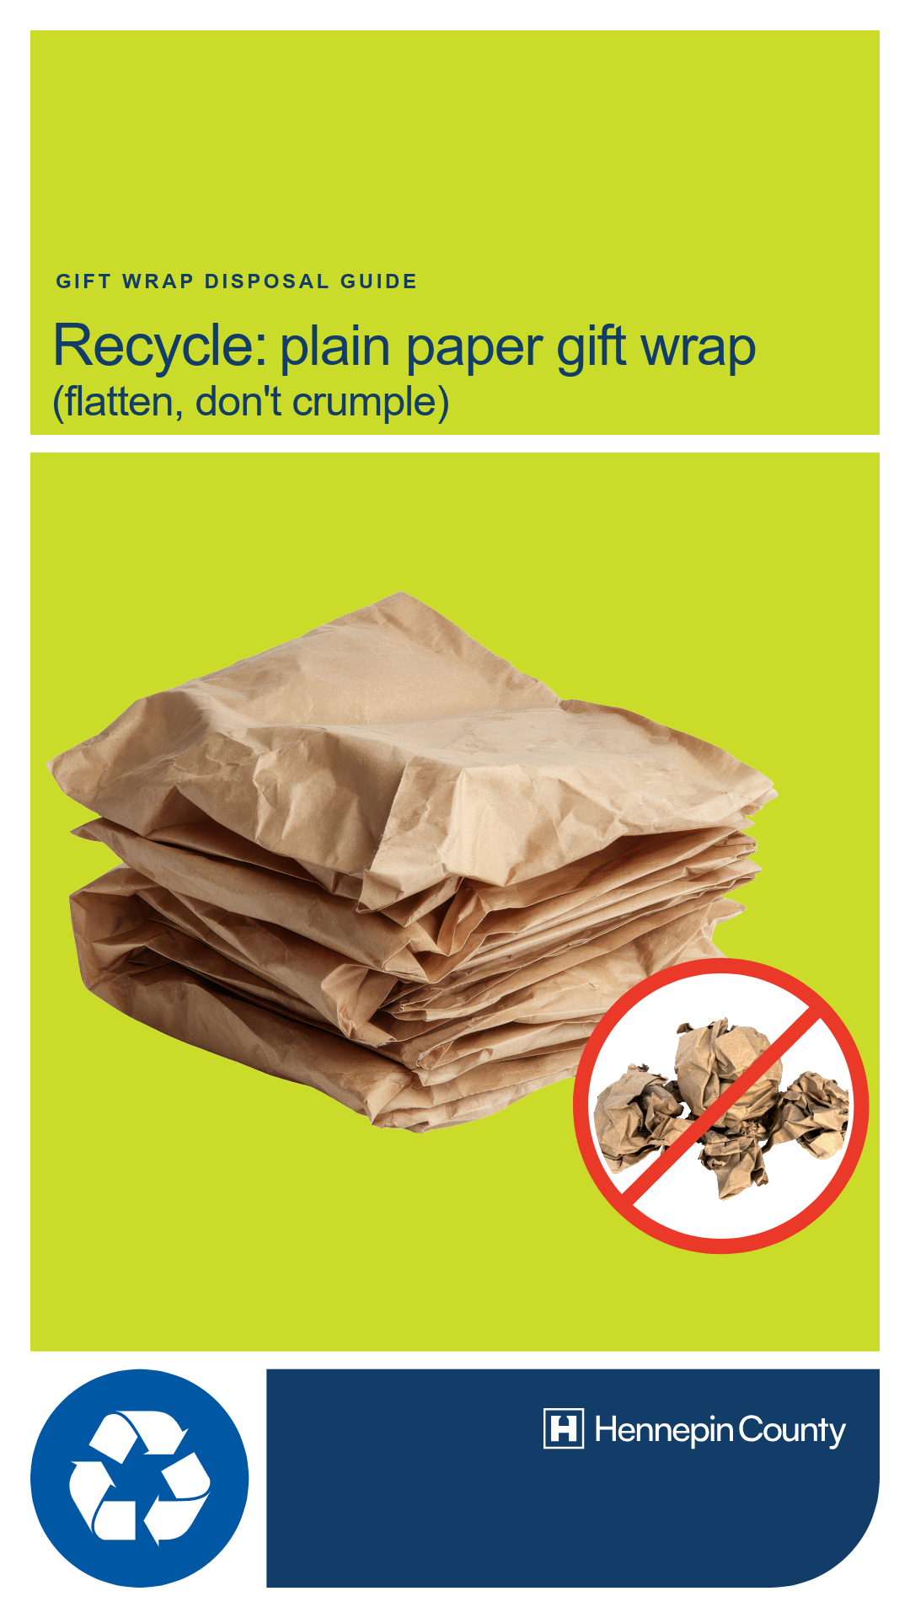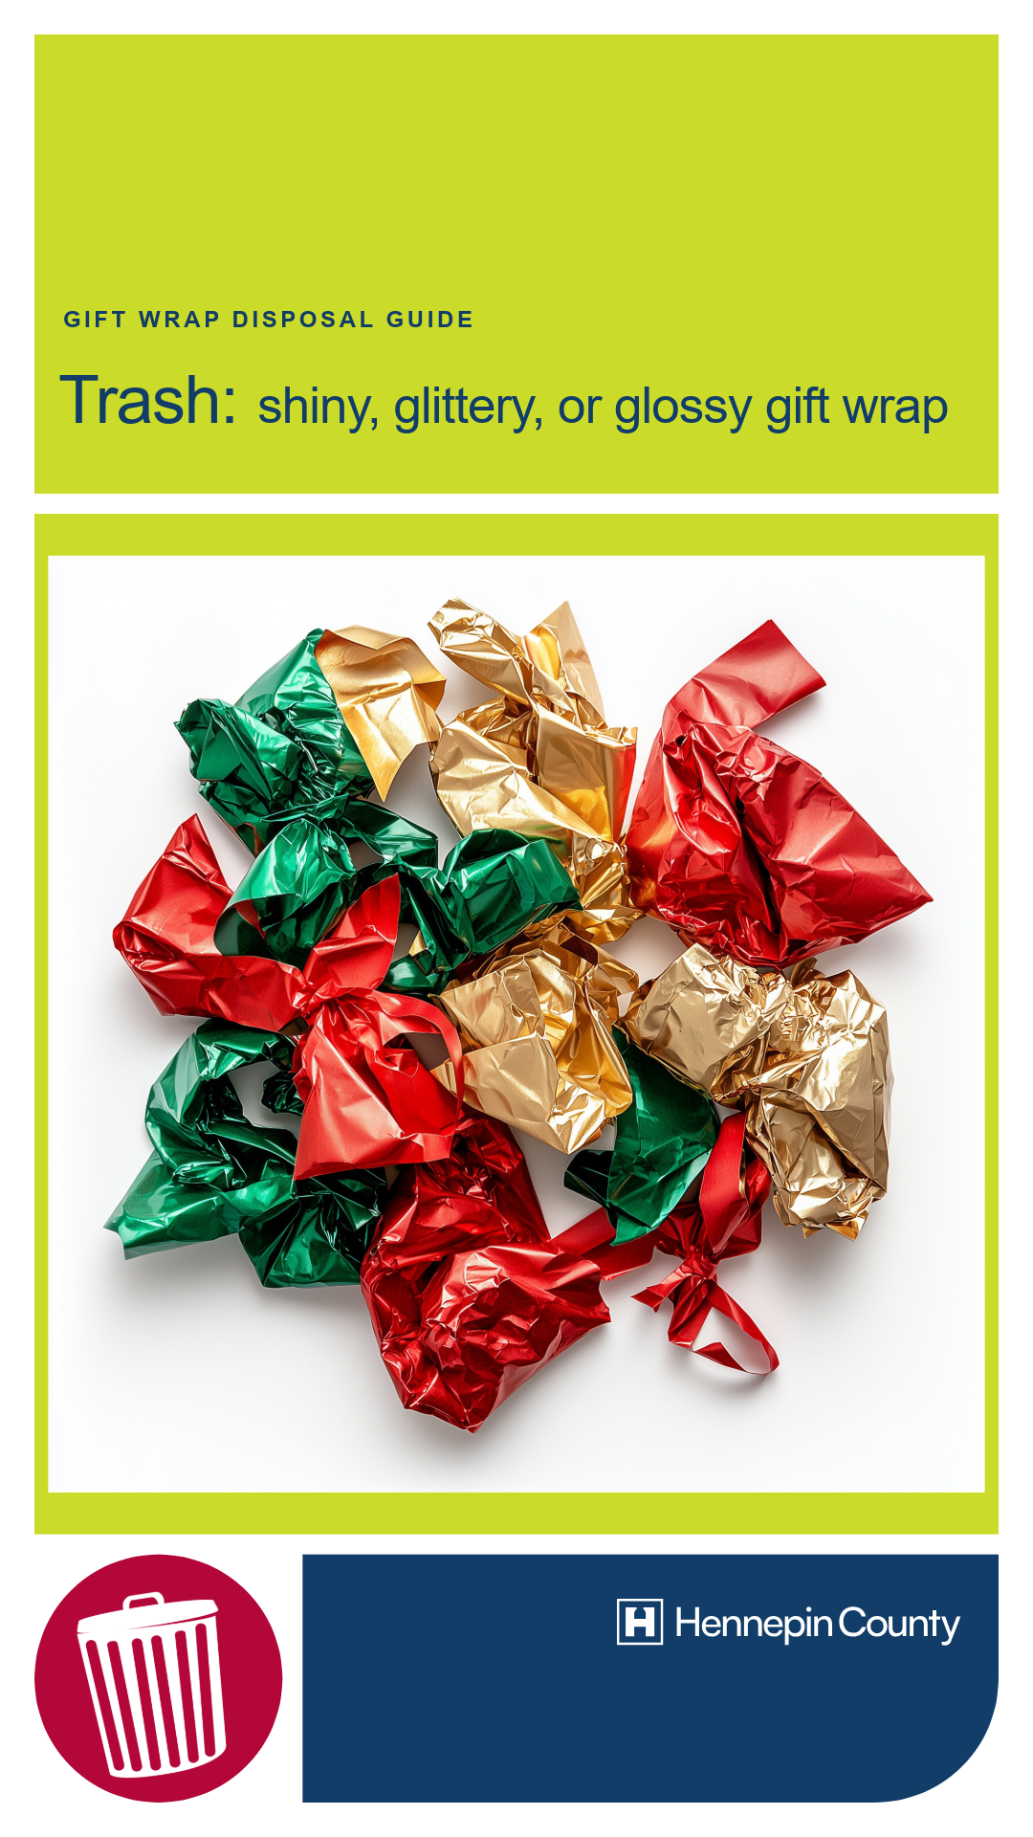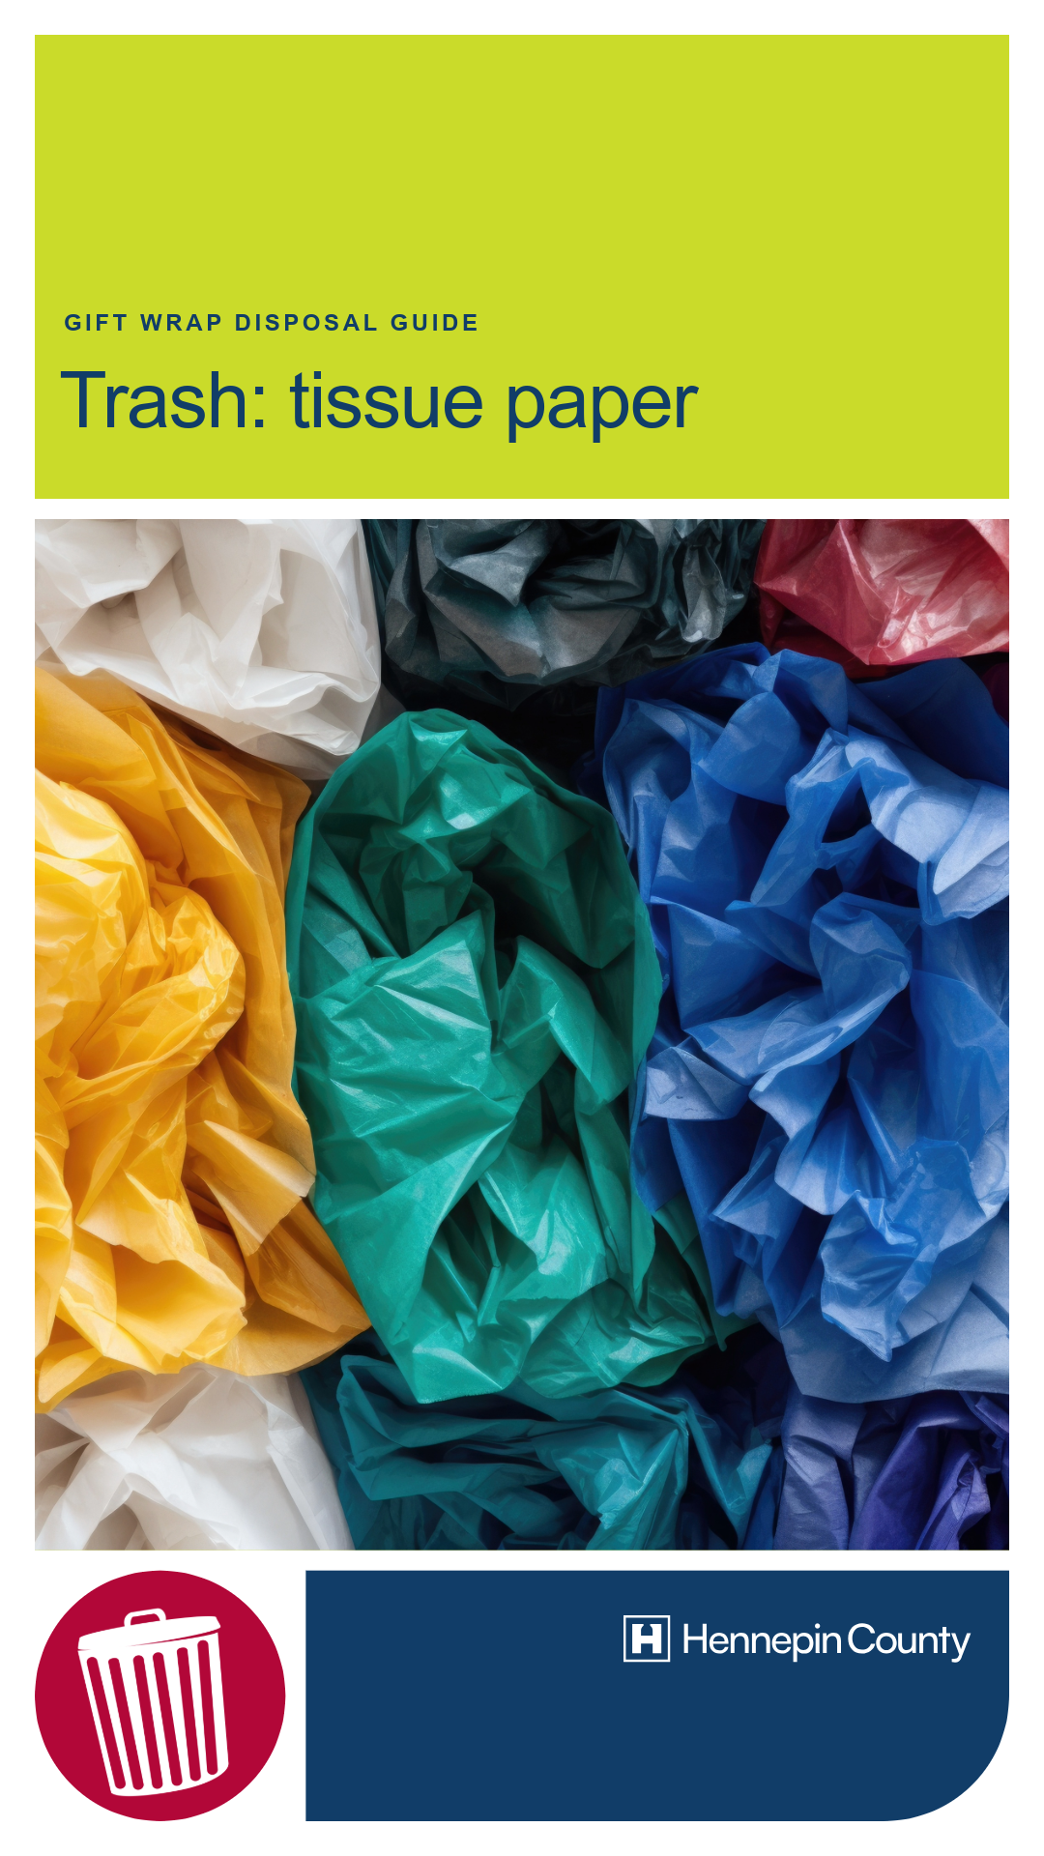

Holiday tree disposal – newsletter

Holiday tree disposal – feed posts

Holiday tree disposal – stories
