

Community Recycling Ambassadors media kit

About the Community Recycling Ambassadors program
To help residents take action for the environment, Hennepin County offers a Community Recycling Ambassador program. During a six-week course, Community Recycling Ambassador volunteers learn about waste prevention, recycling, and composting from industry experts. They then commit to volunteering 30 hours to inspire others in their communities to reduce waste, recycle more, and compost. Hennepin County is holding two rounds of the Community Recycling Ambassador trainings in 2025, one in the spring and one in the fall. See below for class dates and application details.

Help spread the word
Please share the promotional messaging with the communities you work with. You can download campaign assets below.
- Use the sample newsletter article to share on your organization’s website or in your newsletters. These are editable so you can customize the length or message.
- Use the sample social media posts to share through your social media channels. These are editable so you can customize the message and website.
- Download and print the Community Recycling Ambassadors flyer.
- Follow and reshare messages posted on the Hennepin County Environment and Energy social media channels: Hennepin Environment on Facebook, Hennepin Environment on Instagram, and @hennepinenviro on Twitter
- Share the information and resources available at hennepin.us/recycling-ambassadors

Contact
Community Recycling Ambassador coordinator, Kirsten Wahlberg, kirsten.wahlberg@hennepin.us

Upcoming Community Recycling Ambassador trainings

Fall 2025 class
The fall 2025 class will be held in-person every Tuesday from September 9 through October 14 from 5:30 to 7:30 p.m. in the St. Louis Park Library meeting room (3240 Library Lane, St Louis Park).
The application for the fall class will open on Tuesday, August 5 and close on Tuesday, August 26.
Before applying, please ensure that you meet the following requirements:
- You are 18 years of age or older
- You live, work, or go to school within Hennepin County
- You are available for all six class sessions
- You can commit to 30 hours of volunteering after the class completes
Visit the website to learn more about the program and apply.
Sign up to be notified about future Community Recycling Ambassador courses.

Contact
For more information about the Community Recycling Ambassador program, contact Kirsten Wahlberg, Waste Reduction and Recycling Specialist, at kirsten.wahlberg@hennepin.us.

Promotional resources
Use the sample newsletter article and social media posts below to promote the program.

Become a Community Recycling Ambassador
If you are looking for ways to volunteer in your community, consider becoming a Hennepin County Community Recycling Ambassador!
Community Recycling Ambassadors are trained on waste prevention, recycling and composting, and effective communication skills through a six-week course, with one class each week, taught by industry experts and community leaders. This training program is free to participants.
Once training is complete, participants commit to 30 hours of volunteering putting their skills to work on projects and activities that minimize waste and provide waste reduction, recycling and composting education.

Apply for the fall 2025 class
The fall 2025 class will be held in-person every Tuesday from September 9 through October 14 from 5:30 to 7:30 p.m. in the St. Louis Park Library meeting room (3240 Library Lane, St Louis Park).
The application for the fall class will open on Tuesday, August 5 and close on Tuesday, August 26.
Before applying, please ensure that you meet the following requirements:
- You are 18 years of age or older
- You live, work, or go to school within Hennepin County
- You are available for all six class sessions
- You can commit to 30 hours of volunteering after the class completes
Visit the website to learn more about the program and apply.

Social media posts
To use images and graphics: right click on image and select Save as Picture.

Post 1 – sign up to be notified of upcoming classes
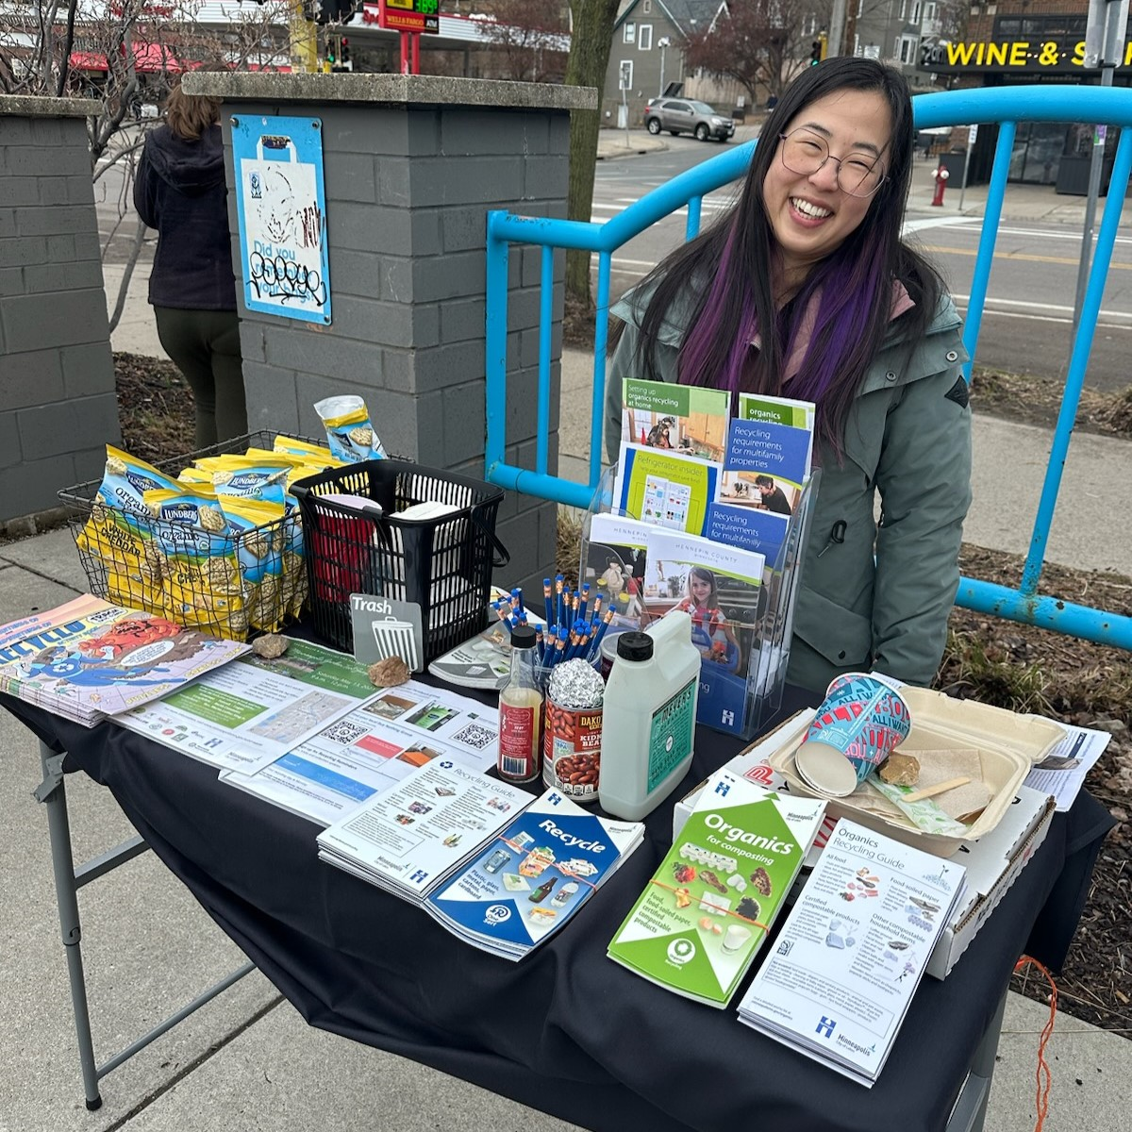
Facebook: If you are looking for ways to volunteer in your community, consider becoming a Community Recycling Ambassador! The application for the fall class will open on August 5. Learn more about the program and sign up to be notified when the application is open: hennepin.us/recycling-ambassadors
X/Twitter: If you are looking for ways to volunteer in your community, consider becoming a Community Recycling Ambassador! The application for the fall class will open on August 5. Sign up to be notified: hennepin.us/recycling-ambassadors #Volunteer #WasteReduction #Recycling #Composting
Instagram: If you are looking for ways to volunteer in your community, consider becoming a Community Recycling Ambassador! The application for the fall class will open on August 5. Learn more about the program and sign up to be notified when the application is open at the link in our bio. #Volunteer #WasteReduction #Recycling #Composting
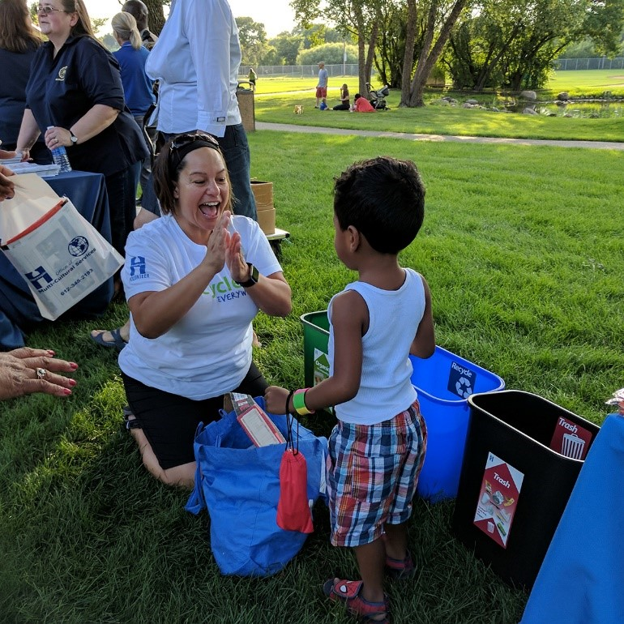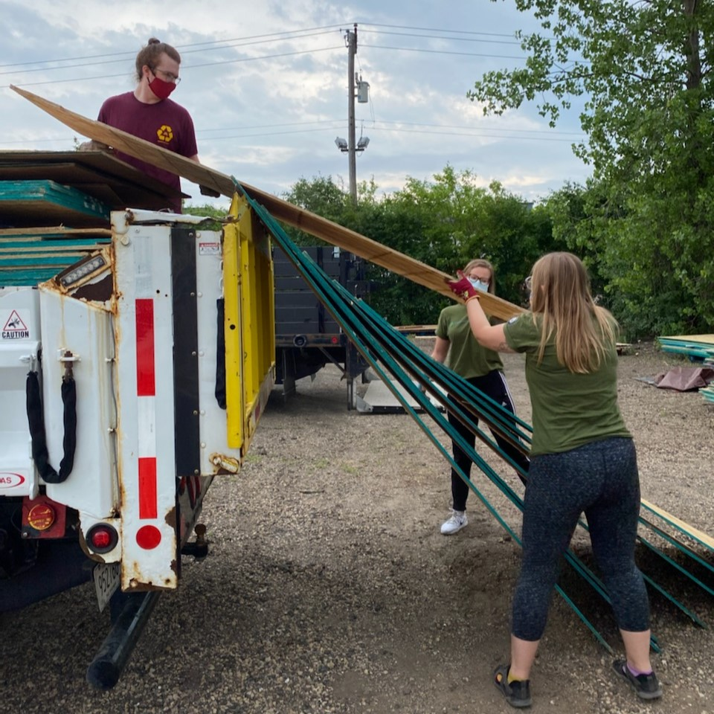

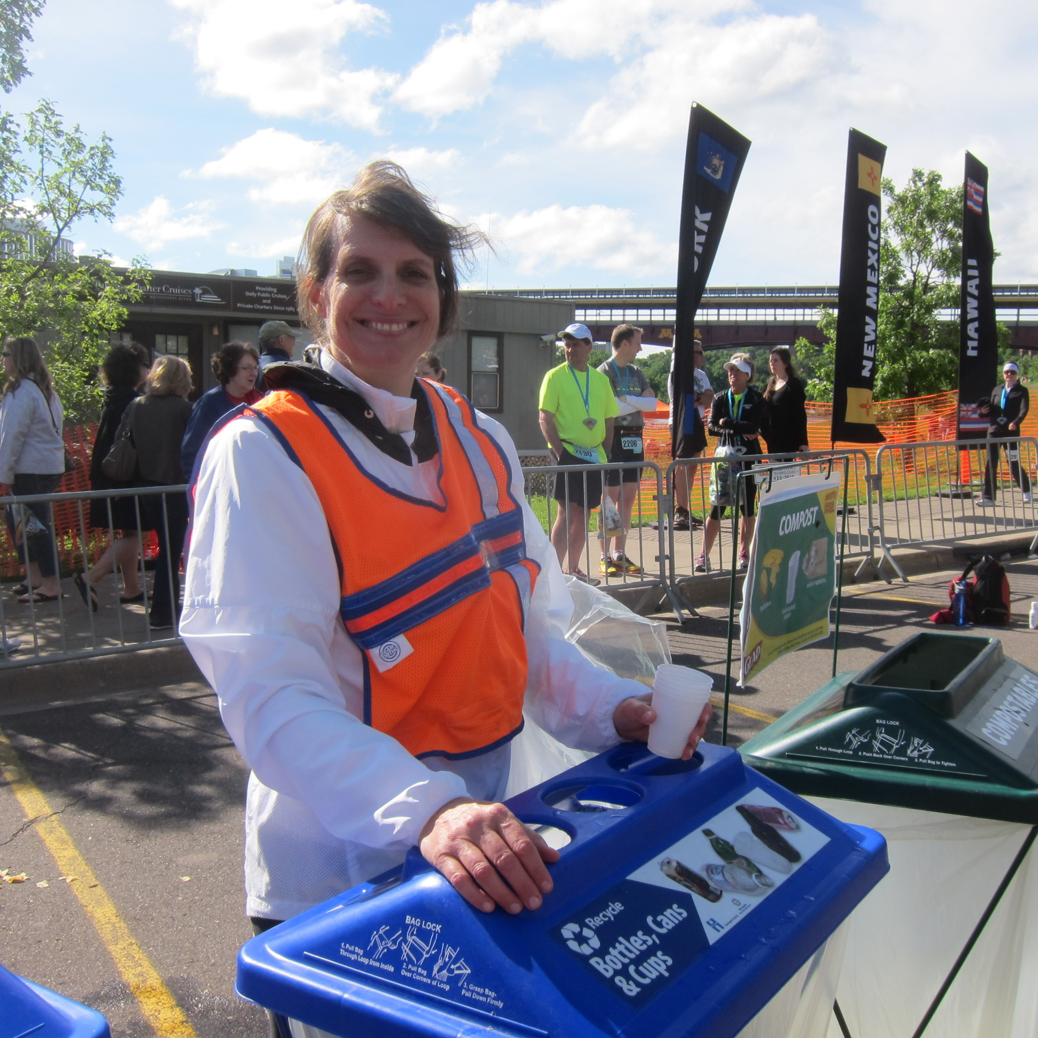
Post 2 – apply!
Facebook: Community Recycling Ambassadors are friendly sources of information on waste prevention, recycling, and composting. Volunteers put their skills to work on projects that minimize waste and educate their community about waste reduction, recycling, and composting. Are you ready to get involved? The application for the fall class closes on August 26. Apply now! hennepin.us/recycling-ambassadors
X/Twitter: Community Recycling Ambassadors are friendly sources of information on waste prevention, recycling, and composting. Are you ready to get involved? The application for the fall class closes on August 26. Apply now! hennepin.us/recycling-ambassadors #Volunteer #WasteReduction #Recycling
Instagram: Community Recycling Ambassadors are friendly sources of information on waste prevention, recycling, and composting. Volunteers put their skills to work on projects that minimize waste and educate their community about waste reduction, recycling, and composting. Are you ready to get involved? The application for the fall class closes on August 26. Apply now at the link in our bio. #Volunteer #WasteReduction #Recycling #Composting
