

Organics recycling basics media kit

About organics recycling

Organics recycling is the best opportunity to reduce our trash – about 25 percent what we throw away is organic materials like food scraps and compostable paper that could be put to better use as compost. Organics recycling involves collecting food scraps, non-recyclable paper, and other compostable products to be recycled into compost at a large-scale composting facility. This process creates a nutrient-rich material that can be used in gardens and landscaping projects.

Resources to promote organics recycling
Ways to educate the public about organics recycling and promote options for signing up include:
- Use the sample newsletter article to share on your organization’s website or in your newsletters. These are editable so you can customize the length or message.
- Use the sample social media posts to share through your social media channels. These are editable so you can customize the message and website.
- Share the organics recycling guide www.hennepin.us/-/media/hennepinus/residents/recycling/documents/residential-organics-recycling-guide.pdf. Printed copies can be ordered from https://environmentalresources.hennepin.us/items
- Share the organics recycling basics overview www.hennepin.us/-/media/hennepinus/business/work-with-hennepin-county/environmental-education-activities/what-is-organics-recycling.pdf
- Follow and reshare messages posted on the Hennepin County Environment and Energy social media channels: Hennepin Environment on Facebook and @hennepinenviro on Twitter
- Share the information and resources available at www.hennepin.us/organics

Contact
For more information about this topic, contact:
Kaitlin Steinberg, residential recycling coordinator, kaitlin.steinberg@hennepin.us
Alisa Reckinger, communications and outreach specialist, alisa.reckinger@hennepin.us

Sample newsletter article
To use images and graphics: right click on image and select save picture as

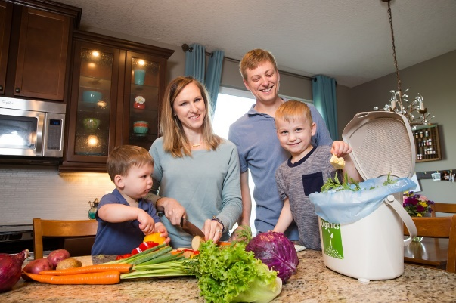
Give back to nature with organics recycling
Organics recycling is the best opportunity to reduce our trash. About 25 percent what we throw away is organic materials like food, napkins, paper towels, and certified compostable products that could be put to better use as compost.

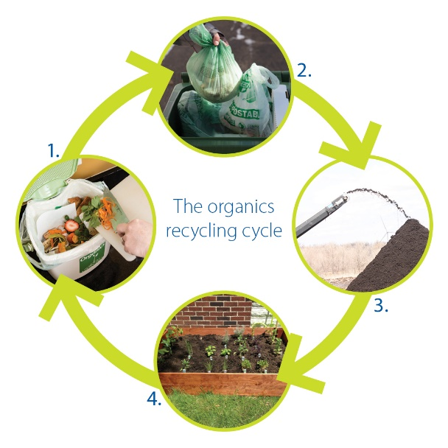
How it works
Organics are a resource, not a waste! Here’s how the organics recycling cycle works:
- You separate your food scraps, coffee grounds, paper towels, tissues and other organics into a certified compostable bag in your home.
- You put your bagged organics into the organics recycling cart provided by your hauler.
- Your hauler picks up your organics recycling and brings it to a commercial composting facility. In just a few months, the materials are recycled into nutrient-rich compost.
- Compost is used in gardens and at farms to add nutrients to the soil to help plants grow.

What is accepted?
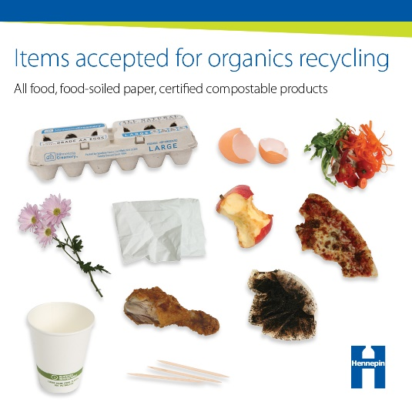
The following materials are accepted for organics recycling
- All food: Including fruits, vegetables, meat, bones, dairy products, eggshells, pasta, bread, and nuts
- Food-soiled paper: Pizza boxes from delivery, napkins, paper towels, and paper egg cartons
- Certified compostable products: Certified compostable paper and plastic cups, plates, bowls, utensils and containers. Look for the term “compostable” or the BPI logo on certified products.
- Other compostable household items: Including coffee grounds and filters, facial tissues, houseplants and flowers, and wooden items such as chopsticks, popsicle sticks, and toothpicks

Important items to keep out of the organics recycling
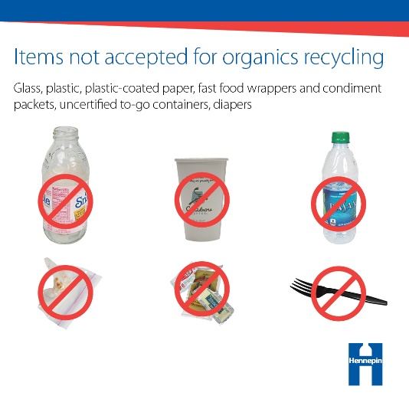
Compost sites need to receive organics with low levels of contamination, or materials that cannot be composted, so they can produce clean, nutrient-rich compost that people want to purchase and use. Compost that contains plastic, glass, and other contaminants is difficult to sell and can only be used for low-end, low-value purposes.
Some of the most important items to keep out of the organics recycling are:
- Glass
- Plastic items, including food stickers, utensils, and Styrofoam™
- Plastic-coated paper items like coffee and soda cups
- Fast food wrappers and condiment packets
- Uncertified to-go containers and not certified compostable products labeled “biodegradable”
- Diapers, sanitary products, and cleaning wipes
- Grease or oil

Make a difference with organics recycling
Participants in organics recycling programs say it’s a surprisingly easy way to make a difference. It provides a feel good benefit, helps the environment, and results in a visible reduction in trash. So get started with organics recycling today! Learn more and find options at www.hennepin.us/organics.

Social media posts
Suggested hashtags: #organicsrecycling #compost #HennepinZeroWaste
To use images and graphics: right click on image and select save picture as

Post 1: Give back to nature with organics recycling
Give back to nature with organics recycling! About 25 percent what we throw away is organic materials like food, napkins, paper towels, and certified compostable products that could be put to better use as compost. Learn more at www.hennepin.us/organics
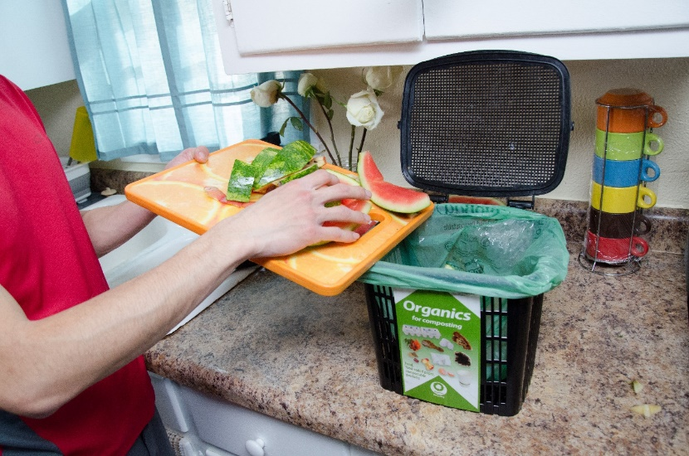

Post 2: The organics recycling cycle
Facebook and Instagram:
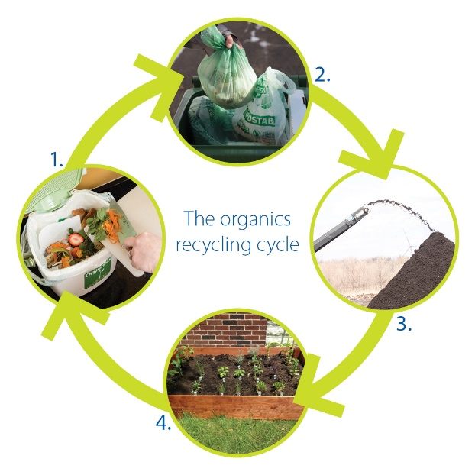
Organics are a resource, not a waste! Here’s how the organics recycling cycle works:
- You separate your food scraps, coffee grounds, paper towels, tissues and other organics into a certified compostable bag in your home.
- You put your bagged organics into the organics recycling cart provided by your hauler.
- Your hauler picks up your organics recycling and brings it to a commercial composting facility. In just a few months, the materials are recycled into nutrient-rich compost.
- Compost is used in gardens and at farms to add nutrients to the soil to help plants grow.
Learn more at www.hennepin.us/organics

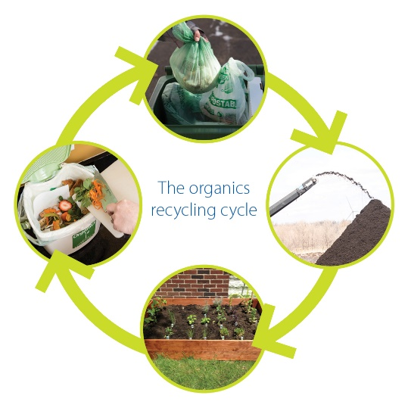
Twitter:
Organics are a resource, not a waste! In the organics recycling cycle, you separate food scraps and other organics at home. Your organics are delivered to a commercial composting facility. Compost is then used to improve soil and help plants grow. www.hennepin.us/organics

Post 3: Make a difference with organics recycling
Make a difference with organics recycling! Current participants say it’s a surprisingly easy way to make a difference. It provides a feel good benefit, helps the environment, and results in a visible reduction in trash. Learn more at www.hennepin.us/organics
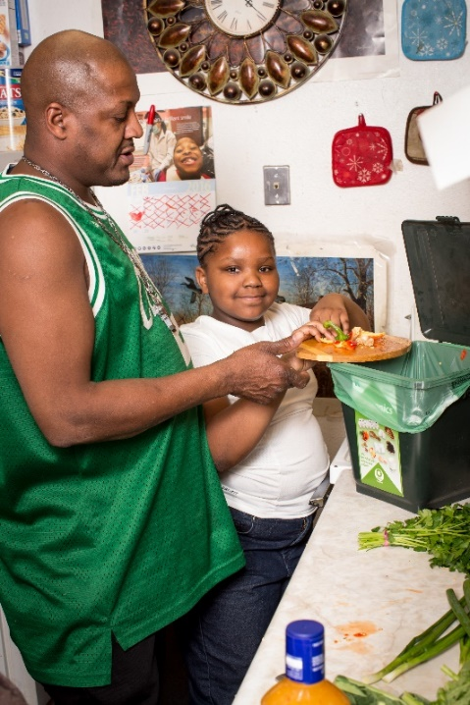

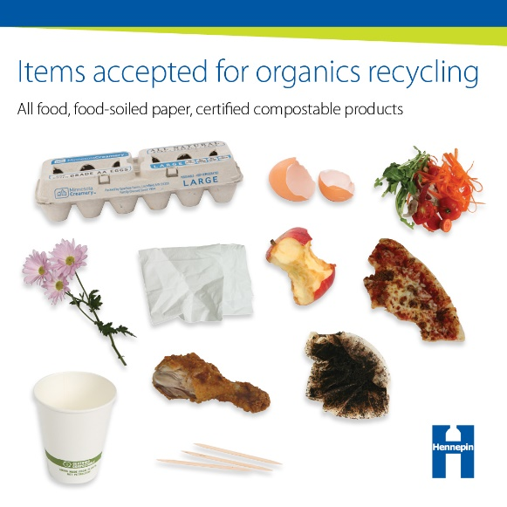
Post 4: What’s accepted for organics recycling
Put your trash to better use. With organics recycling, your food, coffee grounds, napkins, paper towels, certified compostable products, facial tissues, houseplants and flowers, toothpicks, and more can be turned into compost. Learn more at www.hennepin.us/organics

Post 5: Important items to leave out of the organics recycling
Putting the right things in the organics recycling ensures that compost sites can produce clean, nutrient-rich compost that people want to purchase and use. Keep out things like glass, plastic and plastic-coated items, and foil wrappers. Learn more www.hennepin.us/organics
