

Setting up organics recycling media kit

About organics recycling

Organics recycling is the best opportunity to reduce our trash – about 25 percent what we throw away is organic materials like food scraps and compostable paper that could be put to better use as compost. Organics recycling involves collecting food scraps, non-recyclable paper, and other compostable products to be recycled into compost at a large-scale composting facility. This process creates a nutrient-rich material that can be used in gardens and landscaping projects.

Resources to promote organics recycling
Ways to educate the public about organics recycling and how to get set up at home include:
- Use the sample newsletter article to share on your organization’s website or in your newsletters. These are editable so you can customize the length or message.
- Use the sample social media posts to share through your social media channels. These are editable so you can customize the message and website.
- Share the organics recycling guide www.hennepin.us/-/media/hennepinus/residents/recycling/documents/residential-organics-recycling-guide.pdf. Printed copies can be ordered from https://environmentalresources.hennepin.us/items
- Share the setting up organics recycling at home overview https://www.hennepin.us/-/media/hennepinus/business/work-with-hennepin-county/environmental-education-activities/setting-up-organics-recycling.pdf
- Follow and reshare messages posted on the Hennepin County Environment and Energy social media channels: Hennepin Environment on Facebook and @hennepinenviro on Twitter
- Share the information and resources available at www.hennepin.us/organics

Contact
For more information about this topic, contact:
Kaitlin Steinberg, residential recycling coordinator, kaitlin.steinberg@hennepin.us
Alisa Reckinger, communications and outreach specialist, alisa.reckinger@hennepin.us

Sample newsletter article: Getting set up
To use images and graphics: right click on image and select save picture as

Setting up organics recycling at home
Once you’re signed up or are ready to start organics recycling at home, there are a few steps you need to take to get started successfully. This includes making space for your cart, figuring out your set up room-by-room, and getting the supplies you need.

Making space for your cart
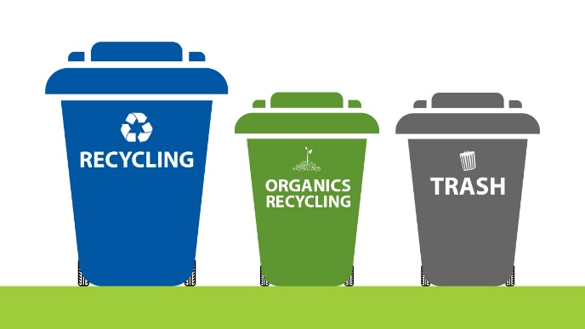
If you are getting a separate cart for organics recycling, determine where you will put your cart. It may work well to store your new cart next to your existing trash and recycling carts. Another option is to store it close to your back door or garage door, as you may be taking your organics out more frequently than your other waste. Figure out what’s most convenient for you!
To make space (and potentially save some money), you may be able to downsize to a smaller garbage cart. Contact your city or hauler for options.

Setting up room-by-room
Kitchen
It’s best to start in the kitchen as this is where most organics recycling is generated. You will generally need a collection container and compostable bags.
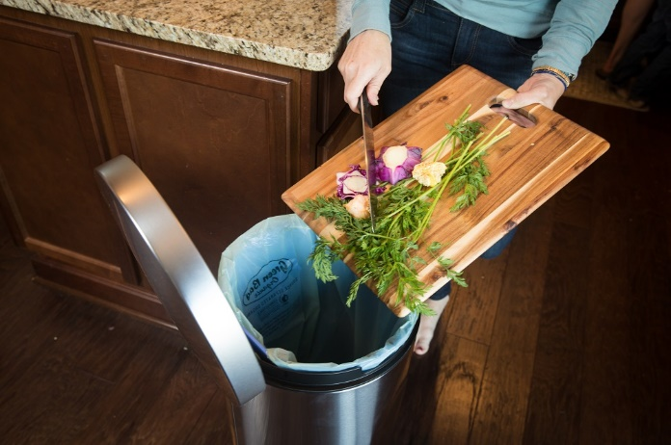
When you’re first getting started, it can be easiest to focus on collecting food. Spoiled food and food scraps are the most common material in the trash and are valuable in the composting process, which makes them the most important material to start collecting for organics recycling.
Once you are comfortable sorting your food scraps, start collecting napkins, paper towels, tissues and other non-recyclable or food-soiled paper for organics recycling as well. You can also add certified compostable paper and plastic plates, bowls, cups, containers, utensils, and other products
If you have issues with pests or smells or want your compostable bags to last longer, consider keeping a container in the fridge or freezer for “wet” organics like fruits, vegetables, and meat scraps.
Expand to other rooms
You can also collect organics in the bathroom, bedrooms and office. Remember items like tissues, paper towels, cotton balls, hair, and pet fur are accepted for organics recycling.

Getting the supplies you need
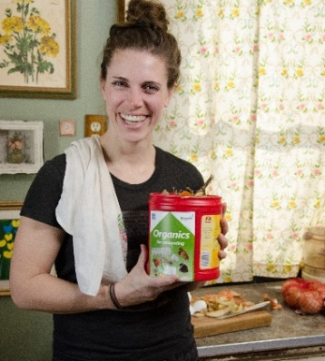
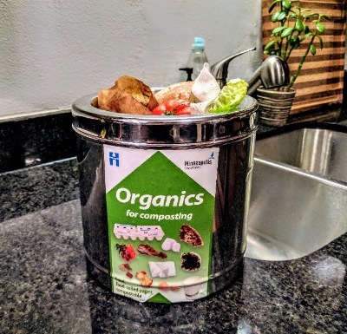
Collection containers
There are many options for collection containers. You can purchase simple to fancy countertop collection containers, convert an existing bin to an organics recycling bin, reuse a coffee can or ice cream pail, or use something as simple as a bowl on your kitchen counter. Choose something that works for you in your space.
Compostable bags
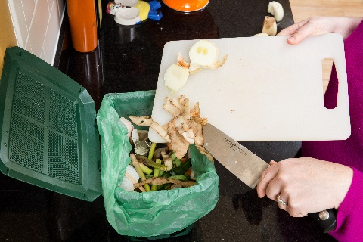
Most programs require that you bag your organics in certified compostable bags before placing it in your cart. These may be provided by your city or hauler, or they can be purchased at most retail or grocery stores or ordered online.
As you get started, you may want to try different brands as they will all perform differently. It may take some time to figure out what works best for you.
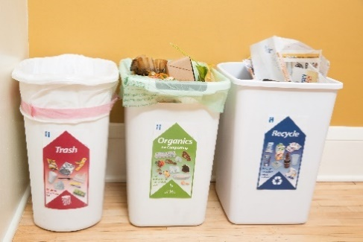
Also check to see what items need to be bagged for your program. Some programs allow you to put larger items like pizza boxes from delivery and paper egg cartons into your cart without being bagged.
Labels for your bins
Well-labeled bins help everyone in your household know what goes where. You can order labels at www.hennepin.us/organics or get creative and make your own!

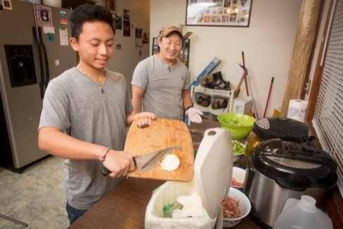
Get ready to make a difference with organics recycling
Once you’ve gathered everything you need and set up your collection containers both inside and outside your home, you’re ready to make a difference with organics recycling! Participants in organics recycling programs say it provides a feel good benefit, helps the environment, and results in a visible reduction in trash. Learn more about the impact you can have at www.hennepin.us/organics.

Social media posts
Suggested hashtags: #organicsrecycling #compost #HennepinZeroWaste
To use images and graphics: right click on image and select save picture as

Post 1: Getting started successfully
Once you’re ready to start organics recycling at home, there are a few steps you need to take to get started successfully. This includes making space for your cart, figuring out your set up room-by-room, and getting the supplies you need. Get tips at www.hennepin.us/organics
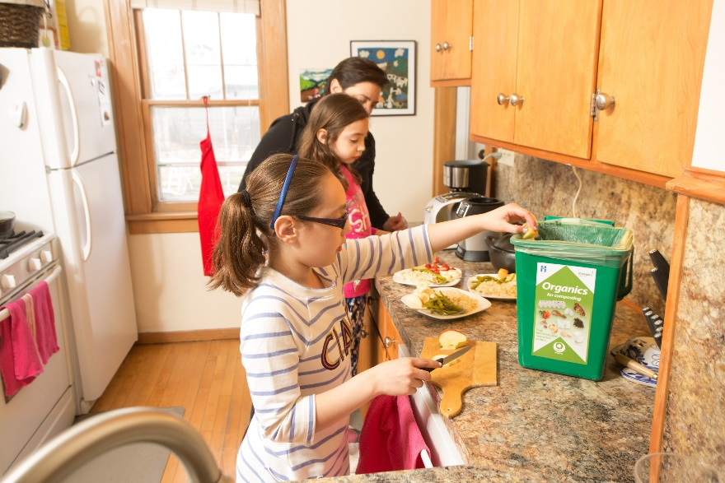

Post 2: Downsize your trash cart
To make space for your new organics recycling cart – and potentially save some money – you may be able to downsize to a smaller garbage cart. Contact your city or hauler for options. Learn more at www.hennepin.us/organics
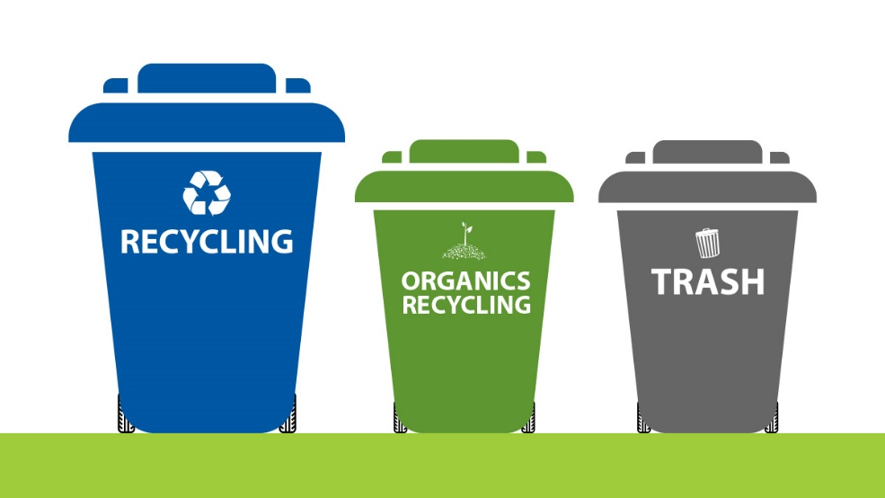

Post 3: Focus on collecting food
When you’re getting started with organics recycling, it can be easiest to focus on collecting food. Food is the most common material in the trash and is valuable in the composting process, making it the most important material to collect for organics www.hennepin.us/organics
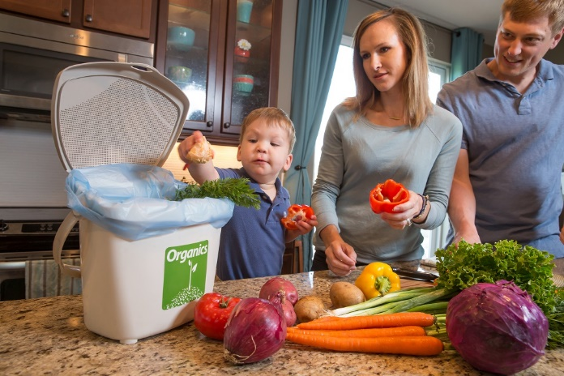

Post 4: Keep wet organics in the fridge or freezer
Organics recycling tip: If you have issues with pests or smells or want your compostable bags to last longer, consider keeping a container in the fridge or freezer for “wet” organics like fruits, vegetables and meat scraps. Learn more at www.hennepin.us/organics
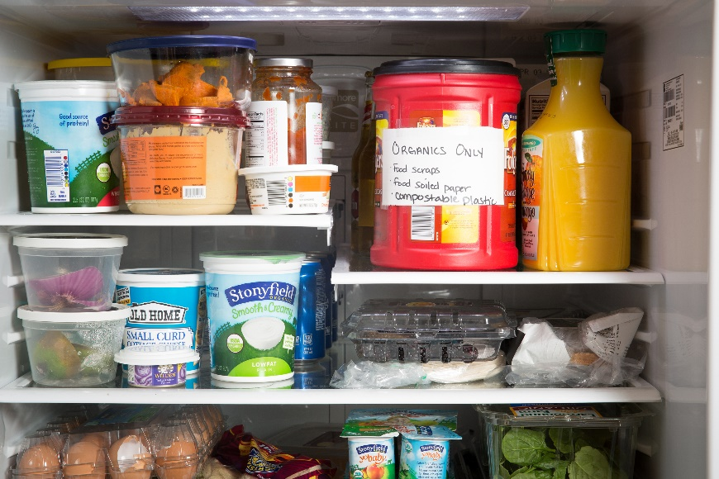

Post 5: Find a container that works for you
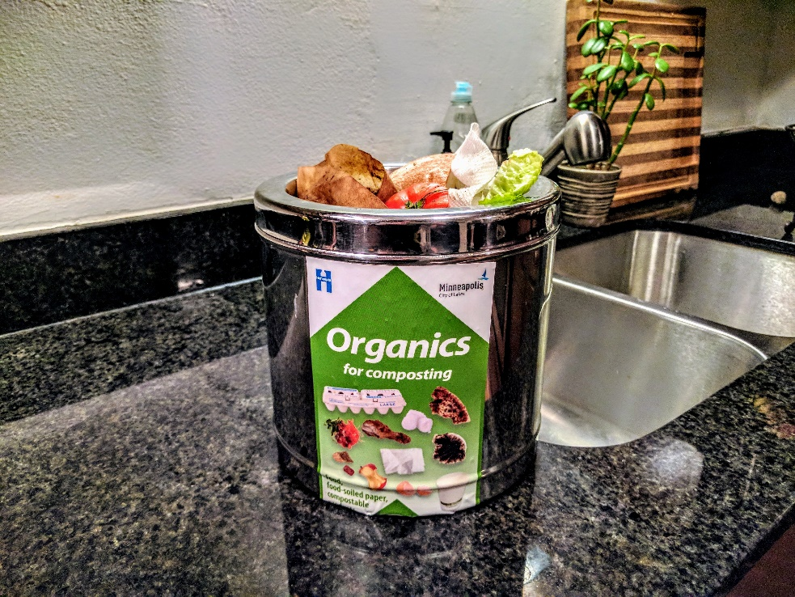
There are many options for organics recycling collection containers. From purchasing a fancy countertop container to reusing a coffee can or ice cream pail, find what works for you! Learn more at www.hennepin.us/organics
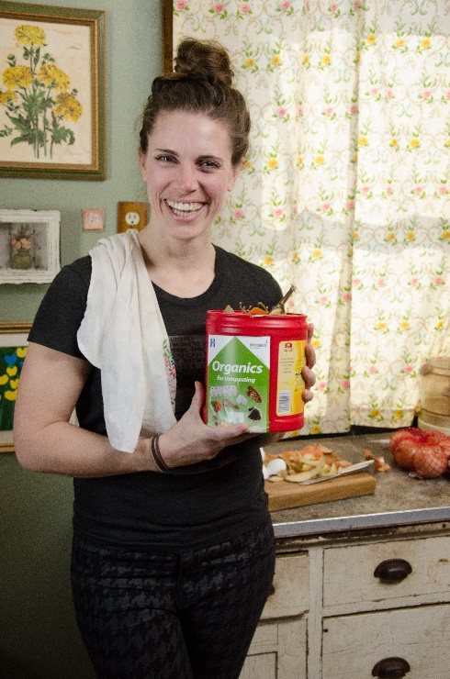

Post 6: Make a difference with organics recycling
Make a difference with organics recycling! Current participants say it’s a surprisingly easy way to make a difference. It provides a feel good benefit, helps the environment, and results in a visible reduction in trash. Learn more at www.hennepin.us/organics
