Promotional materials for the Plastic-Free Challenge

About the challenge
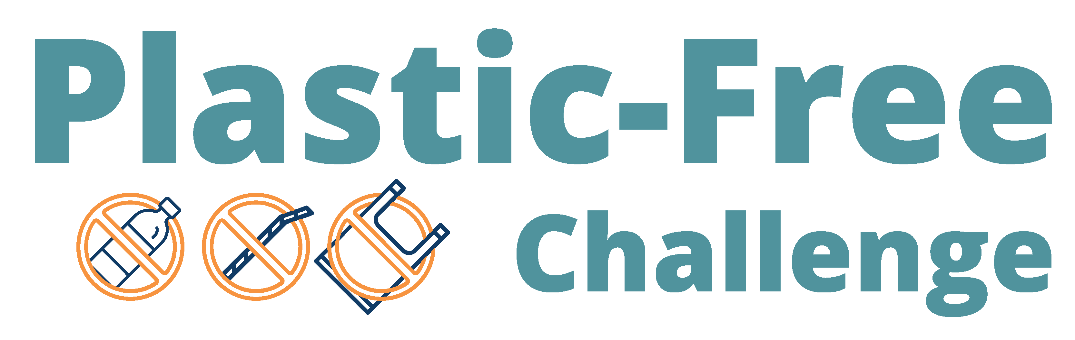
Although plastic is a versatile material with many uses, it can also present health risks, contribute to litter and pollution, and be confusing to dispose of. Some of the most common and problematic plastic items we deal with every day come in the form of packaging and single-use plastics.
The Plastic-Free Challenge (tcplasticfree.ecochallenge.org) engages residents in learning about plastics and plastic waste and committing to actions that help create a world with less plastic. The challenge has over 80 actions to choose from in eight categories. Participants can check off things they already do then select up to five one-time actions and five daily actions. They will track their progress using those new strategies during the four-week challenge.
Participants can create or join a team to take the challenge along with their family, friends, or neighbors. Organizations and businesses, including community groups, neighborhoods, schools, retailers, and more, can become Plastic-Free Challenge partners. Partners help promote the challenge and recruit participants. The online Plastic-Free Challenge is offered in partnership with Hennepin County, Ramsey County, and Washington County on the EcoChallenge platform.

Contact
For more information about the Plastic-Free Challenge, contact the Zero Waste Challenge coordinator at ZWC@hennepin.us

Help spread the word and encourage others to join
Some ways that you can help spread the word about the Plastic-Free Challenge and encourage others to join:
- Become a Plastic-Free Challenge partner (details on page 3).
- Download, print, and post or hand out flyers (linked on page 4) to promote the event and encourage others to join your team.
- Use the sample newsletter articles (on pages 5 – 8) to share on an organization’s website or in newsletters. These are editable so you can customize the length or message.
- Download additional resources from tcplasticfree.ecochallenge.org/about/resources.
- Create a team or join an existing team and invite people you know to join you. Your teammates will keep each other motivated and accountable. Invitations can be sent through the Plastic-Free Challenge website (tcplasticfree.ecochallenge.org) by clicking the “Invite teammates” button in your Dashboard.
- Use the sample social media posts and graphics (starting on page 9) to share on your social media channels. These are editable so you can customize the message. Use #PlasticFree.
- Follow and reshare messages posted on the Hennepin, Ramsey, and Washington counties’ social media channels:
  - Hennepin County:
    - Hennepin Environment on Facebook
    - @hennepinenvironment on Instagram
    - @HennepinEnviro on X
  - Ramsey County:
    - Ramsey County Minnesota on Facebook
    - @ramseycountymn on Instagram
    - @RamseyCounty on X
  - Washington County:
    - Washington County MN on Facebook
    - @WashingtonCoMN on X

Become a Plastic-Free Challenge partner
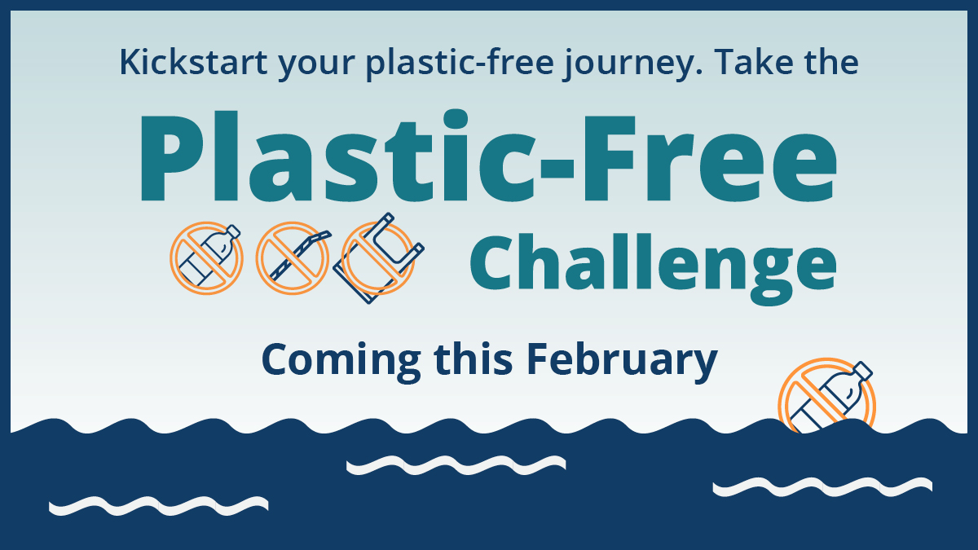
The Plastic-Free Challenge (tcplasticfree.ecochallenge.org), offered by Hennepin, Ramsey, and Washington counties, engages residents in learning about plastics and taking action to create a world with less plastic.
We can’t do it alone! We need your organization’s help with promotion and engagement for the upcoming Plastic-Free Challenge, which will run in February 2026.
All partners will have their logo displayed on the challenge website, gain access to promotional materials, and get various recognition and cross-promotion during the challenge. There is no cost to becoming a partner. Being a challenge partner shows your organization’s commitment to sustainability, helps build community, and promotes collective action.
See the Plastic-Free Challenge partnership page to learn how to become a 2026 Plastic-Free Challenge partner and fill out the partnership form. Businesses, community groups, cities, neighborhoods, schools, and retailers are welcome to be partners.

What does it mean to be a partner?
There are many ways to be a partner in the Plastic-Free Challenge. Here are some ways we ask partners to get involved. Find the way that works for you!
- Expanding our reach by promoting the challenge to your audiences.
- Strengthening engagement in the challenge by creating teams of colleagues, friends, and neighbors who motivate and hold each other accountable.
- Increasing our impact by offering educational events on plastic-free topics or discounts on plastic-free goods and services.

Download and print posters:
Download these posters to help promote the challenge and encourage others to join your team:

Join our team
- Join our Plastic-Free Challenge team 11x17 poster (PDF)
- Join our Plastic-Free Challenge team 8.5x11 letter (PDF)

Proud to be a partner
- Proud to be a Plastic-Free Challenge partner 11x17 poster (PDF)
- Proud to be a Plastic-Free Challenge partner 8.5x11 letter (PDF)

Kickstart your plastic-free journey
- Kickstart your plastic-free journey 11x17 poster (PDF)
- Kickstart your plastic-free journey 8.5x11 letter (PDF)
- Kickstart your plastic-free journey half-page flyer (PDF)

Sample newsletter article (early promotions)
To use images and graphics: right click on the image and select Save as Picture.

Kickstart your plastic-free journey: Take the Plastic-Free Challenge
With so many single-use plastic items in our lives, avoiding them may feel overwhelming! Fortunately, there is a lot we can do to help create a world with less plastic. Are you up for the challenge? Join the Plastic-Free Challenge (tcplasticfree.ecochallenge.org) to explore what’s possible.
During the one-month challenge, you can focus on learning about plastic recycling, making plastic-free swaps, and advocating for changes in your community. As part of a community acting together, see how our individual actions add up to a big impact!

About the Plastic-Free Challenge
The Plastic-Free Challenge is a month-long effort starting February 1 to reduce plastic consumption, especially single-use plastics, in ways that fit best in your lifestyle. Businesses, organizations, and community groups can also join the challenge as Plastic-Free Challenge partners.
The challenge runs during the month of February. Registration opens on January 1. Sign up to be notified when registration opens.

Sample newsletter article (long)

Kickstart your plastic-free journey: Take the Plastic-Free Challenge
With so many single-use plastic items in our lives, avoiding them can feel overwhelming. Fortunately, there is a lot we can do to help create a world with less plastic. Are you up for the challenge? Join the Plastic-Free Challenge (tcplasticfree.ecochallenge.org) to explore what’s possible.
During the one-month challenge, you can learn about plastic recycling, make plastic-free swaps, and advocate for changes in your community. By joining a community acting together, you’ll see how our individual actions add up to a big impact!
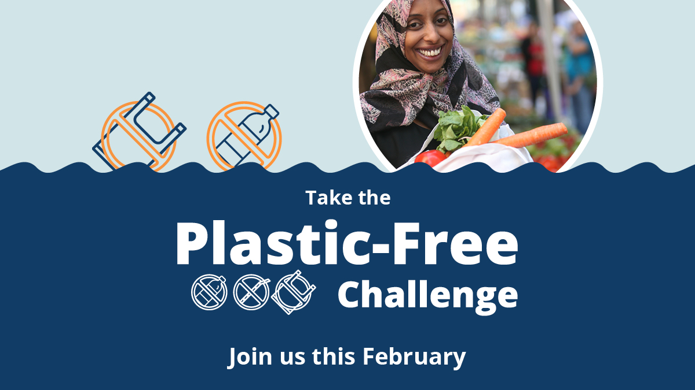

The problem with plastics
Worldwide, plastic production has skyrocketed since the 1970s, and a lot of the growth has come in the form of packaging and single-use plastics.
Most plastics are made from oil and gas – fossil fuels that contribute to climate change. About 4% to 8% of the world's oil production is for plastics, and most plastics are thrown away after a single use.
Since packaging and single-use plastics are used for a short period of time and then discarded, they contribute significantly to the increasing amounts of plastic waste and litter. Recycling can be a good option for certain plastic items. However, many types of plastics are not recyclable.
Unlike items made from natural materials like plants that can be composted and returned to the soil, plastics don’t go away. Instead, they break down into smaller pieces of plastic. These microplastic pieces are now found almost everywhere, including in our air, water, soil, and bodies.
Joining the Plastic-Free Challenge helps you be part of the solution. You will increase your understanding of plastics and plastic waste, uncover opportunities to bring less plastic into your home, and be connected with opportunities to advocate for change in your community.

About the Plastic-Free Challenge
The Plastic-Free Challenge is a month-long effort starting February 1 to reduce plastic consumption, especially single-use plastics, in ways that best fit your lifestyle.
The challenge has over 80 actions to choose from in eight categories. Sign up opens on January 1, and the challenge runs throughout February. Once you sign up and create your profile, you can browse the categories and actions, check off the actions you already take, and select up to five one-time actions and five daily actions to make progress on during the four-week challenge.
You can also create a team to take the challenge along with your family, friends, neighbors, and colleagues. Or encourage an organization, business, or community group you are a part of to become a Plastic-Free Challenge partner.
Once the challenge starts, you will report what actions you take, see the impact of your actions add up, connect with others, and support your team members to keep them motivated and accountable. You’ll earn points for your actions and engagement throughout the challenge, so you can see how you and your team stack up against others,
Hennepin, Ramsey, and Washington counties are working together to reduce plastic waste as part of their efforts to increase recycling, reduce waste, and achieve their climate action goals. Encouraging residents to take action is critical to success. The online Plastic-Free Challenge is hosted on the EcoChallenge platform.
Learn more, sign up, and get ready to kickstart your plastic-free journey at tcplasticfree.ecochallenge.org.

Sample newsletter article (short)

Kickstart your plastic-free journey: Take the Plastic-Free Challenge
With so many single-use plastic items in our lives, avoiding them can feel overwhelming. Fortunately, there is a lot we can do to help create a world with less plastic. Are you up for the challenge? Join the Plastic-Free Challenge (tcplasticfree.ecochallenge.org) to explore what’s possible.
During the one-month challenge, you learn about plastic recycling, make plastic-free swaps, and advocate for changes in your community. By joining a community acting together, you’ll see how our individual actions add up to a big impact!

About the Plastic-Free Challenge
The Plastic-Free Challenge is a month-long effort starting February 1 to reduce how many plastics you use in your life in ways that best fit your lifestyle and have the most impact on reducing your footprint.
The challenge has over 80 actions to choose from in eight categories. Sign up opens on January 1, and the challenge runs throughout February. Once you sign up and create your profile, you can browse the categories and actions, check off the things you already do, and select up to five one-time actions and five daily actions to try during the challenge.
You can also create a team to take the challenge along with your family, friends, neighbors, and colleagues. Or encourage an organization, business, or community group you are a part of to become a Plastic-Free Challenge partner.
Learn more, sign up, and get ready to kickstart your plastic-free journey at tcplasticfree.ecochallenge.org.

Social media posts (early promotions)
To use images and graphics: right click on the image and select Save as Picture.
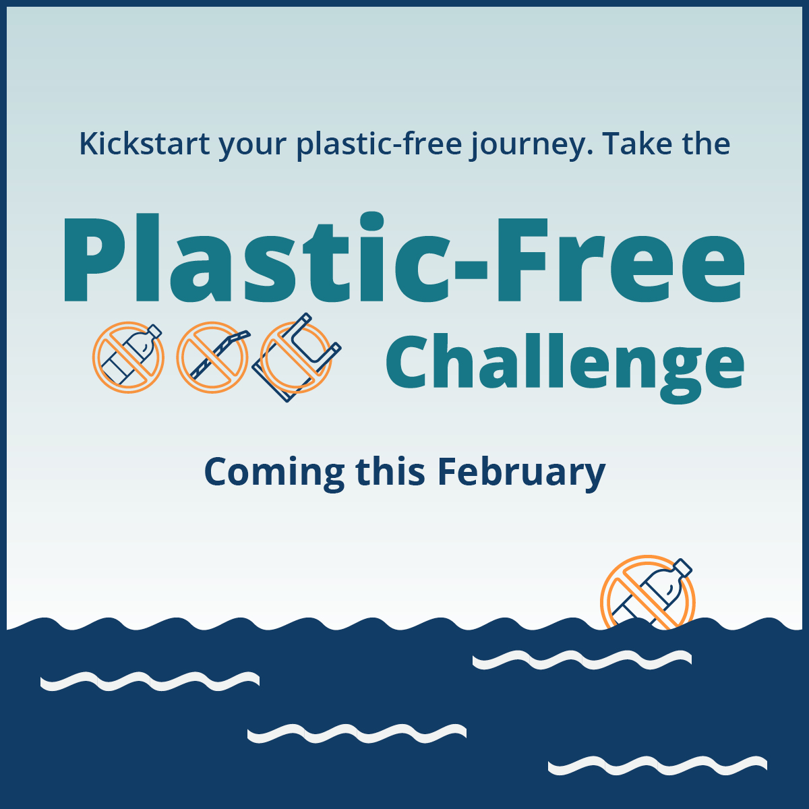
Suggested hashtags: #PlasticFreeChallenge #PlasticFree #ZeroWaste

Get notified when sign up is open

Facebook:
Kickstart your plastic-free journey with the Plastic-Free Challenge this February! Be part of the solution to reduce waste, protect water and wildlife, address climate change, and look after the health of ourselves and future generations. Get notified when sign up opens: public.govdelivery.com/accounts/MNHENNE/signup/38814

X:
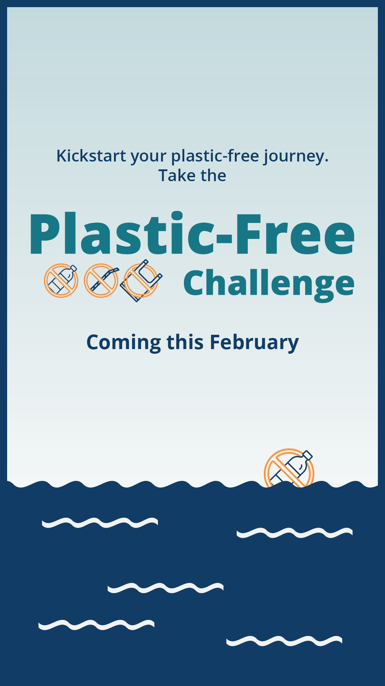
Kickstart your plastic-free journey with the Plastic-Free Challenge this February! Be part of the solution to reduce waste, protect water and wildlife, and address climate change. Get notified when sign up opens: public.govdelivery.com/accounts/MNHENNE/signup/38814 #PlasticFreeChallenge

Instagram:
Are you ready to try going plastic-free this February? Be part of the solution to reduce waste, protect water and wildlife, address climate change, and look after the health of ourselves and future generations. Get notified when sign up for the Plastic-Free Challenge opens at the link in our bio. #PlasticFreeChallenge #PlasticFree #ZeroWaste

Nextdoor:
Try going plastic-free this February! Be part of the solution to reduce waste, protect water and wildlife, address climate change, and look after the health of ourselves and future generations. Get notified when sign up for the Plastic-Free Challenge opens: public.govdelivery.com/accounts/MNHENNE/signup/38814

Social media posts
Suggested hashtags: #PlasticFreeChallenge #PlasticFree #ZeroWaste
Pair these messages with a graphic to promote the challenge (Find the full library of graphics starting on page 13 or download them from the resource page at tcplasticfree.ecochallenge.org/about/resources).

Post: Learn about plastics recycling
Facebook: Knowing what plastics can be recycled and which ones should be avoided entirely can be confusing! Join a community learning how to create a world with less plastic. Get started at tcplasticfree.ecochallenge.org
X: Knowing what plastics can be recycled and which ones should be avoided entirely can be confusing! Join a community learning how to create a world with less plastic. Get started at tcplasticfree.ecochallenge.org #PlasticFreeChallenge #ZeroWaste
Instagram: Knowing what plastics can be recycled and which ones should be avoided entirely can be confusing! Join a community learning how to create a world with less plastic. Get started at the link in our bio. #PlasticFreeChallenge #ZeroWaste

Post: Recycling is not a myth
Facebook: Recycling is real and it works when we recycle the right things. Plastic bottles, jugs, cups, and containers are recycled into new products, including plastic bottles, carpeting, decking, and lawn furniture. Find out what items can be recycled and what to keep out of your recycling bin. Learn more at tcplasticfree.ecochallenge.org
X: Recycling is real and it works when we recycle the right things. Plastic bottles, jugs, cups, and containers are recycled into new products like bottles, carpeting, and decking. Learn more at tcplasticfree.ecochallenge.org #PlasticFreeChallenge #PlasticFree #ZeroWaste
Instagram: Recycling is real and it works when we recycle the right things. Plastic bottles, jugs, cups, and containers are recycled into new products, including plastic bottles, carpeting, decking, and lawn furniture. Find out what items can be recycled and what to keep out of your recycling bin. Learn more at the link in our bio. #PlasticFreeChallenge #PlasticFree #ZeroWaste

Post: Protect water
Facebook: Clean water is essential, but unfortunately, plastics in our environment don't go away. Instead, they break down into smaller pieces of plastic that pollute our water and harm wildlife. This February, go plastic-free to protect our rivers and lakes. Kickstart your plastic-free journey at tcplasticfree.ecochallenge.org
X: Clean water is essential, but unfortunately plastics in our environment don’t go away. This February, go #PlasticFree to protect our rivers and lakes. Kickstart your plastic-free journey at tcplasticfree.ecochallenge.org #PlasticFreeChallenge #ZeroWaste
Instagram: Clean water is essential, but unfortunately, plastics in our environment don't go away. Instead, they break down into smaller pieces of plastic that pollute our water and harm wildlife. This February, go #PlasticFree to protect our rivers and lakes. Kickstart your plastic-free journey at the link in our bio. #PlasticFreeChallenge #ZeroWaste

Post: Protect wildlife
Facebook: Minnesota’s iconic animals, like loons, walleye, and bald eagles need an environment that is clean and free of plastic pollution. Protect wildlife by going plastic-free this February. Kickstart your plastic-free journey at tcplasticfree.ecochallenge.org
X: Minnesota’s wildlife need an environment that is clean and free of plastic pollution. Keep our iconic animals thriving by going #PlasticFree this February. Kickstart your plastic-free journey at tcplasticfree.ecochallenge.org #PlasticFreeChallenge #ZeroWaste
Instagram: Minnesota’s iconic animals, like loons, walleye, and bald eagles need an environment that is clean and free of plastic pollution. Protect wildlife by going #PlasticFree this February. Kickstart your plastic-free journey at the link in our bio. #PlasticFreeChallenge #ZeroWaste

Post: Protect the health of your family and future generations
Facebook: Plastics in our environment break down into tiny microplastics that have been found almost everywhere, including in our air, water, soil, and bodies. Reduce your family’s reliance on plastics to protect the health of your children and the environment for future generations. Kickstart your plastic-free journey at tcplasticfree.ecochallenge.org
X: Plastics in our environment break down into tiny microplastics that have been found almost everywhere, including in our air, water, soil, and bodies. Reduce your family’s reliance on #Plastics to protect their health. tcplasticfree.ecochallenge.org #PlasticFreeChallenge #ZeroWaste
Instagram: Plastics in our environment break down into tiny microplastics that have been found almost everywhere, including in our air, water, soil, and bodies. Reduce your family’s reliance on plastics to protect the health of your children and the environment for future generations. Kickstart your plastic-free journey at the link in our bio. #PlasticFreeChallenge #PlasticFree #ZeroWaste

Post: Advocate for change
Facebook: Ask your favorite restaurant to get rid of single-use plastic and support businesses that are taking action to help create a world with less plastic. Learn how to advocate for change in your community by joining the Plastic-Free Challenge at tcplasticfree.ecochallenge.org
X: Ask your favorite restaurant to get rid of single-use plastic and support businesses that are already taking action. Learn how to advocate for change in your community by joining the Plastic-Free Challenge at tcplasticfree.ecochallenge.org #PlasticFreeChallenge #ZeroWaste
Instagram: Ask your favorite restaurant to get rid of single-use plastic and support businesses that are taking action to help create a world with less plastic. Learn how to advocate for change in your community by joining the Plastic-Free Challenge at the link in our bio. #PlasticFreeChallenge #ZeroWaste

Post: Be an influencer
Facebook: Be a zero-waste leader by encouraging your family, friends, and community to join the Plastic-Free Challenge this February. By working together, we can create a world with less plastic. Kickstart your plastic-free journey at tcplasticfree.ecochallenge.org
X: Be a zero-waste leader by encouraging your family, friends, and community to join the Plastic-Free Challenge this February. By working together, we can create a world with less plastic. Get started at tcplasticfree.ecochallenge.org #PlasticFreeChallenge #ZeroWaste
Instagram: Be a zero-waste leader by encouraging your family, friends, and community to join the Plastic-Free Challenge this February. By working together, we can create a world with less plastic. Kickstart your plastic-free journey at the link in our bio. #PlasticFreeChallenge #ZeroWaste

Post: DIY/Self-sustaining
Facebook: Plastic packaging is often the default when shopping for food, personal care products, cleaning products, and more. Do your part to purchase alternative products with less packaging or learn to make your own. Learn how at tcplasticfree.ecochallenge.org
Twitter/X: Plastic packaging is often the default when shopping for food, cleaning products, and more. Do your part to purchase alternative products with less packaging or learn to make your own. Learn how at tcplasticfree.ecochallenge.org #PlasticFreeChallenge #PlasticFree #ZeroWaste
Instagram: Plastic packaging is often the default when shopping for food, personal care products, cleaning products, and more. Do your part to purchase alternative products with less packaging or learn to make your own. Learn how at the link in our bio. #PlasticFreeChallenge #PlasticFree #ZeroWaste

Library of social media graphics
Download full resolution graphics here: tcplasticfree.ecochallenge.org/about/resources
Pair the social media messages above with a graphic to promote the challenge.
To use images and graphics: right click on the image and select Save as Picture.

Square graphics
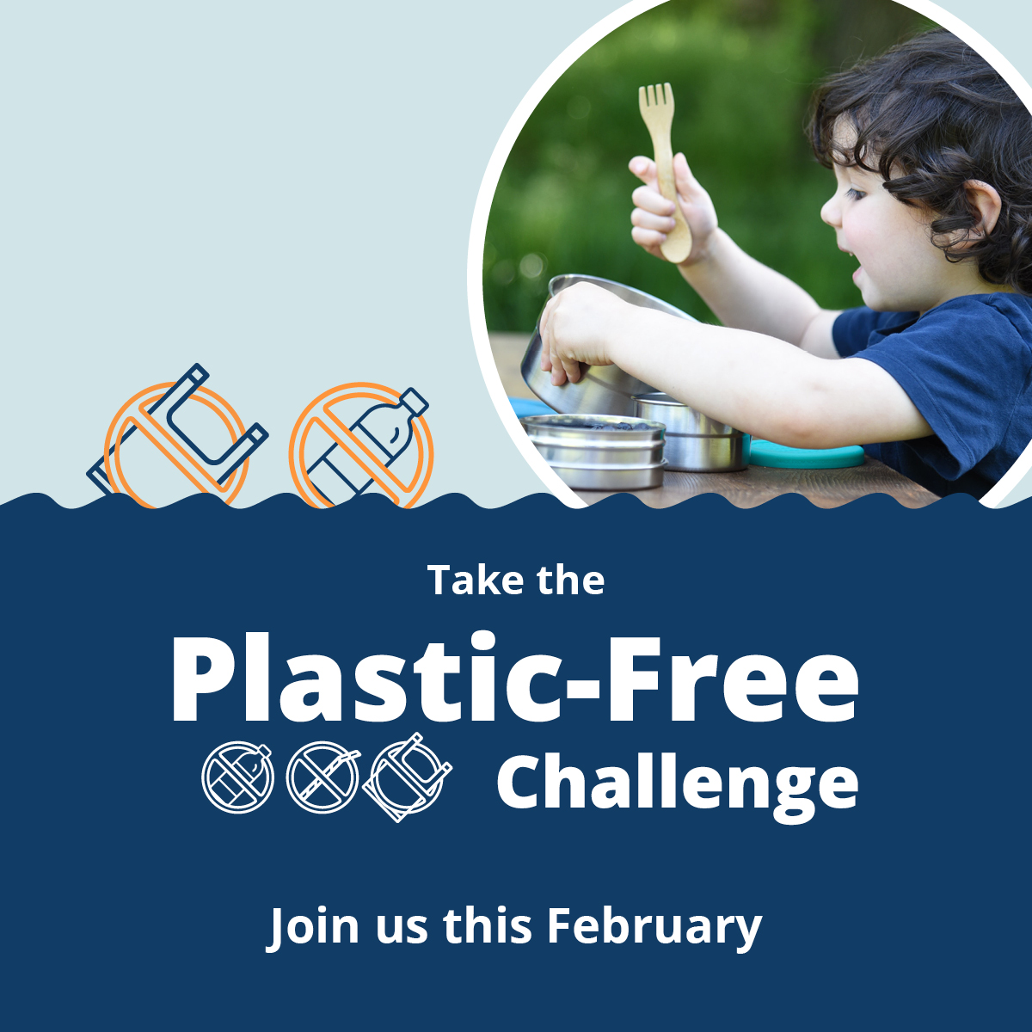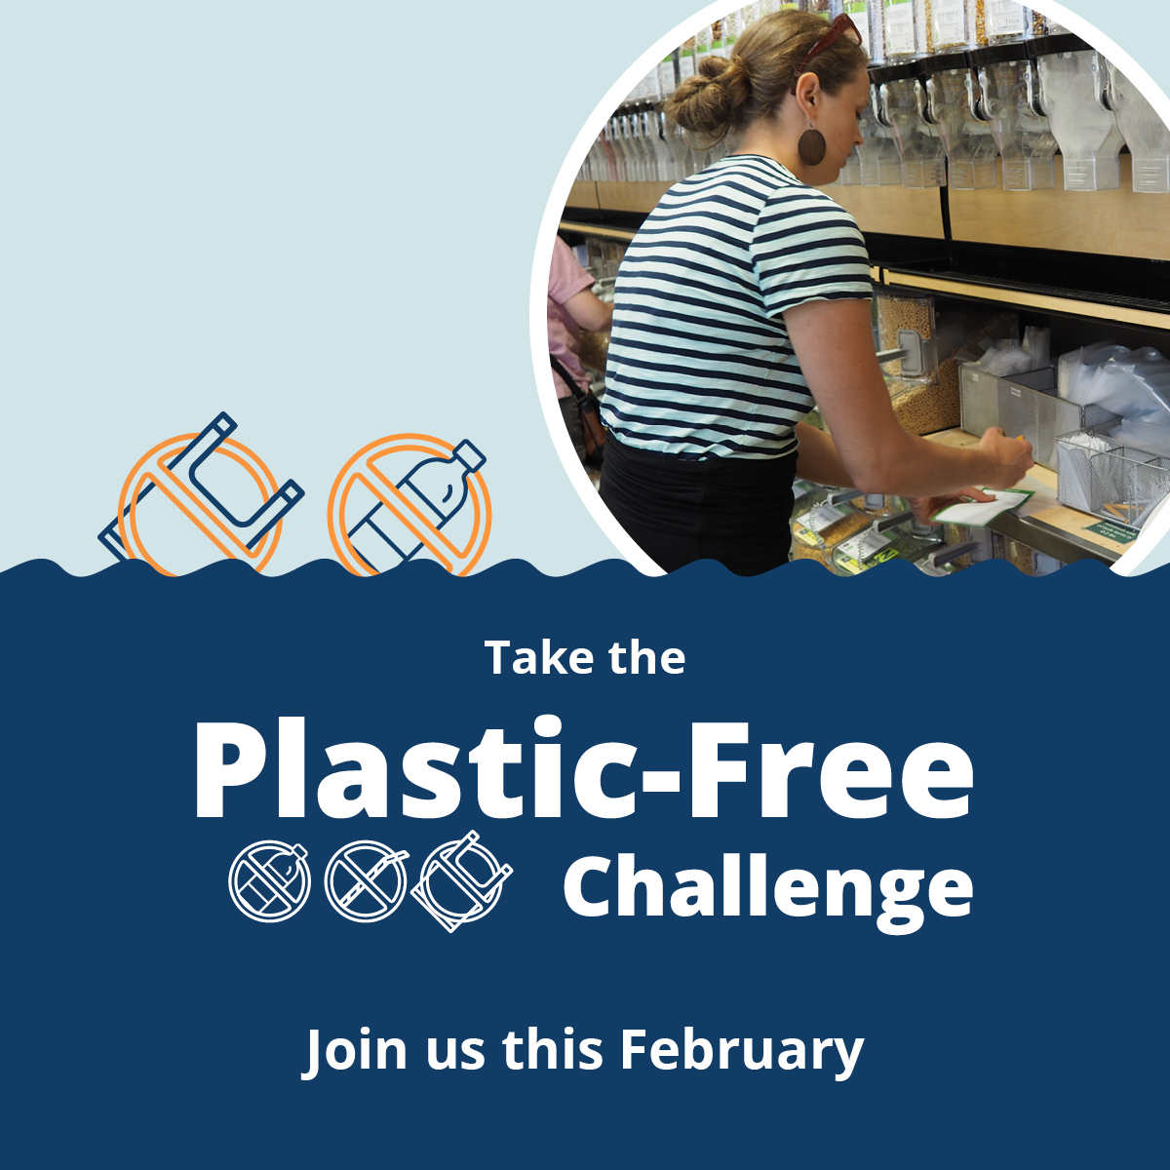
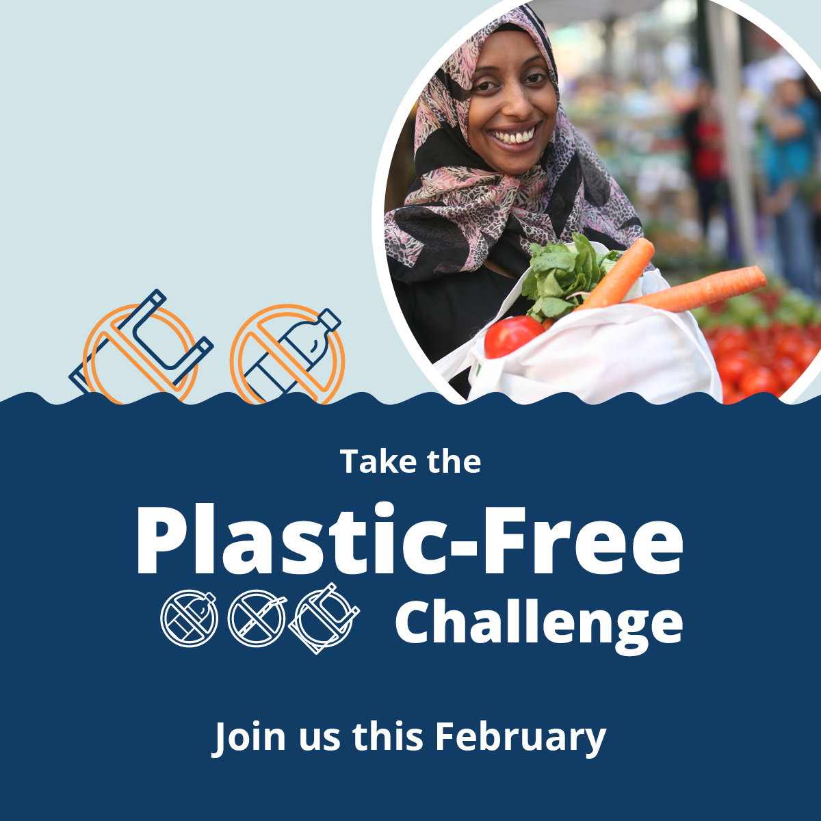
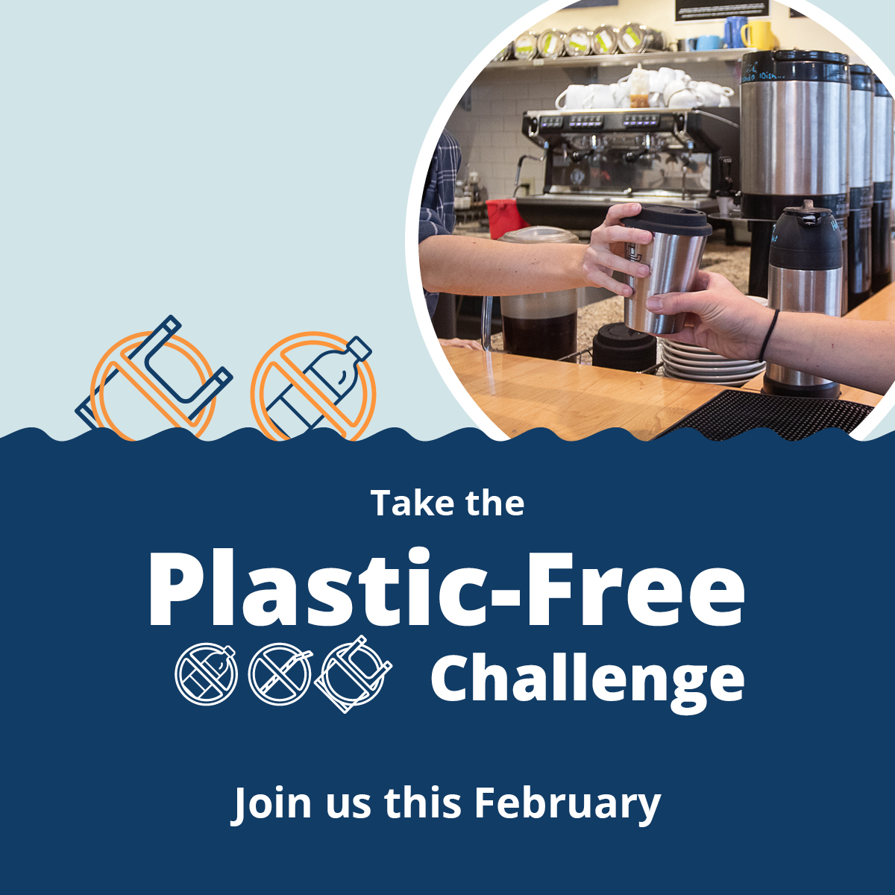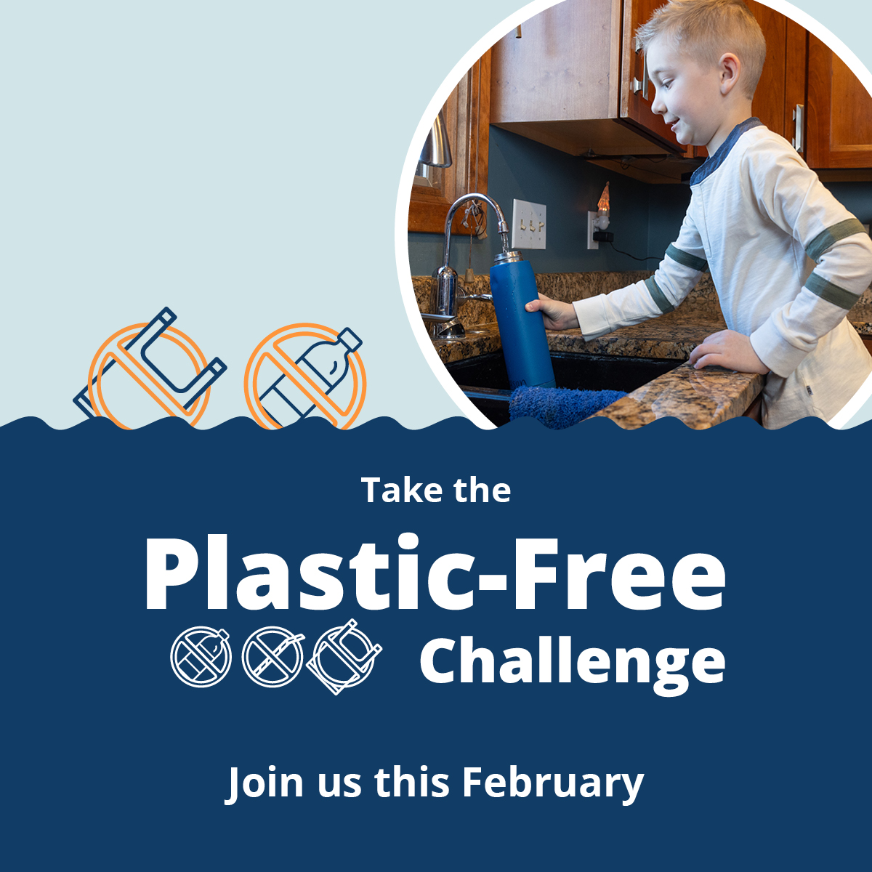

675x1200 rectangle graphics
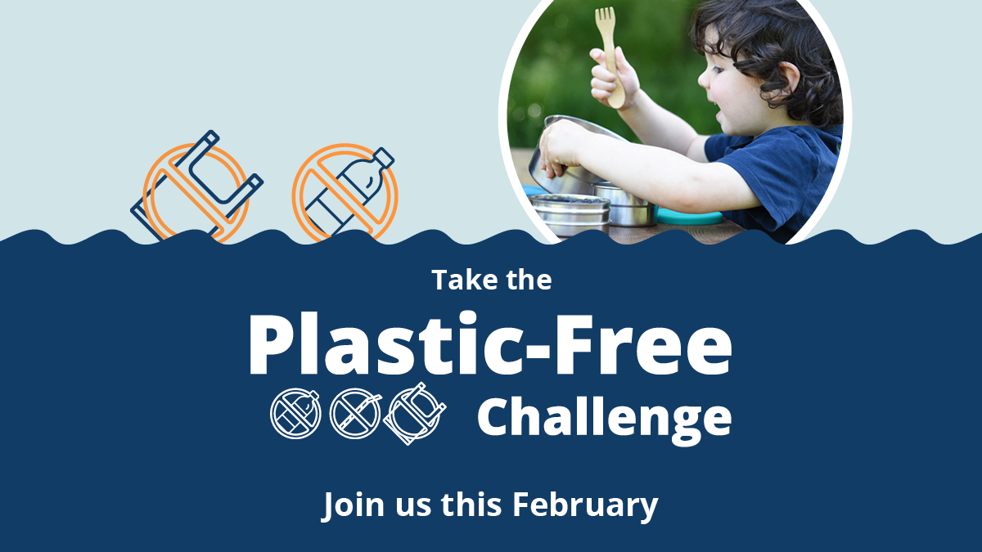
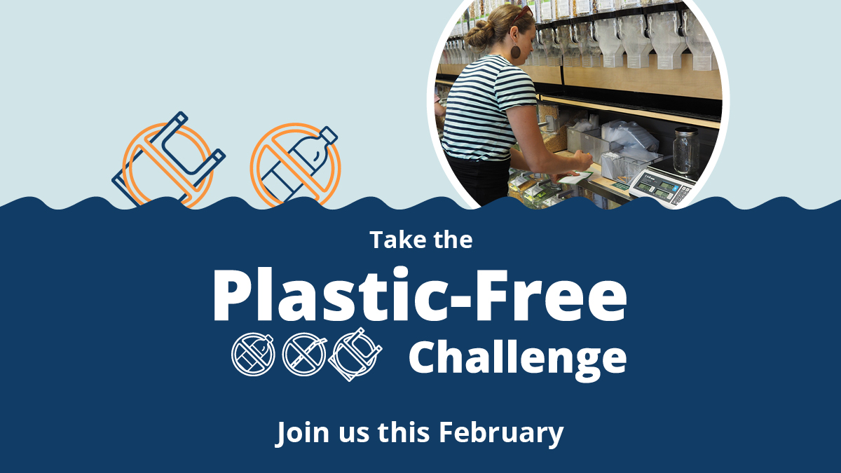
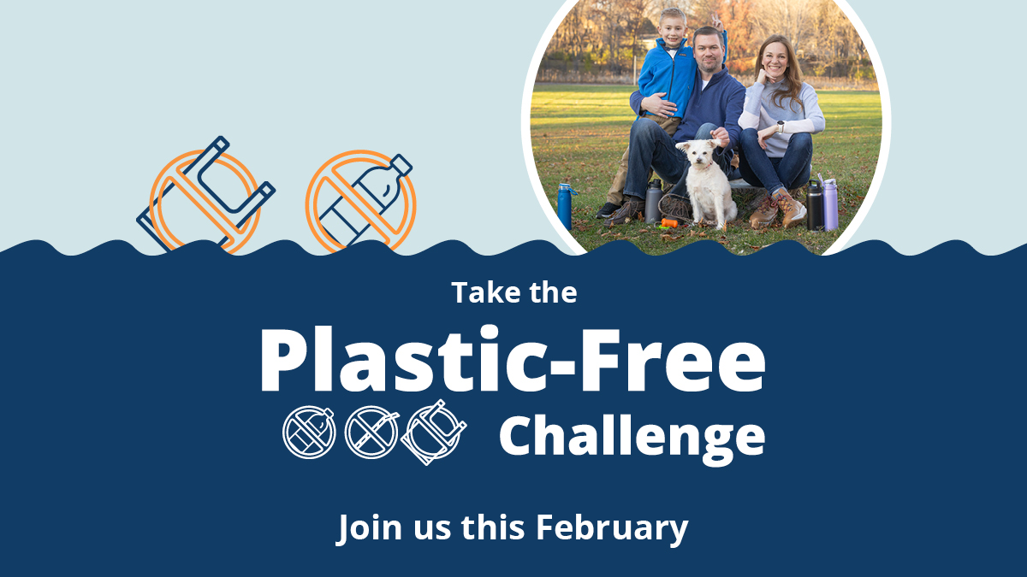
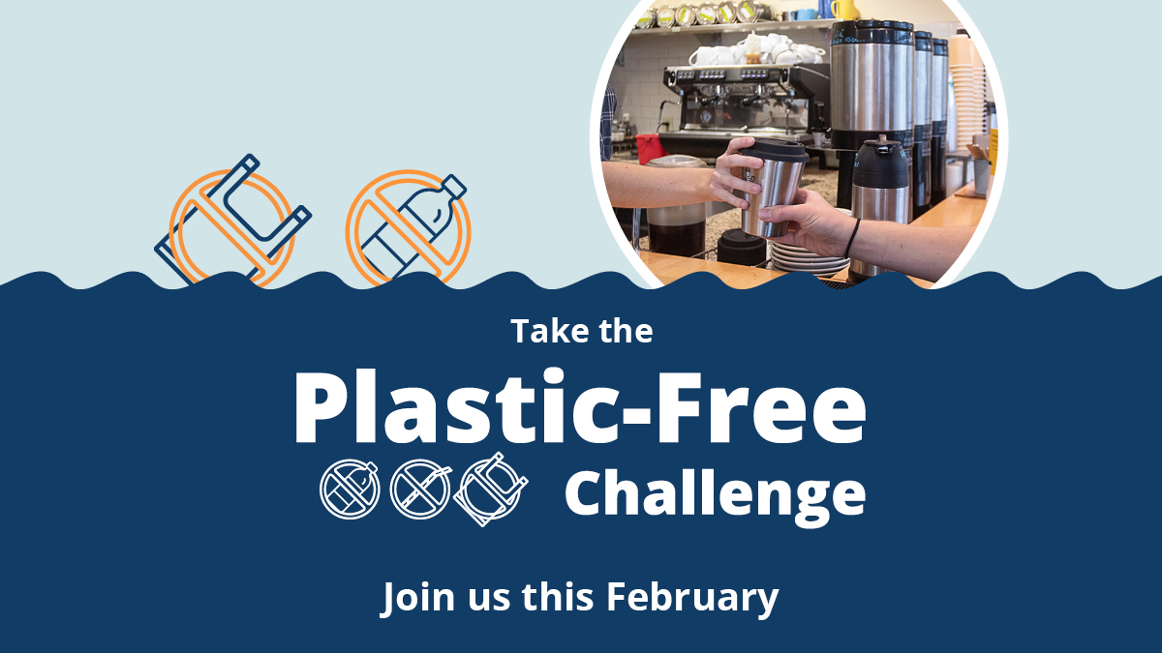
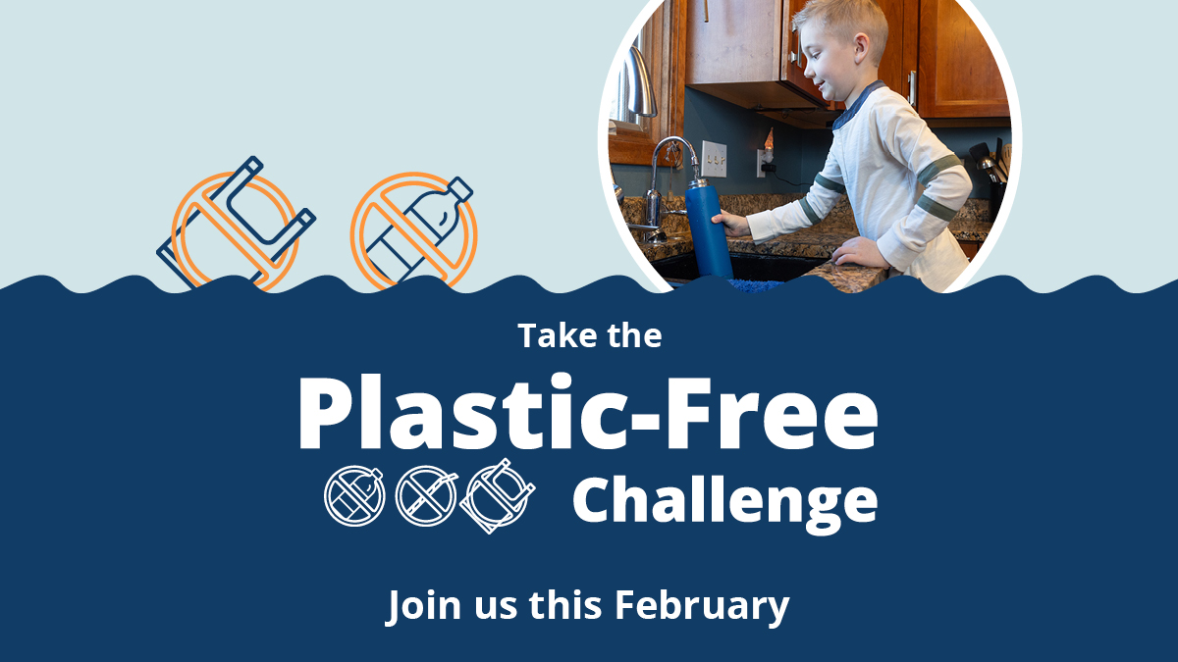

1920x1080 Instagram story graphics
Consider adding a link to the Plastic-Free Challenge website or a relevant action category:
- tcplasticfree.ecochallenge.org
- tcplasticfree.ecochallenge.org/challenges/plastics-101
- tcplasticfree.ecochallenge.org/challenges/at-home
- tcplasticfree.ecochallenge.org/challenges/food
- tcplasticfree.ecochallenge.org/challenges/on-the-go
- tcplasticfree.ecochallenge.org/challenges/personal-care
- tcplasticfree.ecochallenge.org/challenges/community
- tcplasticfree.ecochallenge.org/challenges/kids
- tcplasticfree.ecochallenge.org/challenges/pets
