

Sustainable holidays media kit

We all go into the holidays with the best of intentions. We want to share great gifts, tasty food, and plenty of time together. With all the gift-giving, decorating, and celebrating, the holidays also tend to be a time of increased waste. Fortunately, with a little planning, there are plenty of ways to create joy, not waste, this holiday season.
This media kit includes resources on low-waste gift wrapping, eco-friendly decorating, hosting a low-waste feast, choosing real versus artificial Christmas trees, and planning green gatherings.

Resources to promote sustainable holidays
Ways to educate the public about sustainable holidays:
- Use the sample newsletter articles to share on your organization’s website or in your newsletters. These are editable so you can customize the length or message.
- Use the sample social media posts to share through your social media channels. These are editable so you can customize the message and website.
- Share these resources:
  - Sustainable holiday checklist (hennepin.us/choose-to-reuse/tips/sustainable-holiday-checklist)
  - Secondhand holidays (hennepin.us/choose-to-reuse/tips/secondhand-holiday-guide)
  - Giving experiences as gifts (hennepin.us/choose-to-reuse/tips/giving-experiences)
  - Fix holiday décor (hennepin.us/choose-to-reuse/tips/fix-holiday-decor)
  - DIY holiday guide (hennepin.us/choose-to-reuse/tips/diy-holiday-guide)
  - This Thanksgiving, let’s be grateful for what we already have (hennepin.us/choose-to-reuse/Tips/grateful-for-what-you-have)
- Follow and reshare messages posted on the Hennepin County Environment and Energy social media channels: Hennepin Environment on Facebook, Hennepin Environment on Instagram, and @hennepinenviro on X

Contact
For more information about eco-friendly holiday preparation, contact the Environmental Education and Outreach Team, environment@hennepin.us
To use images and graphics: right click on image and select Save as Picture.

Sample newsletter article (sustainable holiday checklist)

Sustainable holiday checklist
Continue your sustainable lifestyle habits this holiday season by using Hennepin County’s sustainable holiday checklist. Instead of striving for perfection during an already busy time, focus on what you can manage to make meaningful progress. Every action you take is a gift to the planet, your community, and future generations.
Consider adding these sustainable actions to your holiday checklist:
- Shop for gifts at local or secondhand stores
- Give gifts of experiences, that share your talents, or that promote sustainability
- Minimize the number of gifts you give and give things the recipient really wants
- Wrap gifts in reusable bags or fabric
- Buy holiday cards made from recycled paper
- Use Energy Star certified LED lights for decorating
- Avoid buying plastic decorations and incorporate natural elements instead
- Consider what the best environmental options are for buying a real versus artificial tree
- Plan your menu for gatherings using a food calculator to avoid wasting food
- Serve locally grown food when possible
- Use reusable cups, dishes, and utensils during your gatherings and package up leftovers in reusable containers


Sample newsletter article (low-waste shopping and décor)

Shop for gifts and décor secondhand to reduce waste and support local retailers
We all go into the holidays with the best of intentions. We want to share great gifts, tasty food and plenty of time together. With a little planning, you can be sure to create joy, not waste, this holiday season.

Decorations
Check out your local thrift or vintage stores for decorations and ornaments you can reuse and enjoy for years to come. Retailers like Arc’s Value Village, AbleLight, and Time Bomb Vintage are all great options.


Low-waste gifting tips
- Giving experiences never gets old and is usually a less waste, more sustainable option. See our guide for giving experiences rather than physical gifts.
- If you are buying new, look for long-lasting items that can be reused or recycled later. In addition, look for battery-free and plastic-free toys and always opt for minimal packaging.
- Remember to wrap up your gifts the green way. Get creative by reusing gift bags from last year, using recyclable materials, like newspapers and brown paper bags, and adding natural elements to spruce up your packages.

Secondhand gift ideas
Buying secondhand saves money, cuts waste, and allows you to find something unique and special without worrying about shipping delays. See the secondhand holiday gift guide to get your creativity flowing. The guide has tips for finding décor and table settings, a list of ten gift items to look for at reuse stores, and ideas for putting together the perfect holiday outfit.

- Check out the Hopkins Antique Mall, which has 78 booths on two floors packed with vintage finds.
- For the antique lover: Architectural Antiques, Bauer Brothers Salvage, and City Salvage have a variety of unique, vintage items.
- For the DIY-er: Better Futures Minnesota and Habitat for Humanity ReStore have an assortment of salvaged building materials to inspire the next DIY project.
- For game night and date night: Wood from the Hood offers cribbage boards, cutting boards, charcuterie boards, and more made from local, discarded trees.
Consider these other secondhand gift ideas for anyone on your list: picture frames, framed art, vases, sports equipment, books, records, clothing, vintage jewelry, home décor, kitchen gadgets or dishware, seasonal décor, furniture and more!


Sample newsletter article (giving experiences as gifts)
When it comes to gift giving, some common advice that helps avoid adding to the amount of stuff we all have is to give the gift of experiences. But what does that actually mean, and how do you make these gifts just as exciting and meaningful (or more) than traditional gifts? Here are some tips and ideas to get started.

Make it tangible
Gifts of experiences can seem less exciting in the moment compared to the instant gratification of unwrapping a physical item. Give your recipient something to open by wrapping up the tickets or passes, making a coupon or picture, or assembling things you have at home to symbolize the gift (like dish towel and kitchen utensils for a cooking class). Or get creative and send them on a scavenger hunt, finding clues along the way to help them figure out the experience.

Make it specific
Instead of offering broadly to go to a show, attend a game, or buy a class pass, figure out as many specifics as you can. Where will you go, what class will you attend, what dates might work for both of you? If you are purchasing something that is good year-round, like a museum or gym membership, schedule a time to go together within the first few months. The more specific you can get, the more exciting the gift and the more likely you will be to make it happen.

Make it fun
When planning out experiences, it can be easy to plan things that you are excited about. But be sure to keep the gift recipient at the center when finalizing your plans. Though it can be rewarding to choose something that your gift recipient will find challenging or a little out of their comfort zone, make sure it’s also something they’ll find exciting and fun.

Make it happen
Don’t let your gift lose its excitement, become a burden, or never happen because you forget to plan it out. It’s best to give experiences that can happen within a month or two of when they are gifted. If your experience doesn’t come with a set date, give your recipient several days to choose from and schedule it right away once they tell you what works for them. Also consider and try to help with any additional logistics your gift recipient will need to figure out, like childcare or transportation.


Get inspired
Here are some ideas for experiences to give as gifts:
- Attend a winter sports game like basketball, hockey, gymnastics, or volleyball.
- Take in a holiday play, concert, or movie
- Go to a winter festival or event
- Try out a new winter sport – plenty of parks and local retailers offer winter equipment rentals to make trying a new sport easy
- Visit a museum or get an annual membership
- Take a craft or skills class – many are available through local businesses or community education
- Get outside by signing up for a class with a local park, getting a Minnesota State Park permit, or purchasing a ski pass
- Get active with a gym membership, fitness class pass, or by signing up for a race
- Focus on wellness with a massage or spa day
- Keep the kids busy with a visit to a trampoline park, rock climbing gym, or indoor water park or play area
See our Choose to Reuse article on giving experiences as gifts for more ideas.

Sample newsletter article (low-waste gift wrapping)

Low-waste gift-wrapping
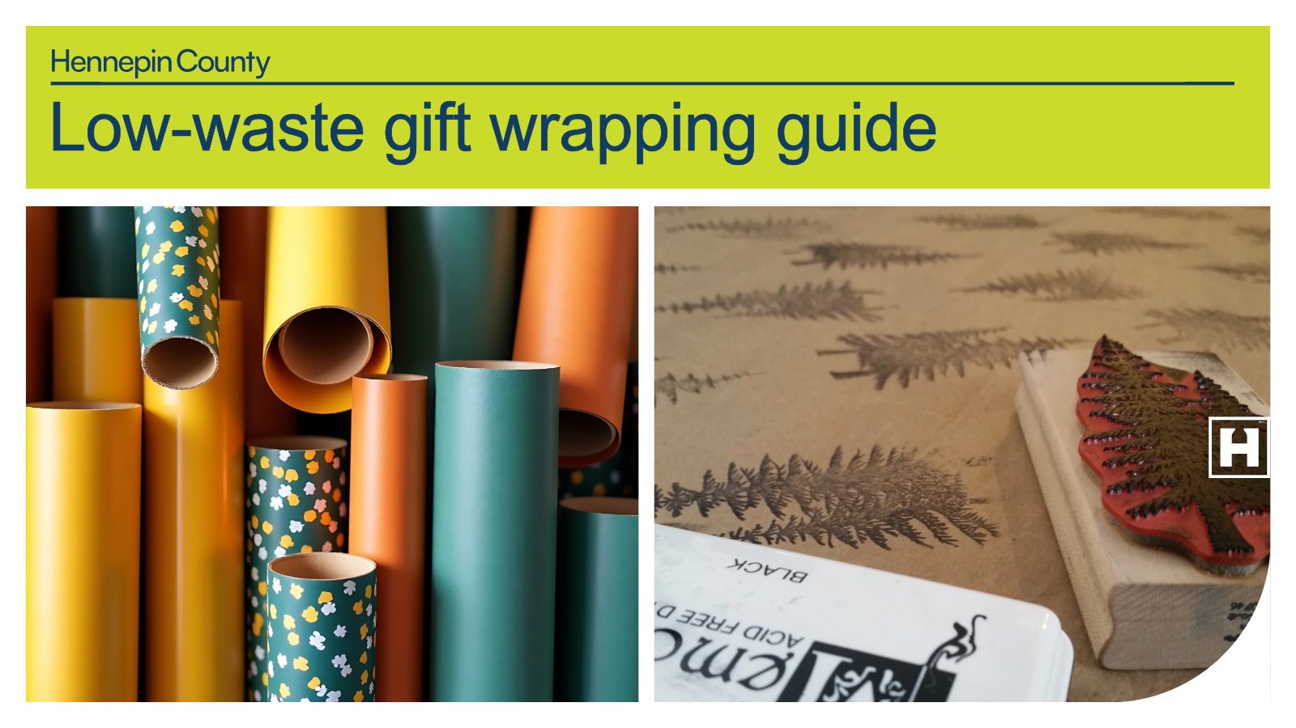
Wrapping paper, fancy bows, and gift tags often go straight from your package into the trash. Reconsider how you wrap your presents! Here are some tips to make your gifts look glam while making the best environmental choice.

Reusable gift wrap
- Reuse what you already have: Pull from your stash of gift bags and tissue paper. If you don’t have any – start collecting!
- Get creative: Reuse paper that you already have like old maps, posters, or brown paper bags. These are great for wrapping, and they can be recycled after!
- Opt for cloth wrapping: Use the Furoshiki method of folding cloth over your gift in the place of wrapping paper.
- Skip the wrapping: Use a decorative box or reusable gift bag to avoid the need for wrapping all together.


Purchasing wrapping paper
- Use recyclable paper: Wrapping paper that isn’t glossy and has no metallic elements can be recycled.
- Avoid shimmer and texture: Metallic, velvet, or glittery paper is not recyclable.
- Buy recycled paper: Continue the recycling loop by purchasing paper with recycled content.
- Choose alternatives to tissue paper: Reuse tissue paper that you already have but avoid purchasing new tissue paper as it isn’t recyclable.

Bows, ribbons, and adornments for gifts
- Reuse ribbon, string, and bows: Saving bows and ribbons means you will have a supply on hand to make presents beautiful and unique.
- Use natural adornments: Dress up simple paper wrapping with natural items, like pinecones, dried flowers, or sprigs of rosemary, fir, cedar or spruce to make your presents look (and smell) festive!
- Choose fabric ribbons: Tie your gift with cotton string or reusable fabric ribbon to avoid tape. These can be reused year after year!

Sample newsletter article (low-waste parties)

Planning a low-waste celebration
You may associate parties and celebrations with an overflowing garbage cart, but it doesn’t have to be that way! With a little planning and setting yourself up with durable goods, you can celebrate and produce minimal waste.

Ditch the disposables
The first rule of low-waste parties is to avoid anything meant to be thrown away after a single use. Make sure to use reusable plates, cups, utensils, and even napkins at your next celebration. Use dishes you already have and purchase any extra dishes you need, like pie plates, at a local thrift store. While you’re there, get inspired and grab festive table décor to make the meal memorable.
Look for extra sets of dishes and utensils at secondhand stores and garage sales. You could also borrow a set from a friend or family member or have people bring their own of whatever you need. At the end of your occasion, load up the dishwasher and add your napkins to the next load of laundry.
If you cannot use reusable tableware, make sure everything is recyclable or certified compostable and dispose of it properly. Make sure recyclable items go in the recycling, and put compostable items in your organics recycling or take them to a drop-off location.

Dining
Think about waste when planning your menu. Buy ingredients from the bulk bins, bring your own shopping bags, and visit farmer’s markets for local foods. Although you want to be a generous host, making too much food that doesn’t get eaten is a waste of money and resources. The Guest-Imator from Save the Food will help you plan and shop for just the right amount.
Some easy snacking or appetizer options are cut-up fruits and veggies or bulk bin items like nuts or unwrapped candies. Serve drinks such as flavored water or tea in dispensers, or purchase beverages in returnable growlers or kegs.
For meals, make an appropriate number of servings and have a plan for leftovers. If you do provide cans, bottles, or other containers, make sure to put out a well-labeled recycling container. If you’re using a caterer, confirm or request their low-waste options.

Decorating
Decorations are another source of trash from celebrations. Avoid plastic or Mylar balloons, streamers, props and other items that are only useful for the day of the party. Instead, consider having a stock of versatile decorations such as reusable string lights, bunting, soy or beeswax candles, and cloth tablecloths that form the foundation of your decorations.
You can change up accent pieces, such as table runners, and make your own centerpieces from fresh cut flowers, houseplants, seasonal produce or greenery. For winter holidays, kids and adults can make paper snowflakes or other cutouts from newspaper, magazines, or other reused paper. Pinecones, cranberries and popcorn on a string, or colorful candies in a dish are excellent traditional options as well.


Disposal
Don’t forget the last step to separate your waste. Make your system easy and clear. If you don’t have any items that go in the trash, keep your trash can closed or out of sight! If you don’t have organics recycling service at home, take compostable foodservice items to a drop-off. After your party is over, clean up using green cleaners.

Sample newsletter article (low-waste feasts)

Reducing waste when planning for a feast
The holiday season is a time when many are planning to host a feast for their family and friends. Many of us have a tradition of going overboard, which unfortunately means that the meal can result in a lot of waste.
Take these steps to prevent waste during all stages of your meal experience. These tips apply to any event or occasion year-round.


Planning
Before you shop, do some planning. You can lower the meal’s impacts by thinking ahead, purchasing the right amounts, and being flexible.
- Use a portion calculator like Save the Food's Guestimator to match servings with the number of guests.
- Simplify your menu. Fewer dishes to cook means less time in the kitchen, less food to put away, and less stress overall. Get ideas for planning a smaller feast from The New York Times, Better Homes and Gardens, and The Food Network.
- Use local ingredients to reduce the "foodprint" of your meal. Get ideas from Minnesota Grown.
- Don’t be afraid to switch things up. Is there a dish that nobody loves but you make it because of tradition? Time to let it go and make room for something better.
- Prepare reusable containers for leftovers. If you're hosting and are planning to send leftovers with family or friends, save containers ahead of time. Recyclable containers from takeout meals or other store-bought items work great for sharing food in containers you don't need to get back. If you're attending an event and know your host will send you home with food, remember to bring your own reusable containers.

Shopping
Once you get into the store to purchase your food, be aware of the packaging and use your zero-waste shopping habits. Ask yourself: Is the packaging recyclable? Compostable? Avoidable?

Cooking
Cut down on food waste while you prepare and cook your meals. While cutting up fruits and vegetables, leave on edible skins (such as for potatoes, carrots, apples and some squash), or save the vegetable scraps for a soup broth (tip: you can freeze them for later use).
For food scraps you cannot prevent or use, separate them for organics recycling or composting.
While you cook, do simple things such as setting timers and keeping your focus to avoid kitchen mishaps like burning food or adding the wrong ingredients. There are also some tricks to save your dish when it just doesn’t taste quite right. One Green Planet has a useful article on fixing common seasoning mistakes to save your dinner.


Sitting down for the meal
There are ways to prevent waste while you eat, too! Cut plate waste by offering smaller plates, which encourages people to take seconds rather than filling up their plate only to realize their eyes are bigger than their stomachs.
Make sure to follow food safety guidelines so that your food is safe to eat later. Keep hot food hot, or above 135 degrees, and cold food under 40 degrees. Don’t leave perishable food out for more than two hours at room temperature. If you have multiple trays of food, keep one on reserve until the first runs out.

Later: the leftovers
After you’ve eaten your meal, place leftover food in small containers so it can cool quickly and get it refrigerated.
If you love leftovers and planned your meal for extra food, you get to reap the rewards of a marathon cooking session for the next week or so! If you don’t like leftovers, reduce the amounts you are making or have a plan to share what’s left with someone who will eat it.
If you get sick of eating the food as is, the Internet has hundreds of recipes that reimagine leftovers. Mashed potatoes can go into pancakes, fritters, or pizza crust. Leftover vegetables can be added to soup, scrambled eggs, stir fries, or sauces. Almost all of it could go into a shepherd’s pie. And that leftover pie could be turned into a delicious ice cream shake. Get additional ideas and recipes from Delish.
Whatever your holiday plans, plan ahead to reduce waste, aim to cook the right amount, keep tabs on what’s left in the fridge or freezer, and enjoy your lower waste feast.

Sample newsletter article (real verses artificial holiday trees)

Should you use a real or artificial holiday tree this season?
What type of tree to buy – real or artificial – is a question that comes up every holiday season. Which is not surprising, because there are pros and cons to each and ways to make either decision greener. Consider each option when you make your choice:

Artificial trees
Minimize the impact of artificial trees by finding a used tree and using it for as many years as possible. If you already have an artificial tree, keep using it! Consider purchasing your tree from a thrift store or community marketplace. If stringing your tree with lights, use LED lights.

Real trees
If purchased locally and disposed of as yard waste, real trees generally have a lower environmental impact than artificial trees. Purchase a locally grown tree. Use LED lights on your tree. Don't spray on any flocking (fake snow) because it is not compostable. At the end of the season, dispose of your tree as yard waste after removing decorations.
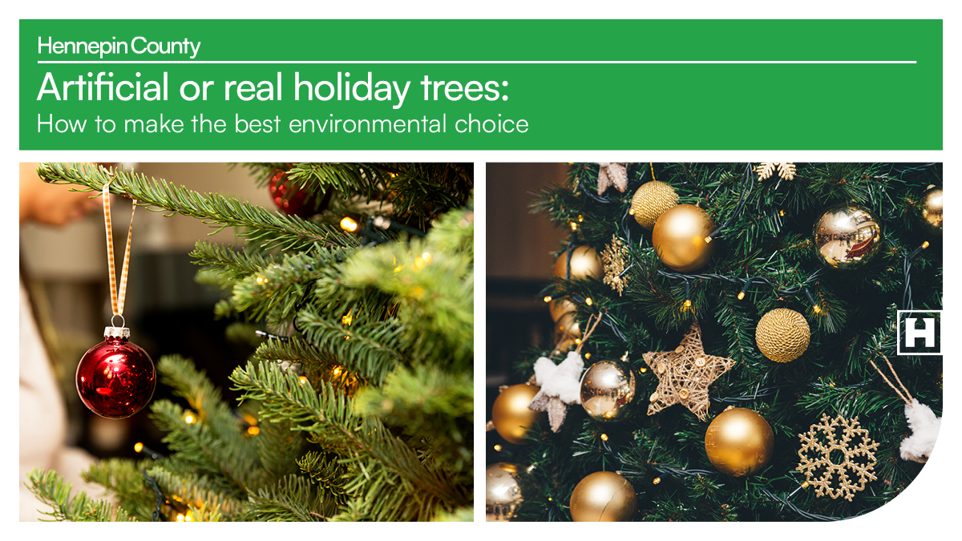

Social media posts
Suggested hashtags: #LowWaste #Reuse #GiftWrapping #Holiday
To use images and graphics: right click on image and select Save as Picture.

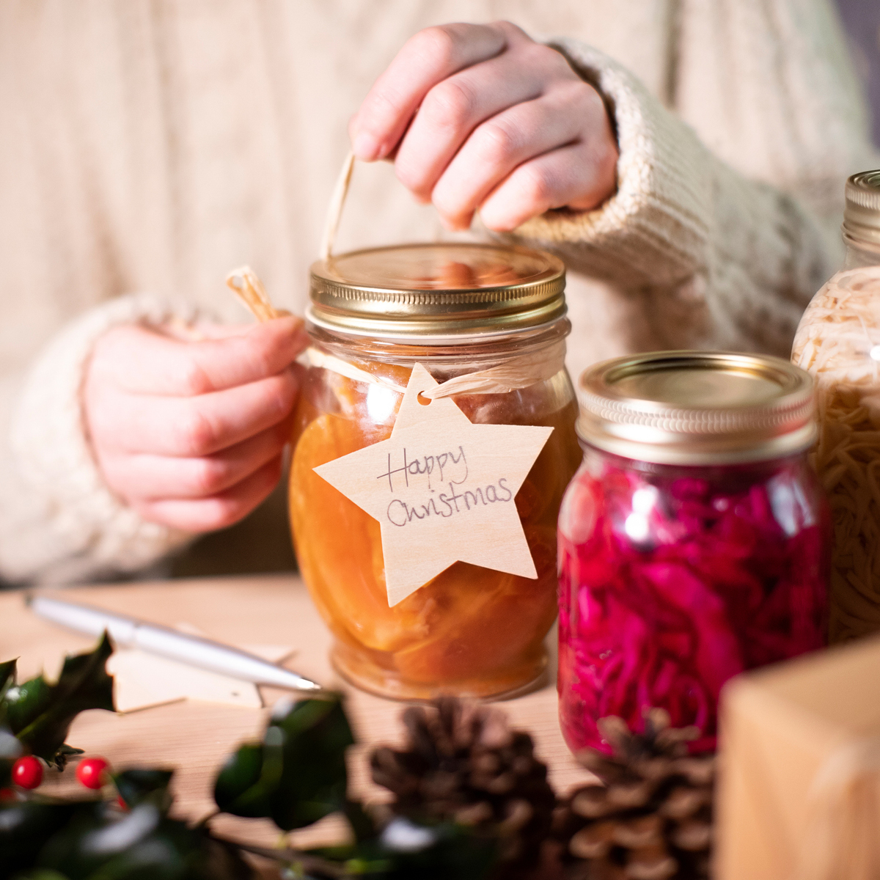
Post 1: Sustainable holiday checklist
Facebook: Want to celebrate the season sustainably? Use the sustainable holiday checklist as inspiration! It’s filled with sustainable holiday tips and suggestions for reducing waste generated by seasonal celebrations and gift giving. hennepin.us/choose-to-reuse/tips/sustainable-holiday-checklist
X: Want to celebrate the season sustainably? Use the sustainable holiday checklist as inspiration! It’s filled with sustainable holiday tips and suggestions for reducing waste generated by seasonal celebrations and gift giving. hennepin.us/choose-to-reuse/tips/sustainable-holiday-checklist #SustainableHolidays #LowWaste


Post 2: Secondhand holiday gift giving guide
Facebook: We all go into the holidays with the best of intentions. We want to share great gifts, tasty food and plenty of time together. With a little planning, you can create joy, not waste this holiday season. See our secondhand holiday gift guide for tips to find décor and table settings, a list of ten gift items to look for at reuse stores, and ideas for putting together the perfect holiday outfit. hennepin.us/choose-to-reuse/tips/secondhand-holiday-guide #LowWaste #Holiday #SecondhandGifts
X: With a little planning, you can create joy, not waste this holiday season. See our secondhand holiday gift guide for tips to find décor and table settings and a list of ten gift items to look for at reuse stores. hennepin.us/choose-to-reuse/tips/secondhand-holiday-guide #LowWaste #Holiday #SecondhandGifts

Post 3: Real and artificial trees
Facebook: Shopping for a tree but unsure how to make the best choice for the environment? If purchased locally and disposed of as yard waste, real trees generally have a lower environmental impact than artificial trees. Minimize the impact of artificial trees by finding a used tree and using it for as many years as possible.
X: If purchased locally and disposed of as yard waste, real trees generally have a lower environmental impact than artificial trees. Minimize the impact of artificial trees by finding a used tree and using it for as many years as possible. #ChristmasTree #LowWaste #Holiday
Instagram: Shopping for a tree but unsure how to make the best choice for the environment? If purchased locally and disposed of as yard waste, real trees generally have a lower environmental impact than artificial trees. Minimize the impact of artificial trees by finding a used tree and using it for as many years as possible. #ChristmasTree #LowWaste #Holiday
Use these images as a carousel on social media:
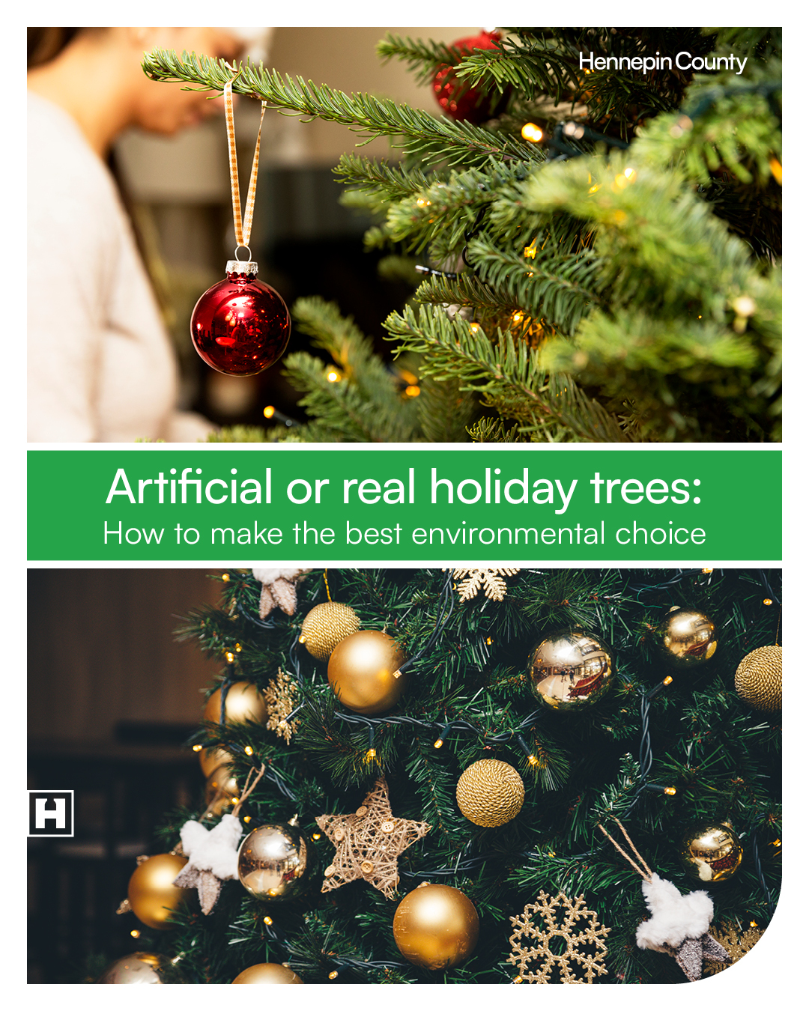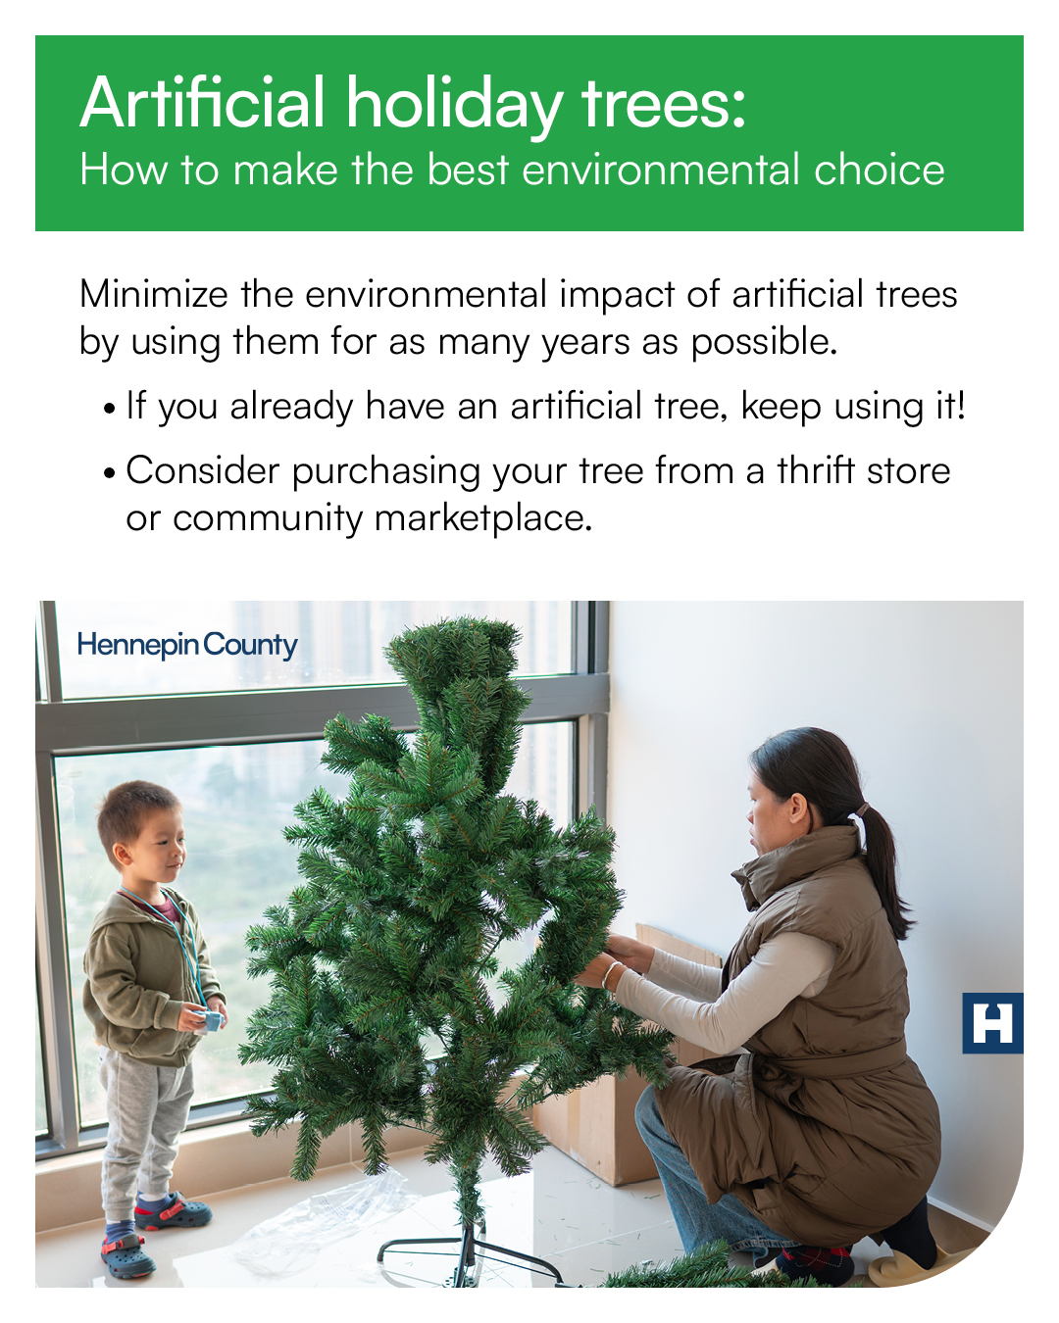
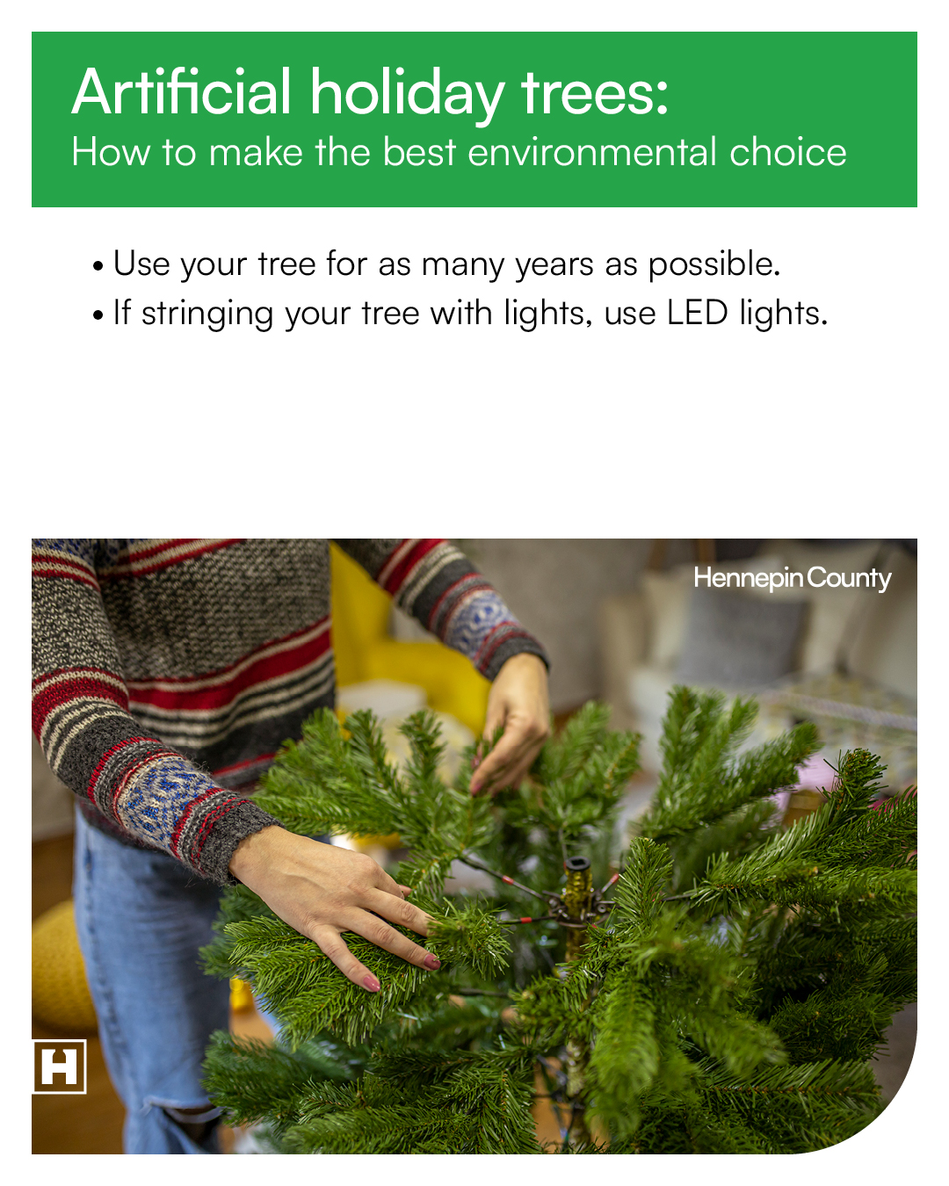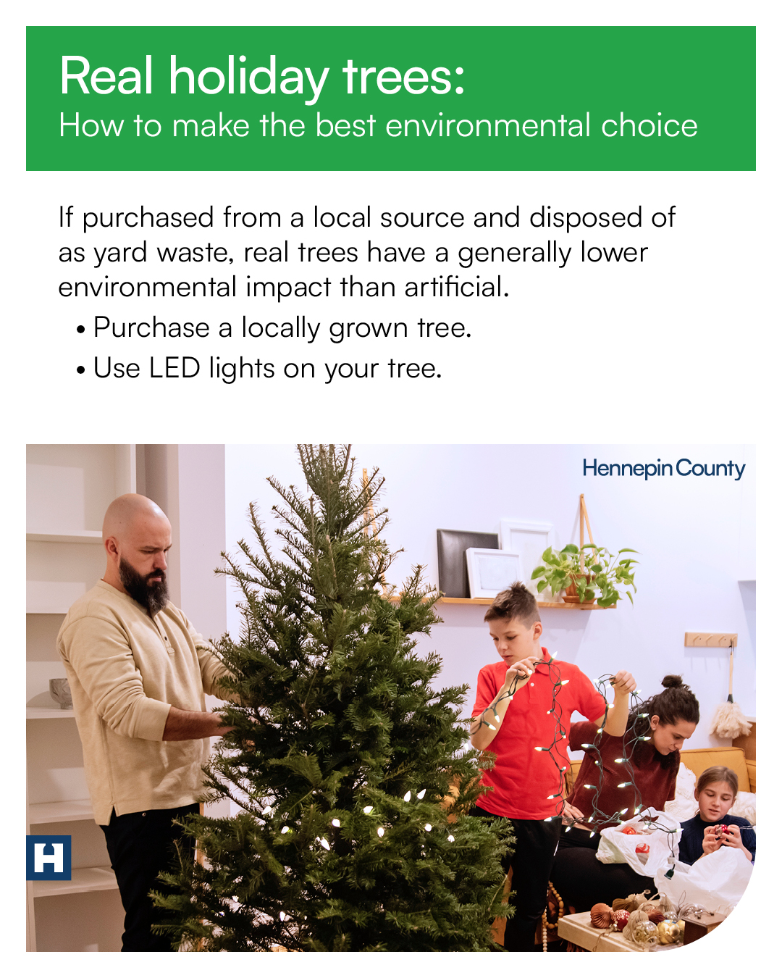
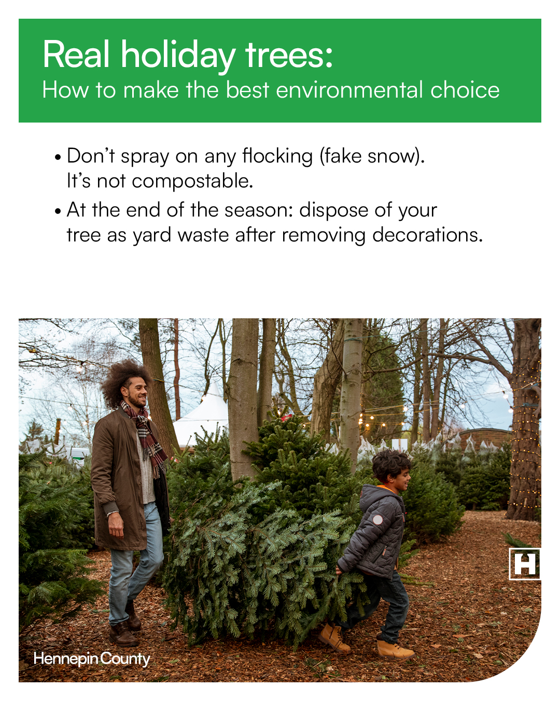

Story-sized images:
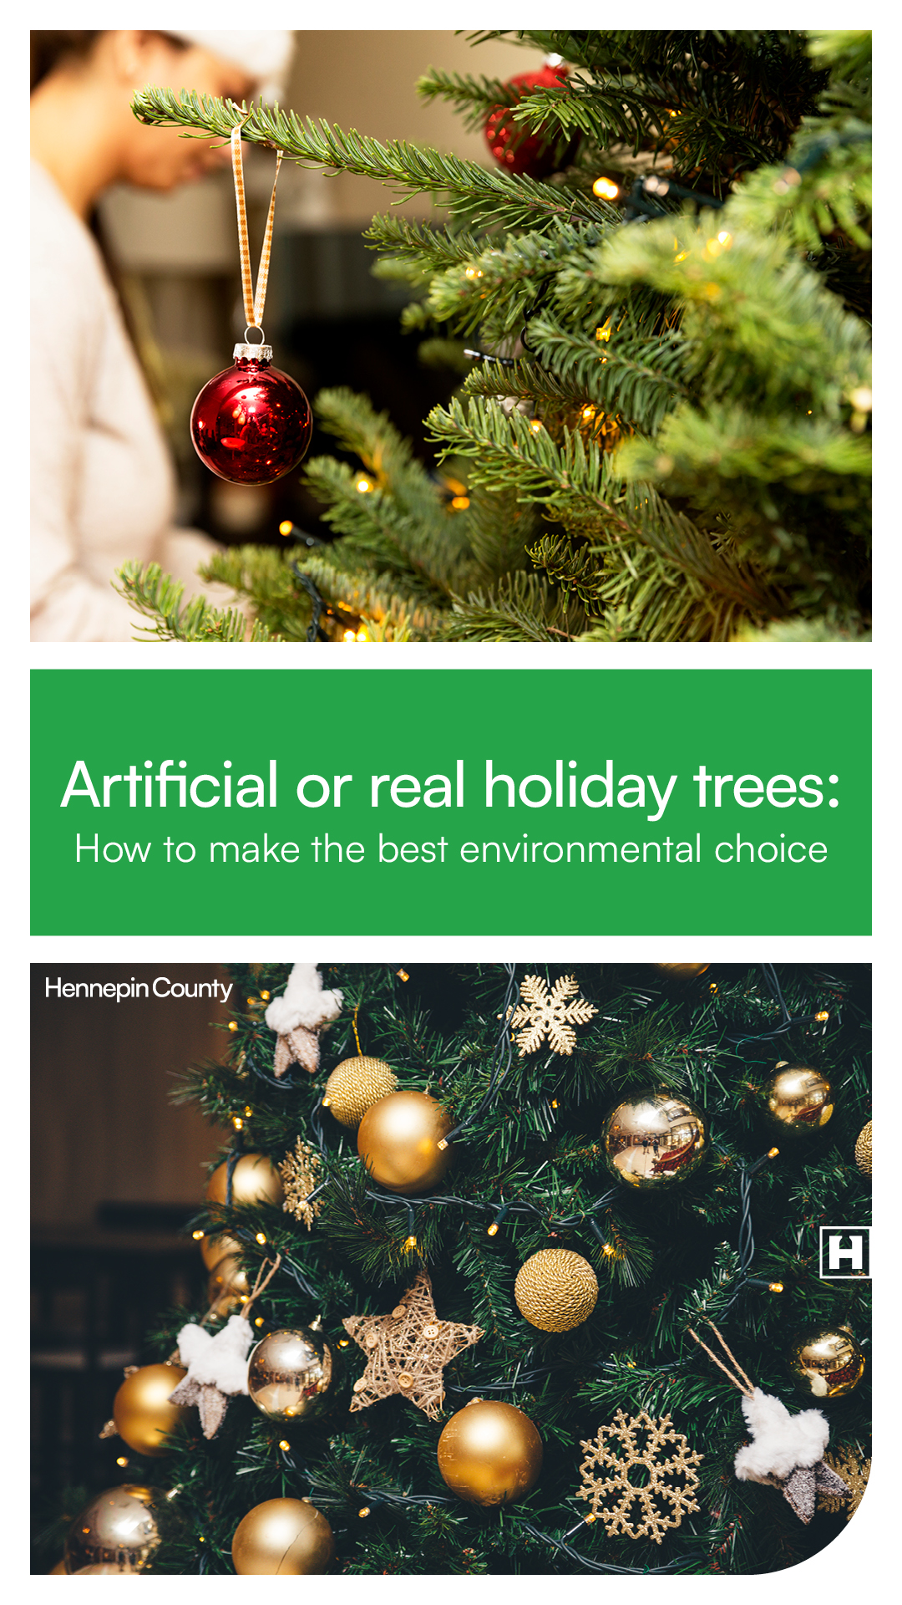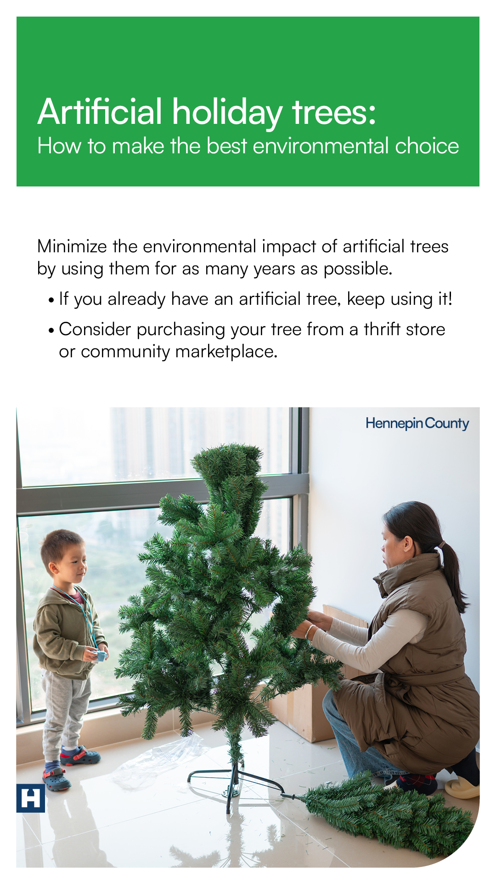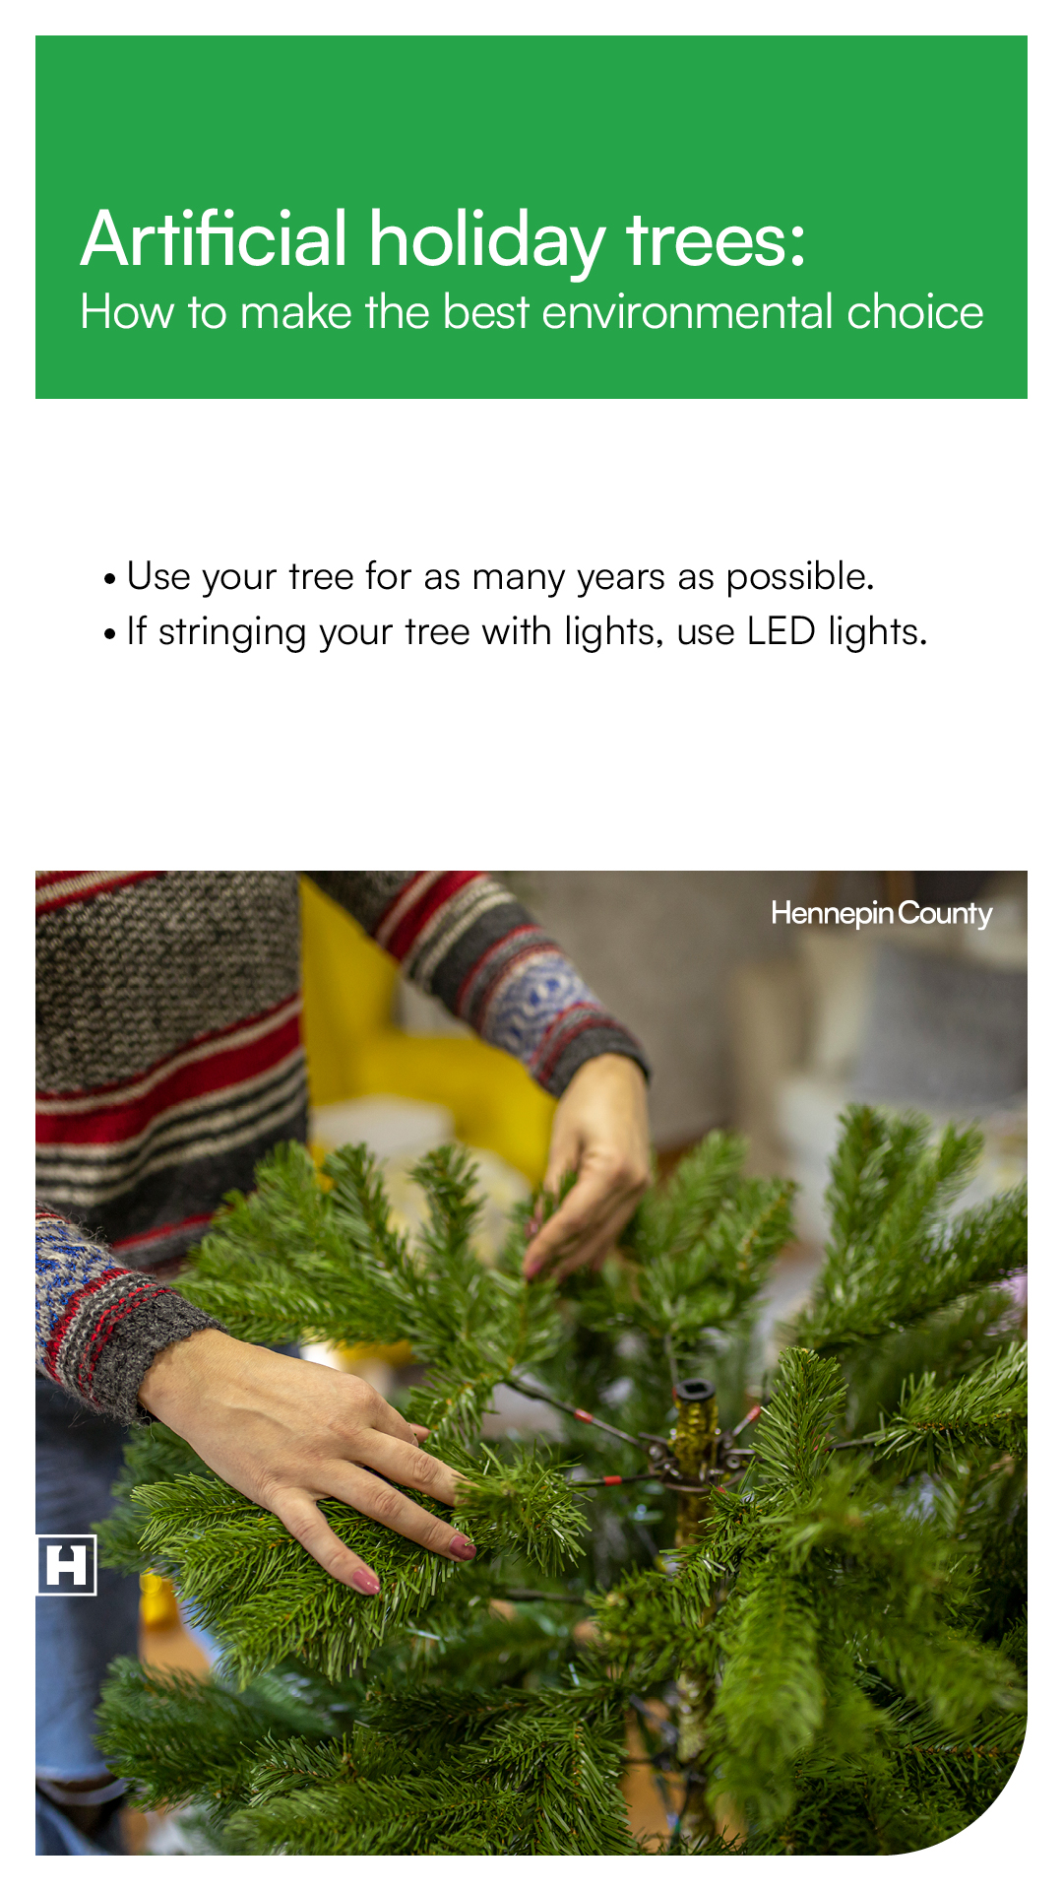
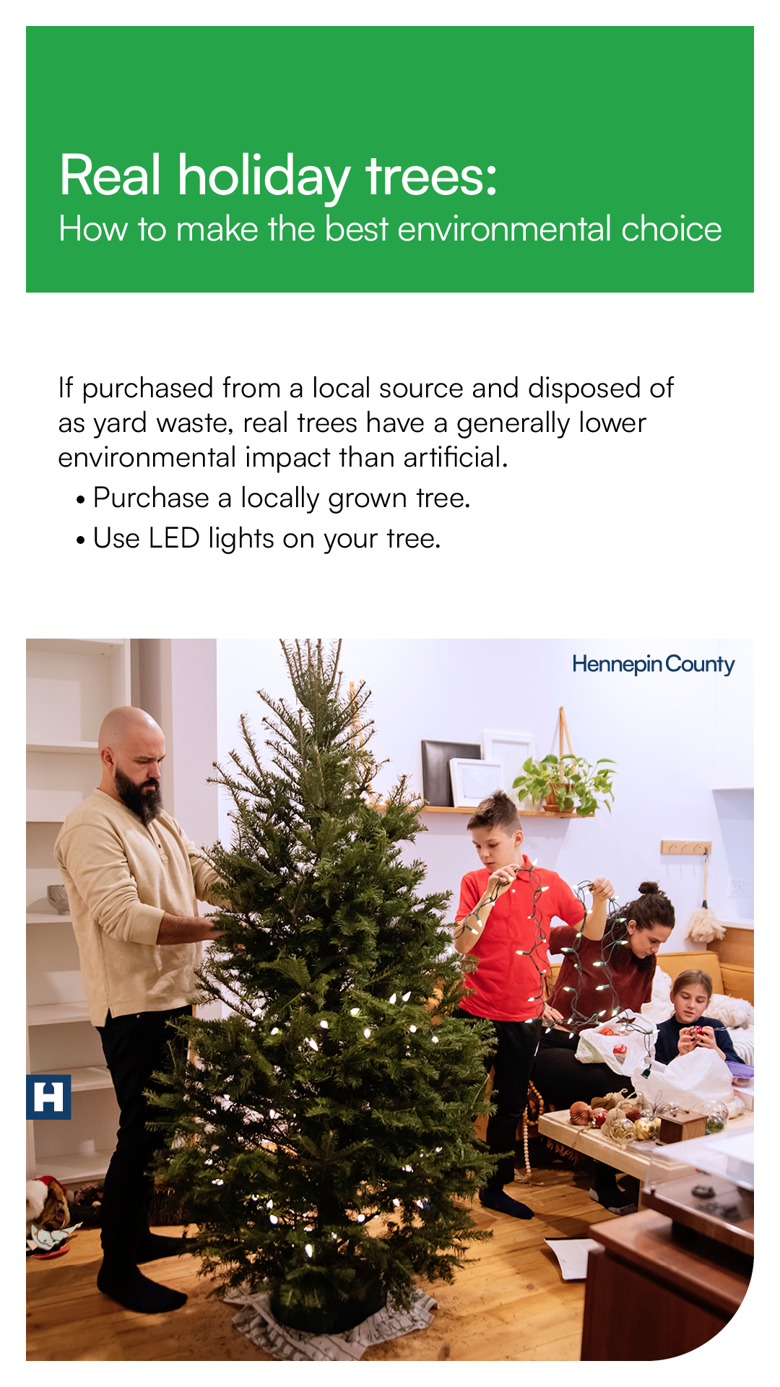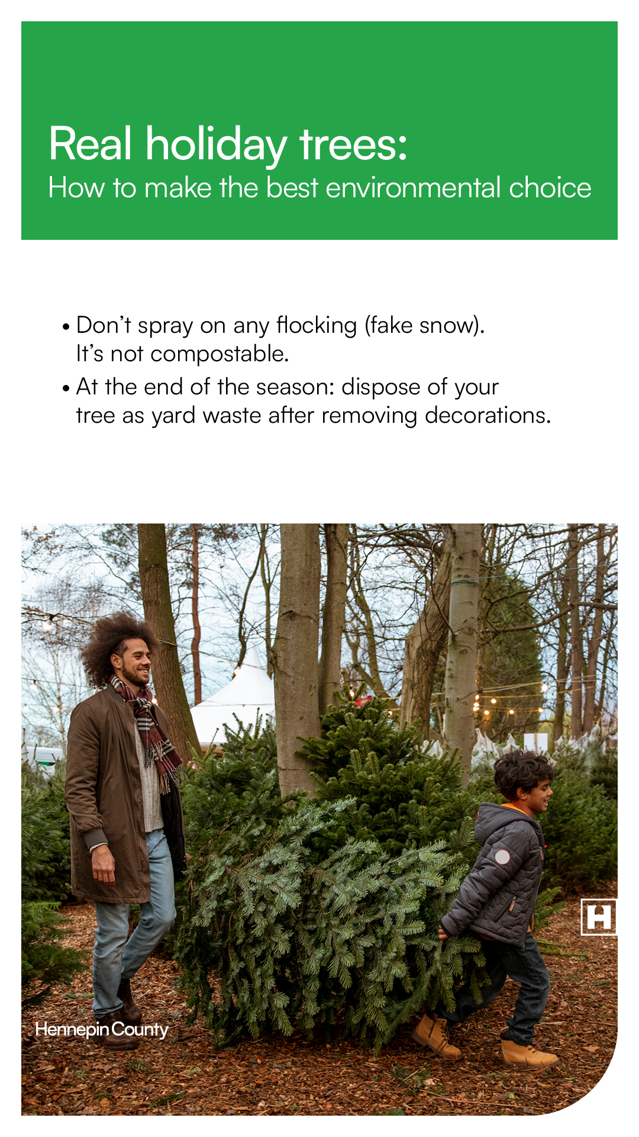

Post 4: Low-waste gift wrapping series
(Consider posting this series in a carousel or as a series of posts in a row. Find the full library of images at the end of this media kit.)

Post 4: Carousel of all graphics
Facebook: Are you cozying up to wrap gifts this week? Follow these tips to make your gifts beautiful while avoiding all the waste that comes with gift wrap.
- Choose cloth wrapping and use the Furoshiki method of folding cloth over your gift in the place of wrapping paper.
- Use a decorative box or gift bag to avoid purchasing new wrapping paper.
- Avoid wrapping paper that is glossy, metallic, velvet, or glittery – it is not recyclable!
- Buy wrapping paper made with recycled content.
- Use natural adornments like pinecones or sprigs of rosemary, fir, cedar, or spruce to make your presents look (and smell) festive.
- Reuse ribbon, string, and bows year after year.
Instagram: Are you cozying up to wrap gifts this week? Follow these tips to make your gifts beautiful while avoiding all the waste that comes with gift wrap. #LowWaste #GiftWrapping
- Choose cloth wrapping and use the Furoshiki method of folding cloth over your gift in the place of wrapping paper.
- Use a decorative box or gift bag to avoid purchasing new wrapping paper.
- Avoid wrapping paper that is glossy, metallic, velvet, or glittery – it is not recyclable!
- Buy wrapping paper made with recycled content.
- Use natural adornments like pinecones or sprigs of rosemary, fir, cedar, or spruce to make your presents look (and smell) festive.
- Reuse ribbon, string, and bows year after year.

Post 4a: Introduction
Facebook: Are you cozying up to wrap gifts this week? Follow these tips to make your gifts beautiful while avoiding all the waste that comes with gift wrap.
X: Are you cozying up to wrap gifts this week? Follow these tips to make your gifts beautiful while avoiding all the waste that comes with gift wrap. #LowWaste #GiftWrapping
Instagram: Are you cozying up to wrap gifts this week? Follow these tips to make your gifts beautiful while avoiding all the waste that comes with gift wrap. #LowWaste #GiftWrapping

Post 4b: Cloth wrapping
Facebook: Be eco-friendly this holiday season! Choose cloth wrapping and use the Furoshiki method of folding cloth over your gift in the place of wrapping paper.
X: Be eco-friendly this holiday season! Choose cloth wrapping and use the Furoshiki method of folding cloth over your gift in the place of wrapping paper. #LowWaste #GiftWrapping
Instagram: Be eco-friendly this holiday season! Choose cloth wrapping and use the Furoshiki method of folding cloth over your gift in the place of wrapping paper. #LowWaste #GiftWrapping

Post 4c: Gift bags
Facebook: Avoid purchasing new wrapping paper by reusing what you already have! Pull from your stash of gift bags and tissue paper. If you don’t have any – start collecting!
X: Avoid purchasing new wrapping paper by reusing what you already have! Pull from your stash of gift bags and tissue paper. If you don’t have any – start collecting! #Reuse #GiftWrapping
Instagram: Avoid purchasing new wrapping paper by reusing what you already have! Pull from your stash of gift bags and tissue paper. If you don’t have any – start collecting! #Reuse #GiftWrapping

Post 4d: Glossy wrapping paper
Facebook: Be sure to use recyclable wrapping paper this holiday season! Avoid wrapping paper that is glossy, metallic, velvet, or glittery – it is not recyclable!
X: Be sure to use recyclable wrapping paper this holiday season! Avoid wrapping paper that is glossy, metallic, velvet, or glittery – it is not recyclable! #LowWaste #Holiday
Instagram: Be sure to use recyclable wrapping paper this holiday season! Avoid wrapping paper that is glossy, metallic, velvet, or glittery – it is not recyclable! #LowWaste #Holiday

Post 4e: Recycled wrapping paper
Facebook: One way to have a low-waste holiday season is to use recycled wrapping paper! Always purchase wrapping paper made from recycled content and continue the recycling loop by recycling paper after the holidays.
X: One way to have a low-waste holiday season is to use recycled wrapping paper! Always purchase wrapping paper made from recycled content and continue the recycling loop by recycling paper after the holidays. #GiftWrapping #Holiday
Instagram: One way to have a low-waste holiday season is to use recycled wrapping paper! Always purchase wrapping paper made from recycled content and continue the recycling loop by recycling paper after the holidays. #GiftWrapping #Holiday

Post 4f: Natural adornments
Facebook: Get creative while minimizing waste this holiday season. Using natural adornments like pinecones or sprigs of rosemary, fir, cedar, or spruce will make your presents look (and smell) festive!
X: Get creative while minimizing waste this holiday season. Using natural adornments like pinecones or sprigs of rosemary, fir, cedar, or spruce will make your presents look (and smell) festive! #LowWaste #Holiday
Instagram: Get creative while minimizing waste this holiday season. Using natural adornments like pinecones or sprigs of rosemary, fir, cedar, or spruce will make your presents look (and smell) festive! #LowWaste #Holiday

Post 4g: Reuse bows
Facebook: Remember to reuse ribbon, string, and bows this holiday season. Saving bows and ribbons means you will always have a supply on hand. If purchasing ribbon, buy fabric ribbon that can be reused year after year.
X: Remember to reuse ribbon, string, and bows this holiday season. Saving bows and ribbons means you will always have a supply on hand. If purchasing ribbon, buy fabric ribbon that can be reused year after year. #Reuse #GiftWrapping
Instagram: Remember to reuse ribbon, string, and bows this holiday season. Saving bows and ribbons means you will always have a supply on hand. If purchasing ribbon, buy fabric ribbon that can be reused year after year. #Reuse #GiftWrapping
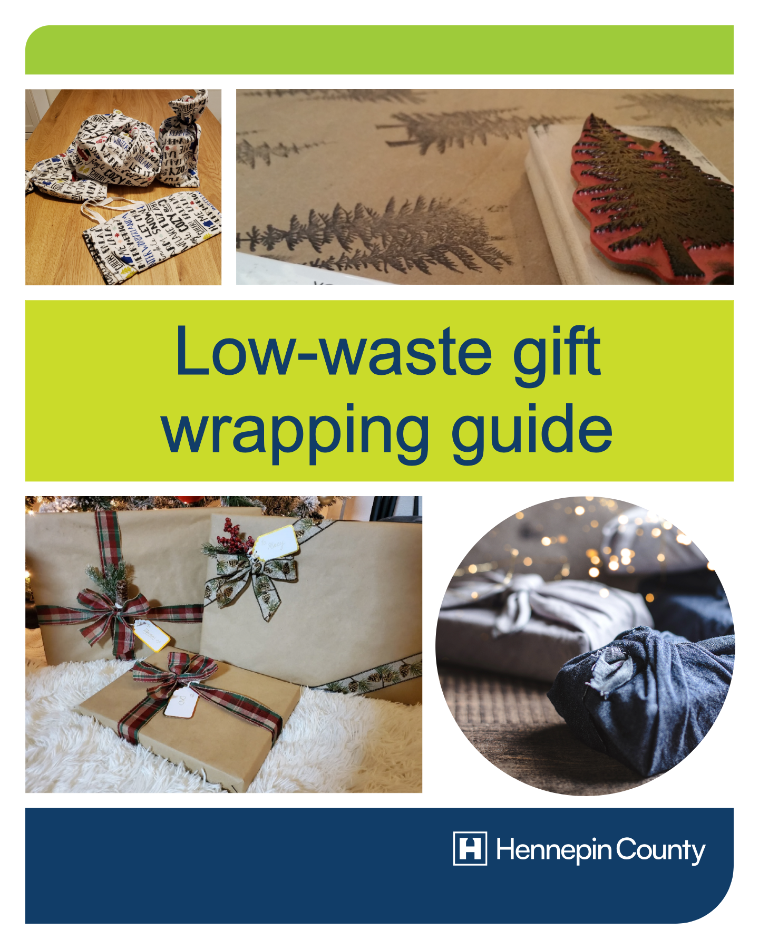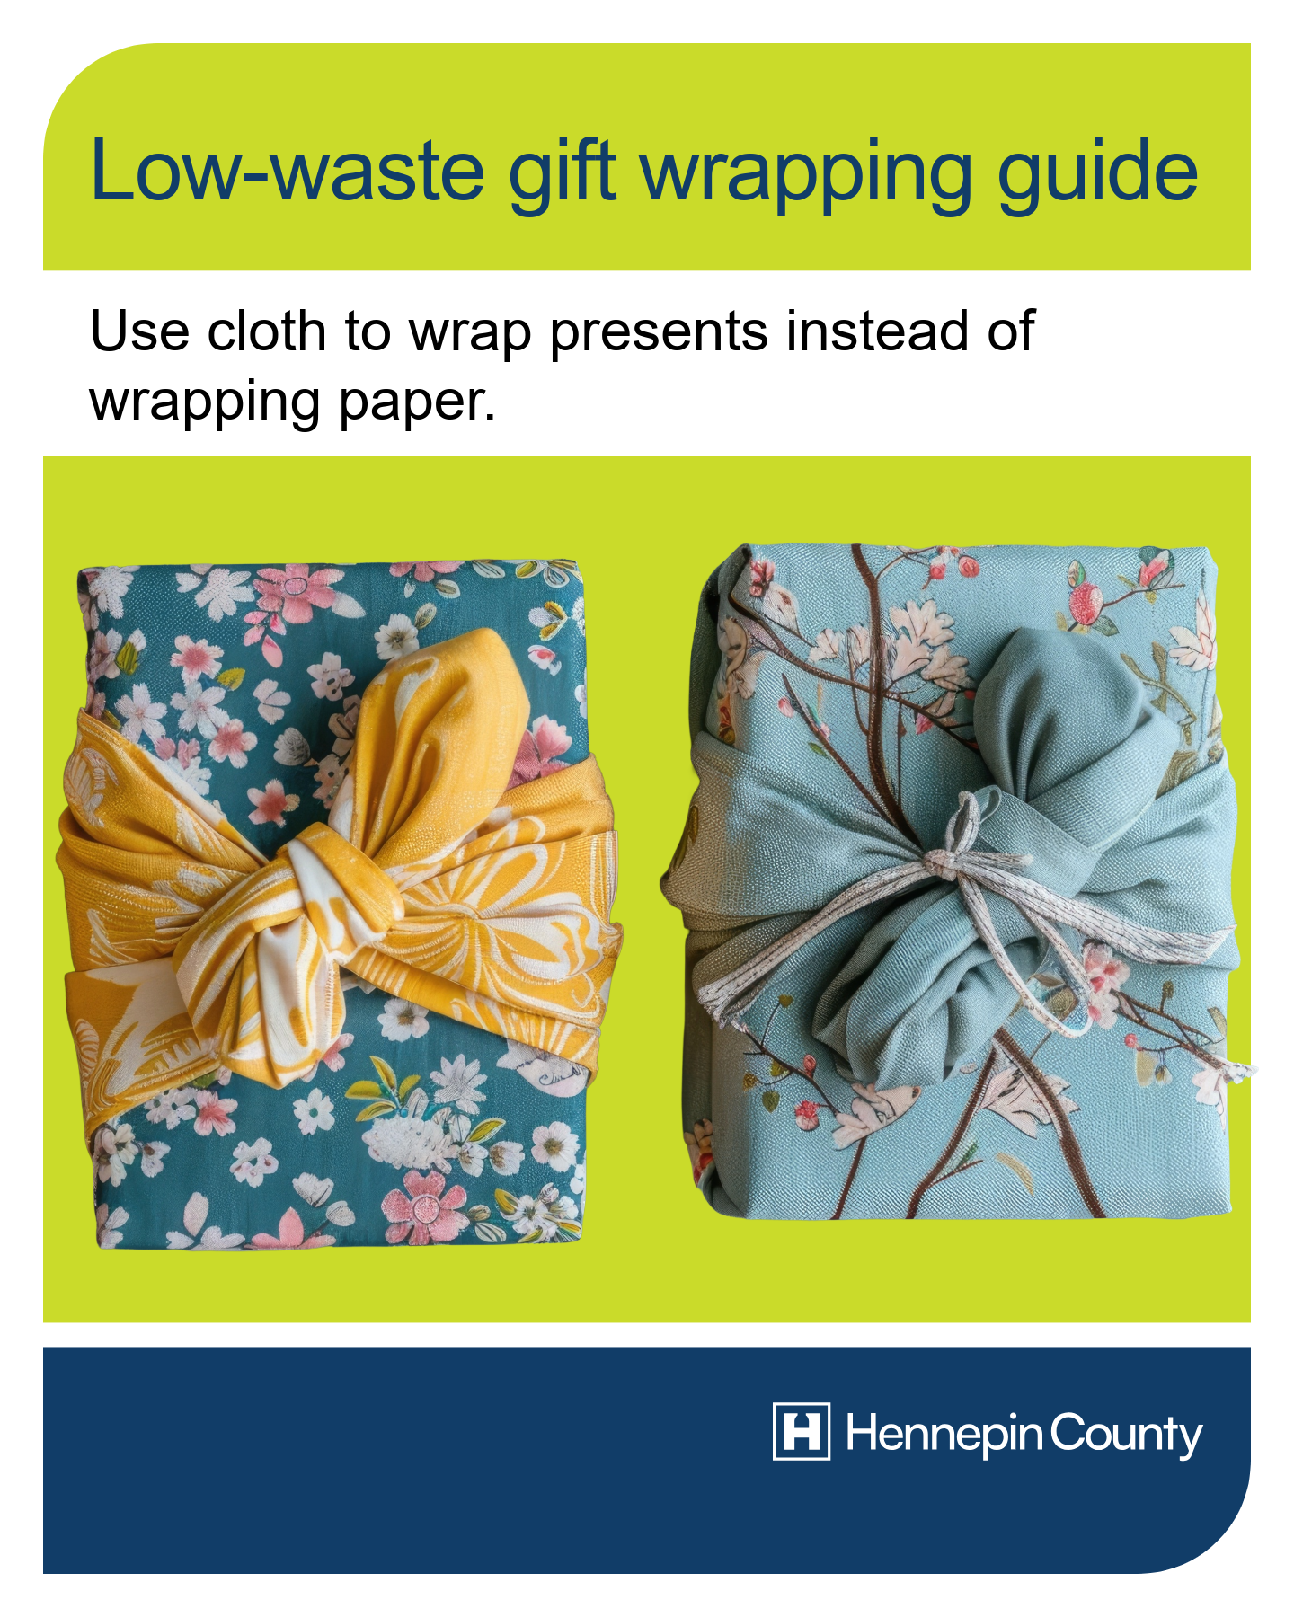
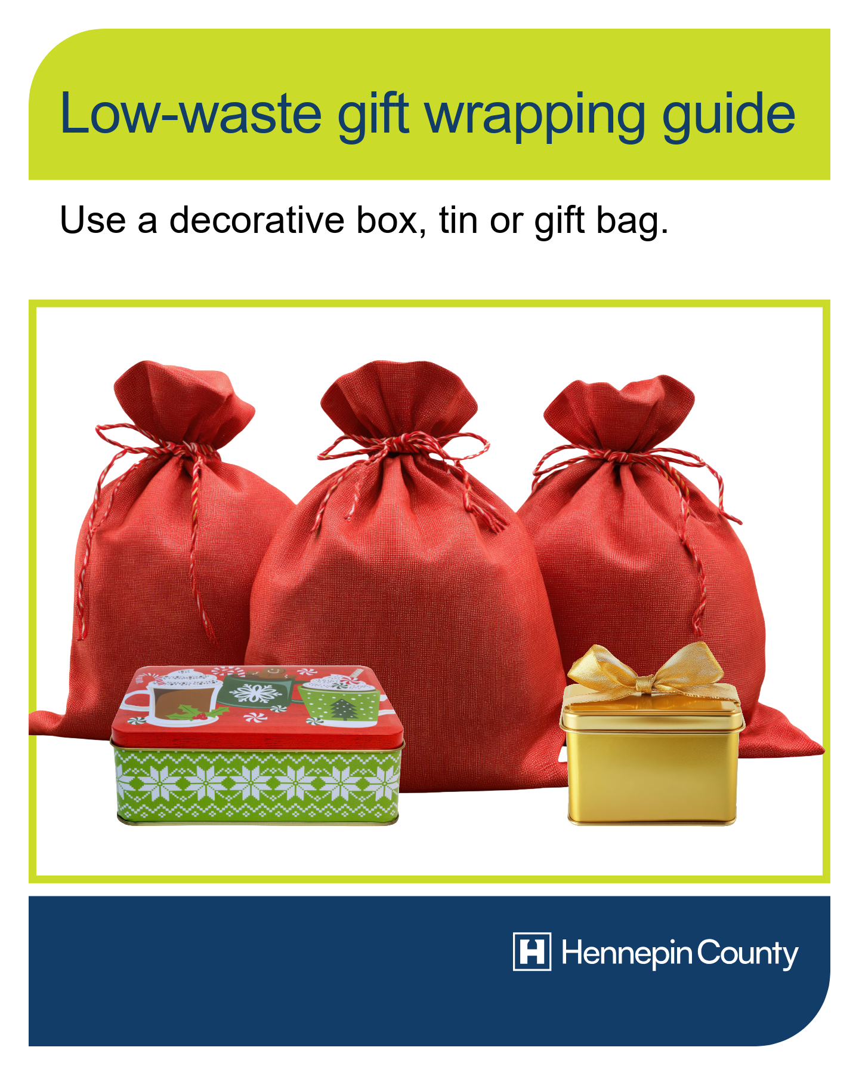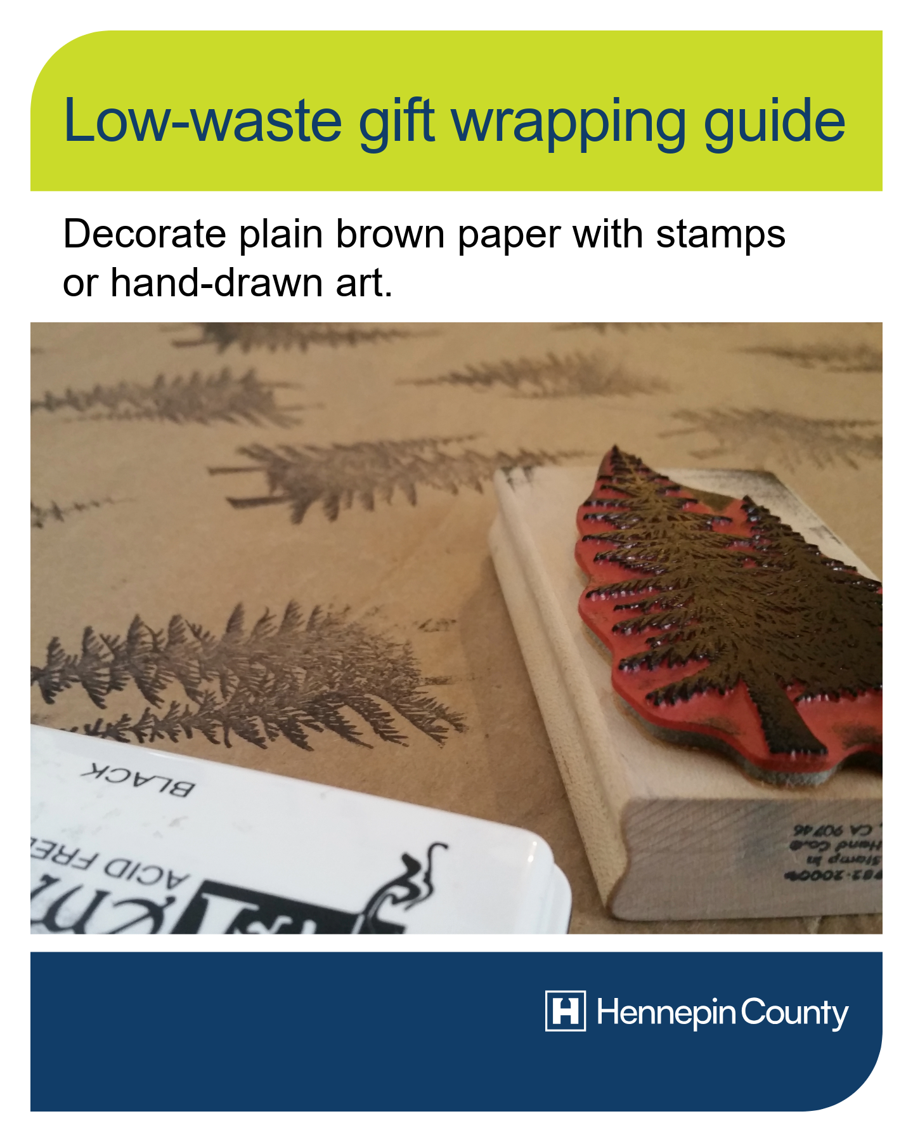
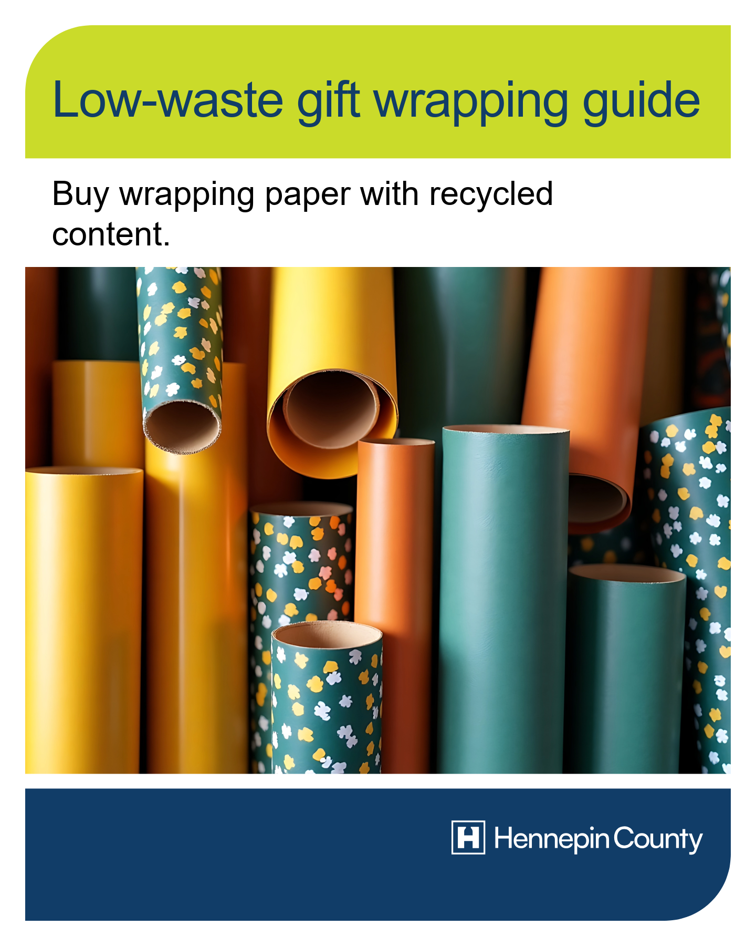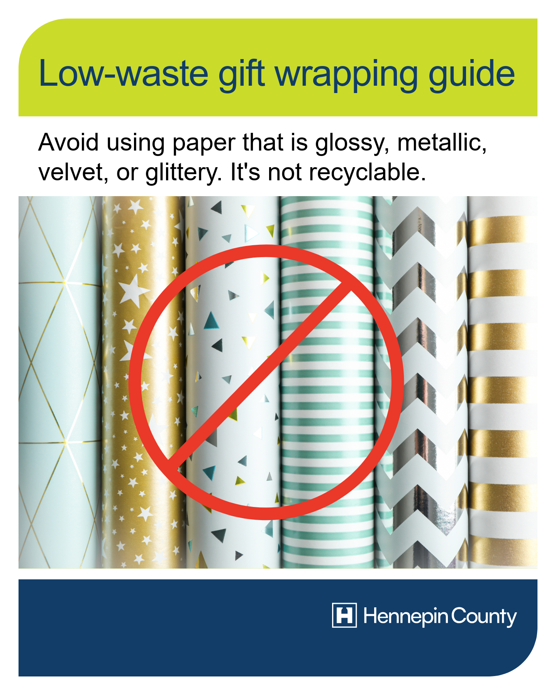
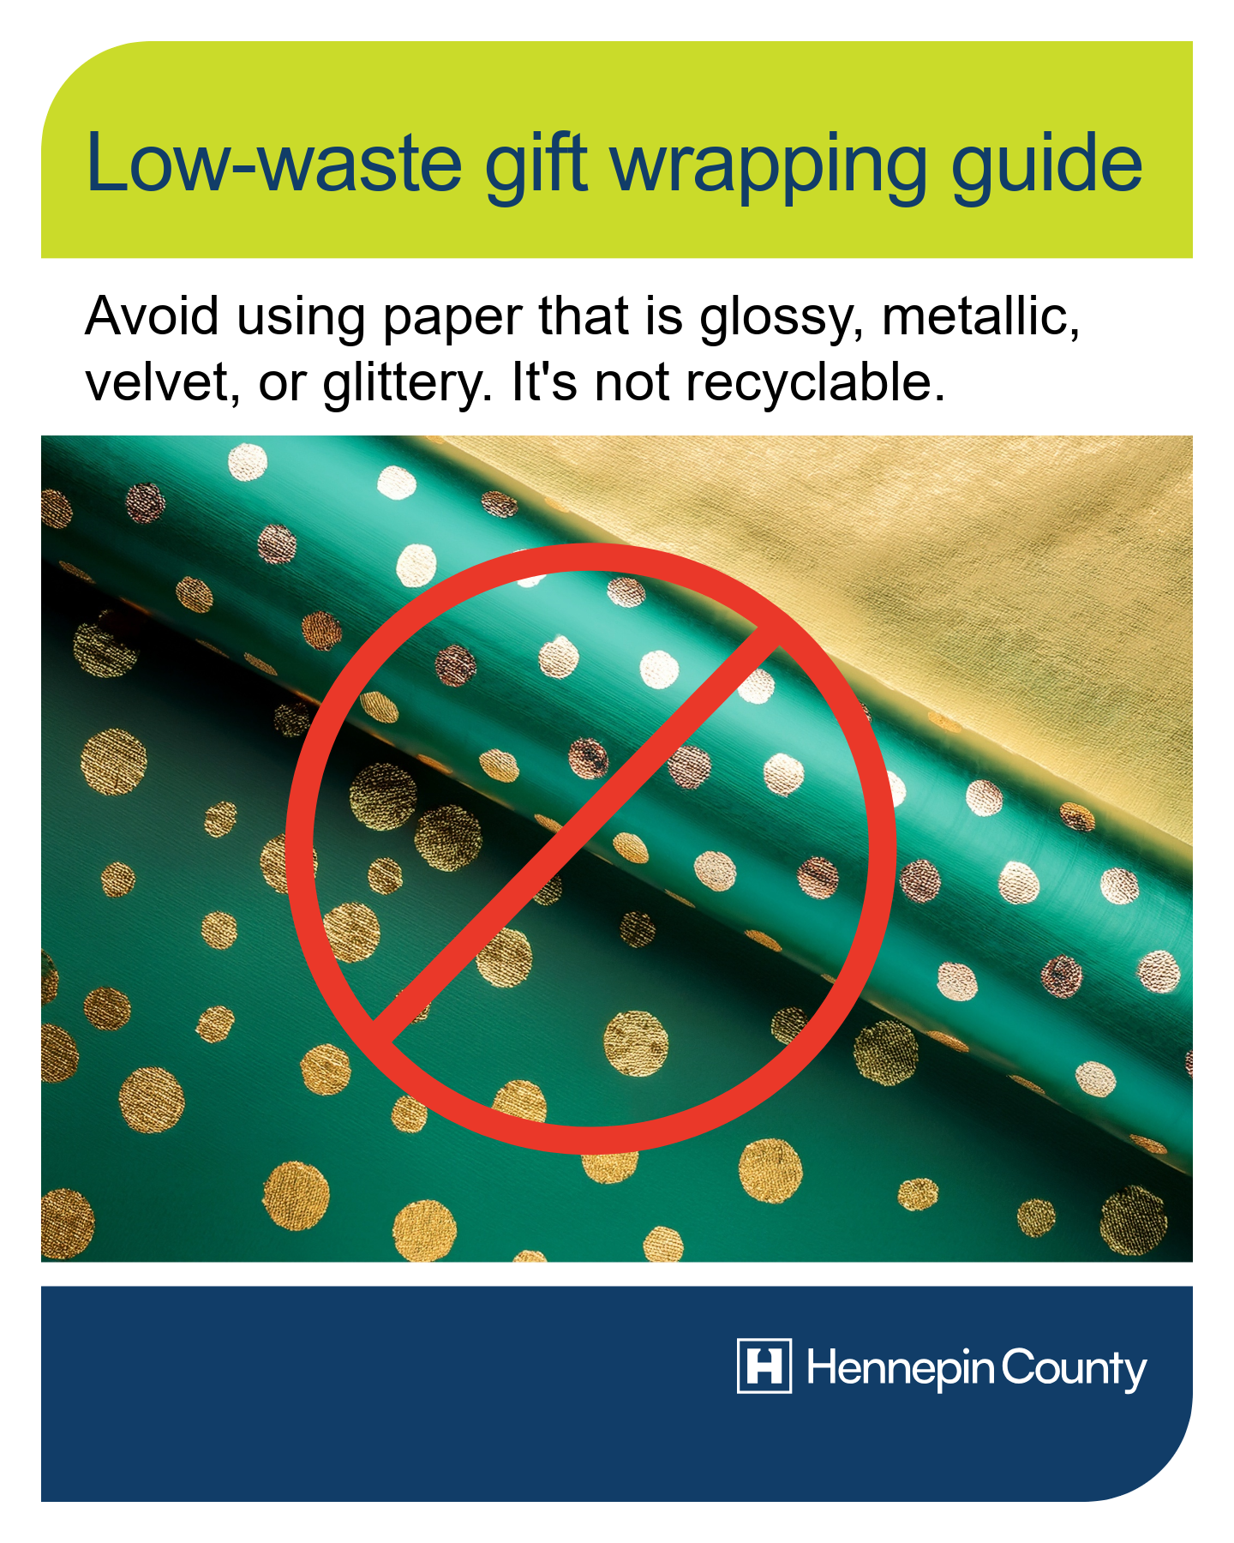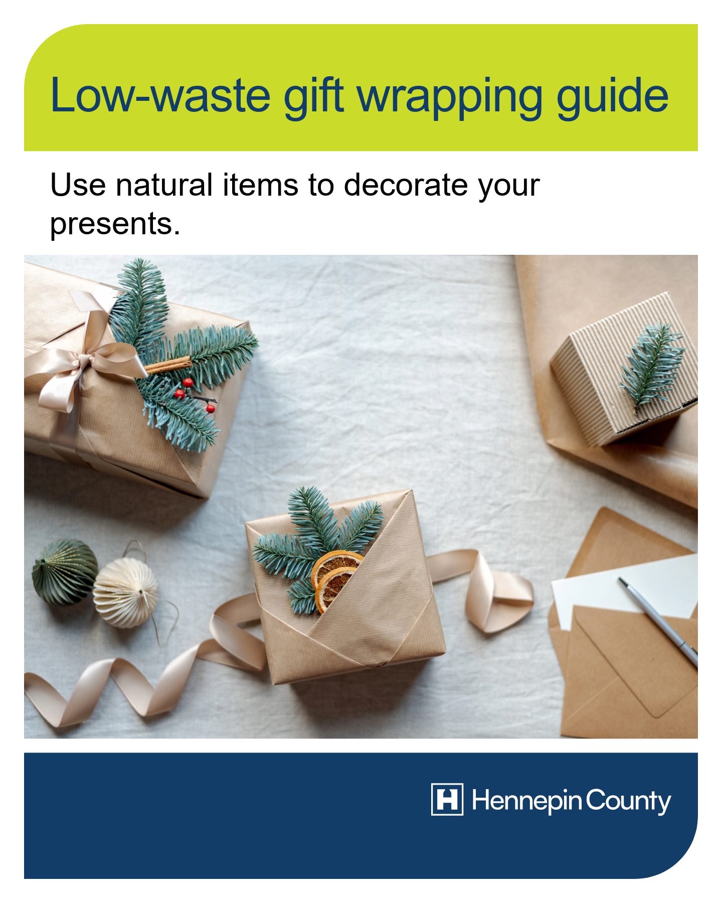
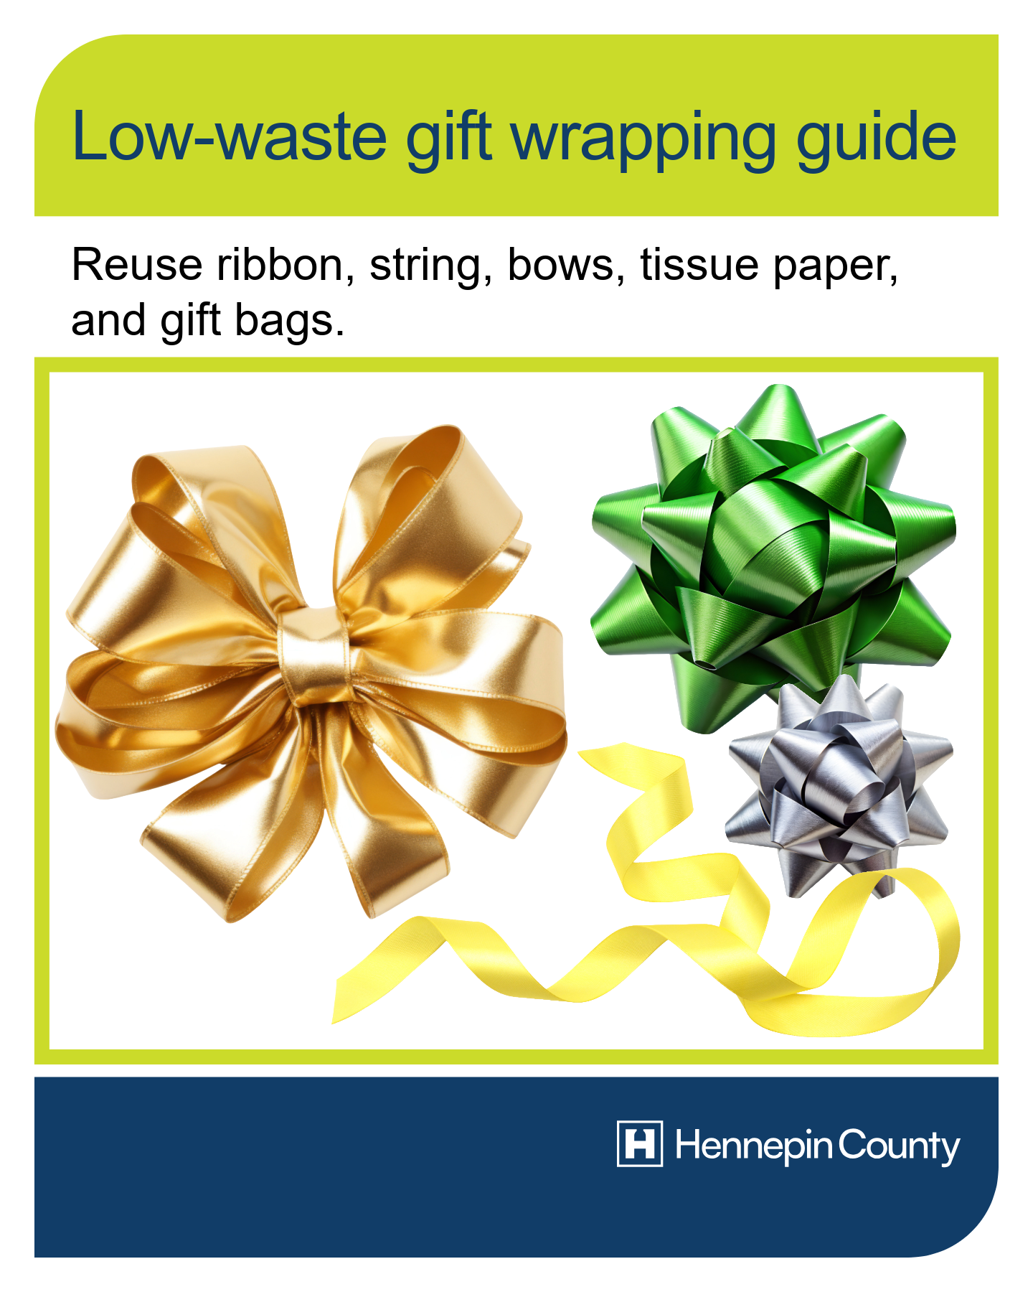

Story-sized images:
